National Federation of the Blind of Idaho
Dana Ard, President
1320 E. Washington
Boise, ID 83712
Ph: (208) 345-3906
danalynard@q.com
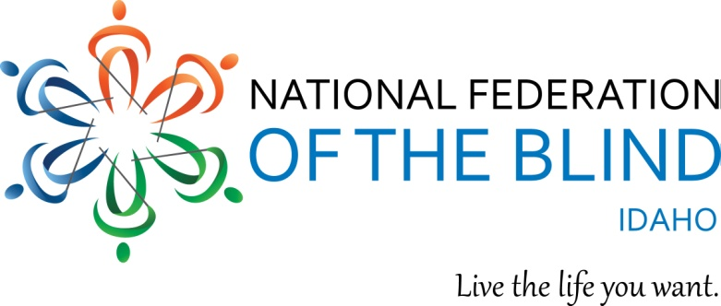

Dear Friend,
The National Federation of the Blind of Idaho is once again conducting our Spring online auction through Auction Frogs. We will be posting items, pictures and a descriptions, on the website. We hope you can donate an item for this worthwhile fundraising event.
One of our most important educational events each year in our State Convention. We provide training and updates on technology for the blind. We offer connections, support and training for people who are newly blind. Services are promoted to adults, including seniors and college students. Adjusting to blindness can be challenging. It is usually difficult, but with proper assistance and current skills, blinded people can lead active, productive and satisfying lives. Our State Convention provides those opportunities.
This year, our State Convention will be in Twin Falls April 27-28, 2018. We will conclude the auction that weekend, coinciding with the conclusion of our convention. Funds from the auction items support the many varied activities of the NFB Idaho. These include programs that benefit children, transitioning young adult, adults and seniors.
The Federation’s purpose is to help blind people achieve independence, self-confidence, self-respect, and self-determination. The NFB helps the blind to become an integral part of society and attain full employment in the workforce. NFB Idaho is a state affiliate. We also have chapters throughout the state. NFB Idaho and our chapters support blind and visually impaired people of all ages throughout the state.
For all of these reasons, your support of our fundraising events is critical to our success. Thank you for your continuing support!

Sincerely yours,

