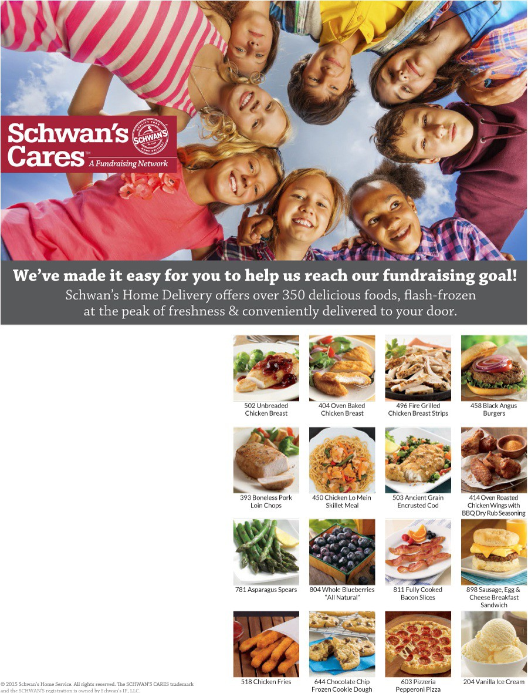

Through Schwans-Cares.com, you can order from Schwan’s Home Delivery and help the National Federation of the Blind of Idaho meet our fundraising goal. When you order by Dec 16 2017, 20% of product and 40% of eGift Card sales will go back to our organization. We help newly blind people adjust and assist families with blind children. We award scholarships to blind college students. We appreciate your support.

Here are two ways to support us!

ORDER ONLINE:

- Visit www.schwans-
cares.com/c/35452
2. Click "Shop to Give"
4. Start shopping !

ORDER BY PHONE:

Call 1-855-870-7208 and provide
Campaign ID:35452.

