National Federation of the Blind of Idaho
Dana Ard, President
1320 E. Washington
Boise, ID 83712
(208) 345-3906
danalynard@q.com
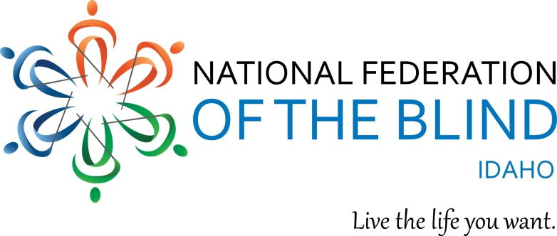

Fact Sheet

The National Federation of the Blind of Idaho

The National Federation of the Blind is the oldest and largest blindness self-advocacy organization in the United States and in Idaho. Our membership consists of blind and visually impaired individuals, as well as sighted members who care about our issues. We believe that blindness does not define a person or that person’s future. Low expectations of society, lack of opportunity, inadequate training in the skills of blindness such as braille, cane travel and technology, lack of quality education for blind students, limited access to information, and inaccessible technology are some factors that will negatively impact the future for the blind. Through our programs and advocacy efforts on local, state and national levels, the National Federation of the Blind of Idaho is working to create a better world and a brighter future for the blind of Idaho.

The Braille Enrichment for Literacy and Learning (Bell) Academy is a summer program which helps blind children develop and strengthen their blindness skills, raise their expectations of themselves, experience new activities, and learn from blind role models who work as teachers in the program. In 2017, the NFB of Idaho had BELL Programs in Boise, Idaho Falls, and Coeur d’Alene, serving a total of 25 children. In addition to daily classes in braille reading and writing, cane travel, nonvisual skills, and technology, students learned and gained confidence from other activities and field trips. Examples included a trip to the Boise transit center to explore the buses, experiencing various tools (including a chain saw) in the wood shop at the Idaho Commission for the Blind and Visually Impaired, a recording session in the booth at the Idaho State Library, yoga, pottery, dance, a visit from Corbin Maxey’s reptile menagerie, a trip to the Idaho Falls airport, and rock climbing and repelling.

We believe in literacy for all blind people. To encourage braille reading, we have a yearly braille-a-thon which begins January 4, (Louis Braille’s birthday) and continues for the next two months. This activity is open to anyone from beginner to advanced readers. All participants receive a cash prize and our recognized at our state convention, which will be in Twin Falls, April 26-28, 2018.

We believe that access to higher education is vital for employment. Our scholarship program has assisted many blind students over the past several years. Beginning in 2016 and continuing this year, we have increased the amount of our scholarships which has increased the number and quality of applicants. We will be giving four scholarships in 2018.

Access to up-to-date print information is vital for all people including the blind. The NFB of Idaho has been fortunate to partner with the Idaho Commission for the Blind to make the NFB- NEWSLINE® service available to all blind and print disabled people in Idaho. This service provides over 300 state newspapers, including four Idaho newspapers, 17 national newspapers, 13 international newspapers, 61 magazines, job and TV listings, weather alerts, and retail adds from Target and Walmart. This information can be downloaded on to a computer, Victor Reader Stream or smart phone, produced in braille or read auditorily over the phone.

We have provided seminars for seniors, students, parents, and for those new to vision loss. We advocate for local, state, and national issues for the blind. This year we are advocating for state funding for the talking book program. In the past, we have advocated and been successful in getting a transition specialist position for the Idaho Commission for the Blind, and increasing the number of teachers at the Idaho School for Deaf and Blind.

Each year, members of our organization travel to Washington D.C. to meet with our Idaho senators and representatives to advocate for specific issues that will improve the lives of blind people around our country. This year these issues will include legislation to assist institutions of higher education to increase accessibility in educational materials to blind students, provision of a refundable tax credit to help blind people to obtain technology needed for employment and independence, opposition to the “ADA Reform and Education Act” which will weaken the Americans with Disabilities Act, and the Marrakesh treaty to facilitate access to published works for people who are blind, visually impaired and otherwise print disabled. We also work with our national office on such projects as insuring that ATM machines are accessible for the blind, that Uber drivers do not discriminate against people who travel with service animals, and assuring that we can vote privately and independently.

Members in our eight chapters around the state build relationships as they work on advocacy issues specific to their communities, raise much needed funds, enjoy social events, and participate in educational, fun, and thought-provoking meetings.

Since the founding of the National Federation of the Blind in 1940, and our Idaho organization in 1935, we have accomplished much and changed what it means to be blind. As our world changes, we will work to remove those barriers that keep us from realizing our dreams. Through our love, hope, and determination, we will transform our dreams into reality.

