National Federation of the Blind of Idaho
Dana Ard, President
1320 E. Washington
Boise, ID 83712
(208) 345-3906
danalynard@q.com
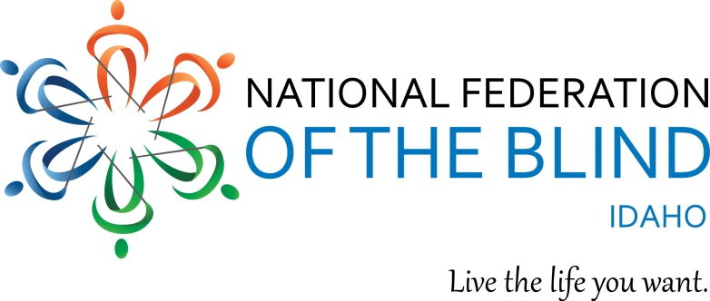
Fact Sheet
Requesting restoration of state funding for the Commission for Libraries Talking Book Program

In 1931, the Pratt-Smoot Act was passed to provide braille and recorded materials for blind individuals. In 1966, people with physical disabilities who are unable to access printed material were added to the service. Currently the Idaho Commission for Libraries serves approximately 3500 talking book users, which is 13% per capita higher than the national average. This service equalizes access to all types of reading material and serves as the public library for those who cannot access printed material. Talking Book patrons can receive materials directly from the Idaho Commission for Libraries, or by downloading materials to a device such as an iPhone, computer, Victor Reader Stream, or other electronic device.

The Idaho Talking Book Program was funded with state funds until 2010, when state funding was cut by 18%. In order to maintain the program, Federal LSTA funds have been used. These funds are diminishing with the 2017 allotment being only 95% of that in 2010. The demand for the service continues to increase, while the funding decreases. The current federal administration recommends the elimination of the Museum and Library Services, which provides the LSTA federal funds. If the State of Idaho will not fund the Talking Book Program, and federal funds are lost, blind and other people who cannot access print would no longer have access to recorded materials. Additionally the provision of Talking Book Services in each state is designed to be a partnership with the Library of Congress and the State Agency responsible for delivering these services.

One of the greatest challenges for blind people is access to print information. We need information just like everyone else. When I was in high school and college, I used the Talking Book Program to complete assignments in subjects such as literature, history, religion, music and counseling. In my work as a vocational rehabilitation counselor with the State of Idaho, I used the service to get information on careers, job search methods, resume writing and other aspects of my job. I often would refer a blind client to a specific talking book to help gain more career focus and job skills. As a retired adult, I use the service to read books that other friends are reading, and to participate in activities in the community.

The National Federation of the Blind knows that blindness does not define us as people or define our future or limit our dreams. However lack of access to print materials will. The National Federation of the Blind of Idaho asks that you support state funding for the Talking Book Program at a cost of $356,400 to insure that we have continued access to these much needed recorded materials.

