National Federation of the Blind of Idaho
Dana Ard, President
1320 E. Washington
Boise, ID 83712
(208) 345-3906
danalynard@q.com
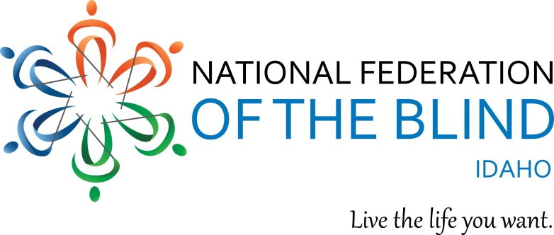
WINNING OPPORTUNITIES!!!
National Federation of the Blind of Idaho Online Auction

Beginning April 16, you can bid on almost 100 items to support the blind of Idaho. Bidding will continue until midnight on April 30, 2018. You may visit the website www.nfbidaho.afrogs.org at any time to plan for your bidding.

Categories are: Adventure and Travel; Appliances and Tools; Beautiful Puzzles; Beauty and Comfort; Collectables; Creativity at its Best; Decorating your Home; Food and Lodging; For Kids and Pets; and Learning Opportunities.

Here are a few of our many items in the Auction:

$100 Gift card to Chandlers Prime Steaks and Fine Seafood
3 Scenic Flight for two over Idaho Gold Country with pilot Joseph Bejsovec
1-night stay and complimentary breakfast buffet at Residence Inn by Marriott
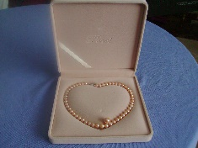
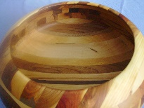
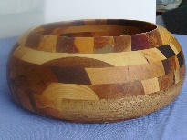
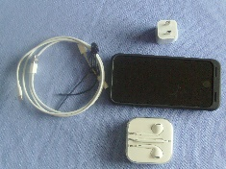

Fresh Water Pearl Large wooden i-Phone 7 with
Necklace bowl extra battery

The National Federation of the Blind of Idaho is the largest organization of the blind in this State. It seeks to improve education for blind and visually impaired children; Advance employment for blind adults; assist those who are adjusting to sight loss; and educate the public at large about what it means to be blind.

Donations are appreciated and can be made if no item is purchased. We are proud of this auction and grateful to all who have provided items for this event. Any questions please send an email to walhoframona@gmail.com.

