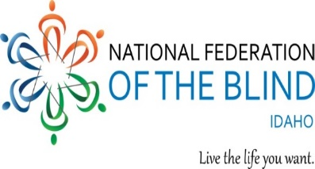
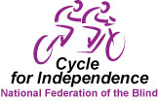

The NFB knows that blindness is not what
defines you or your future. You can

www.cycleforindependence.org

Al Schneider
Event Coordinator
Ph: 208-870-4831
aaschneider@hotmail.com
LIVE THE LIFE YOU WANT.
Blindness is not what holds you back
Treasure Valley Chapter
Susan Bradley, President
Ph: (208) 794-9431
craftisue@hotmail.com

2019 Cycle for Independence -- May 18, 2019

Each year our local chapter of the NFB puts on a bike ride as a fund raiser called the Cycle for Independence. Although this is not a race, we attract serious riders in our 10-mile, 25-mile, and metric century rides, followed by music, food, prizes, and comradery. The event raises money for the blind of Idaho, but just as important it is an opportunity for sighted people to interact with blind people and witness them accomplishing all facets of this endeavor from event organization to cooking to registration to manning water stops and so on.
We are hoping that as leaders of the Great State of Idaho, you would be willing to become a rider on a team of legislators participating in this wonderful family-centered event. Our idea is not pitting Democrats against Republicans in competition to prove which had the largest team, but instead welcoming a noticeably non-partisan team of legislators promoting by example the empowerment of blind Idahoans “Living the Life They Want” and living that life with independence.
To participate as a rider on TEAM IDAHO LEGISLATORS, or for your company to become a sponsor or to volunteer to help with the event, contact Rep. Dustin Manwaring’s office or log on to www.cycleforindependence.org or contact event coordinator Al Schneider at 208-870-4831 or aaschneider@hotmail.com.

The NFB Works with Legislators Advocating For:

--Removing 1938 law that allows employers to pay disabled people below minimum wage
--Web site accessibility
--Home appliance accessibility
--Accessibility for higher education classroom materials
--Airport (and other) kiosk accessibility
--Transportation

Local NFB Chapter Projects:
--Cycle for Independence
--Legislative meet and greet
--College Scholarships for blind and visually impaired students
--Newsline (Magazines and newspapers via telephone voice over)
--Birding by sound
--Talking Books
--BELL summer camps for blind children to live and learn with other blind children
--Braille Reading Club

Your participation helps:

- Blind seniors to live independently
- Work to improve education of blind children
- Provide scholarships and transition services for blind young adults
- Educate blind adults about opportunities for employment
- Assist blind people in learning about new advances in services and adaptive technology
- The NFB work with legislators advocating for legislation designed to give equal opportunities for blind people

National Federation of the Blind of Idaho, Treasure Valley Chapter Tax ID # 94-3144114

