National Federation of the Blind of Idaho
Dana Ard, President
1320 E. Washington
Boise, ID 83712
(208) 345-3906
president@nfbidaho.org
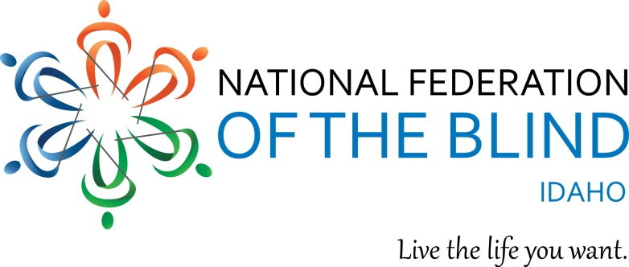

Legislative Fact Sheet

Requesting $342,100 to Restore State funding for the Commission for Libraries Talking Book Program

In 1931, the Pratt-Smoot act was passed to provide braille and recorded materials for blind individuals. In 1966, people with physical disabilities who are unable to access printed material were added to the service. Currently the Idaho Commission for Libraries serves approximately 3,500 talking book users, which is 13% per capita higher than the national average. This service equalizes access to all types of reading material and serves as the public library for those who cannot access printed material. Talking book patrons can receive materials directly from the Idaho Commission for Libraries, or by downloading materials to a device such as an iPhone, computer, Victor Reader Stream, or other electronic device.

The Idaho Talking book program was funded with state funds until 2010, when state funding was cut by 18%. In order to maintain the program, federal Library Services and Technology Act (LSTA) funds have been used. If state monies were used to fund the Talking Book Program, the LSTA funds could be used to enhance other statewide programs such as workforce development activities, STEM education, etc. LSTA funds have been included in the 2019 federal budget, but there is no guarantee that they will continue in subsequent years. If Idaho will not fund the Talking Book Program and federal funds are lost, blind and other people who cannot utilize print would no longer have access to recorded materials. Additionally, the provision of talking book services in each state is designed to be a partnership with the Library of Congress, which provides the equipment and recorded materials, and the state agency responsible for delivering the service.

One of the greatest challenges for blind people is access to print information. We need information just like everyone else. Patrons use this program for education, career development, participation in community book clubs, and to read books that their friends or family members are reading. Many readers state that the program is a lifeline for them.

The National Federation of the Blind knows that blindness does not define us as people or define our future or limit our dreams. However the lack of access to print materials will. We appreciate the fall back resolution which earmarked $200,000 for the Talking Book Program if federal funding was lost. We ask that you consider funding the Talking Book Service, so that Idaho’s blind and print disabled citizens can be guaranteed recorded materials for years to come.

