National Federation of the Blind of Idaho
Dana Ard, President
1320 E. Washington
Boise, ID 83712
(208) 345-3906
president@nfbidaho.org

Tax id 2307039334
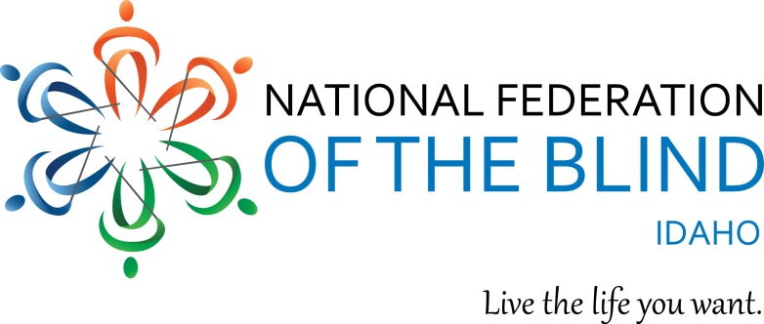

Dear Friend,

The National Federation of the Blind of Idaho is the largest organization of the blind in this state and is committed to helping blind individuals build better lives and more opportunities. We will be conducting an online auction this winter and spring to raise much needed funds.

Our goals are to assist families with young blind children; assist seniors who lose vision late in life and must make a difficult adjustment; work toward better employment opportunities for the blind; provide information to help families and the public at large understand the needs of the blind and much more.

We are hoping that you can support our work with a donation of a gift certificate or gift that we will show on our auction website and invite visitors to bid on. Our website is managed by Auctionfrogs.org. All names of donors are displayed along with the descriptions and pictures of each item.

Bidding will finish immediately following our State Convention March 22/23. We will advertise the auction along with this convention. Blind persons, friends and families from all parts of Idaho and other states will participate in our convention.

Thus, your assistance with a donation will help the blind and provide you with an opportunity to show the communities through Idaho and beyond that you care.

Cordially, Dana Ard, President
Ramona Walhof, Auction Chair

