National Federation of the Blind of Idaho

**Dana Ard**, President

1320 E. Washington

Boise, ID 83712

(208) 345-3906

president@nfbidaho.org

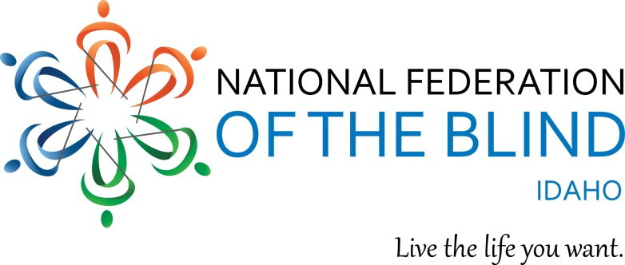

Dear Friend,

The National Federation of the Blind of Idaho will be holding our annual State Convention on April 16 – 18, 2020 in Idaho Falls at the Hilton Garden Inn. We give out door prizes and have a live auction throughout the convention. We hope we can count on you for a donation of a door prize or auction item or to be a sponsor.

The National Federation of the Blind is a self-help organization consisting of blind people, their family members and friends. We are advocates for the blind seeking better employment opportunities; better education for blind children; better understanding of the needs and abilities of blind people. With quality training, blind people can be contributing members of society throughout their communities.

We appreciate all your support. This year we will be awarding four scholarships to blind college students. In July we will have a one-week residential Braille Enrichment for Literacy and Learning (BELL) Academy for blind children age 6 to 12 in Boise. All donors who contribute $100 or more will be listed in their respective categories on our state website: [www.nfbidaho.org](http://www.nfbidaho.org/). We are a 501c (3) nonprofit organization and our Tax ID # is 23-7039334.

Levels of Sponsorship are:

Louis Braille $1,000

Helen Keller $500

John Milton $250

White Cane $100

Supporting Sponsor $50

Any support you may be able to offer is greatly appreciated.

Sincerely

Dana Ard, President

National Federation of the Blind of Idaho