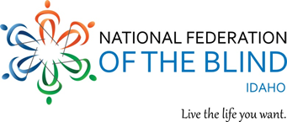 | National Federation of the Blind of Idaho  Dana Ard, President  1320 E. Washington  Boise, ID 83712  (208) 345-3906  pres.nfbidaho@gmail.com

2022 NFBI State Convention Registration

April 21 - 23, 2022 Idaho Falls, ID

Holiday Inn 3005 S. Fork Blvd, Idaho Falls ID 83402, Phone 208-227-9800
Room reservations must be made by April 15, 2022 to get the Convention rate. Be sure to state that you are registering for the National Federation of the Blind Convention and you want the room rate of $109.00 plus tax.
“Dream, Believe, Achieve”

You must register for rooms directly with the hotel, and then then complete the rest of the form below.

To make your hotel registration please call the hotel directly at 208-227-9800 and identify yourself as part of the National Federation of the Blind group.
Complete the following attendee information and meal preferences and return it by April 8^{th.} Information on where to send this information and your payment is included below the tables.

Attendee Information
Name:
Address:
City, State, Zip:
Please indicate any access accommodations for you or any of your guests:

Attendance and Meal Information and Costs | Number | Cost
Registration Fee $20.00 per person (number x $20.00)
Board Dinner $15.00 per person (number x $15.00)
Special Diet Restrictions (please specify below)
Saturday Box Lunch $10.00 (number x $10.00)
Banquet $30.00 per person (number x $30.00)
Number of Stuffed Tuscan Chicken Banquet Guests
Number of Sirloin Banquet Dinner Guests
Special Diet Restrictions (please specify below)
Total of All Charges Noted Above
If you are paying by check, please send your completion of this form and payment
to the NFB-Idaho Treasurer at treasurer@nfbidaho.org or to the address noted below.
Don Winiecki
Treasurer, NFB-Idaho
1422 E Woodvine Court
Boise ID 83706-4484
If you would like to pay by credit or debit card, please (a) send your completion of this form to the NFB-Idaho Treasurer at the E-mail or postal address noted above, and (b) use the following QR Code to visit the NFB-Idaho E-commerce site to submit your payment. The QR Code is centered immediately below this paragraph.
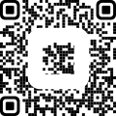

We welcome convention sponsorships from our exhibitors and others. $300.00 is a suggested amount but any amount is appreciated. Our 501(c)(3) Tax ID # 23-7039334.

