**2024 NFBI State Convention Registration**

**March 27 - 30, 2025 Burley, ID**

**Burley Inn Convention Center**

**800 N Overland Ave, Burley ID 83318, 208-678-3501**

**Convention theme “Believe, Lead, Dream”**

**Get ready to join our Federation family at the 2024 state convention,**

**In Burley, ID, at the Burley Inn Convention Center, 800 N Overland Ave, Burley ID 83318. Room rates are $100.00 +tax per night. Be sure to make your reservations by calling them at 208-678-3501. Complimentary breakfast is served daily at the hotel. Our National Representative will be Donald Porterfield, President of NFB of Arizona and a National Board Member.**

We have three ways for you to register for the Convention. It you are paying by check, please send your completed form below and payment to NFB-Idaho Treasurer at [treasurer@nfbidaho.org](mailto:treasurer@nfbidaho.org) or Don Winiecki, 1422 E Woodvine Court, Boise ID 83706-4484. If you would like to pay by credit or debit card, please use the following URL for the online registration and payment page.

<https://tinyurl.com/nfb-idaho-2025> or you can use the QR code following QR Code to visit the NFB-Idaho E-commerce site to submit your payment. The QR Code is centered immediately below this paragraph.

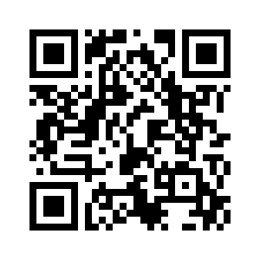

**NAME**

**ADDRESS**

**CITY, STATE, ZIP**

**REGISTRATION FEE $20.00 PER PERSON (NUMBER x $20.00) $**

**BOARD DINNER $15.00 PER PERSON: (NUMBER x $15.00) $**

**STUDENT, YOUNG ADULT (35 and under) LUNCH SATURDAY Yes**

**BANQUET: $30.00 PER PERSON (NUMBER x $30.00) $**

**SPECIAL DIET Please specify:**

**TOTAL OF ABOVE $**

**Our meal counts must be in by March 9, 2024**

**Do you receive the Braille Monitor Yes No**

**Do you receive the Gem State Milestones Yes No**

**Please indicate any accommodations needed to participate in the Convention.**