I was thinking this morning about our influences, and how we got to where we are today as artists. Have you stopped to think about where the ideas come from when you are creating your own art?

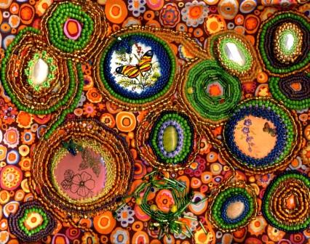

I thought about the choices we make. How do we decide what to create?

I immediately think of my MOTHER who patiently teaching me to do embroidery when I was a very young child. We were sitting side by side in my GRANDMOTHER’s kitchen. She had purchased a kit. It consisted of a piece of beautiful linen fabric, in white. There were three colors of embroidery thread: Light blue, dark blue, and silver gray. I held those little skeins of thread in my hands and moved them about to catch the light on them. They seemed to shimmer as I turned them over and over again. They felt so silky soft in my small hands. The colors seemed to me like they were magic; they were the colors of the sky on a summer afternoon.

There were two more thing in my embroidery kit; there was a slender, sharp, silver needle and a round metal embroidery hoop.

As I speak of this day, I can still see my mother bending over me, and showing my how to put my needle into the cloth, to push gently down on it, and to bring it to the back of the linen cloth. I searched for just the right spot where the needle would be pushed into the back of the cloth, and gave it a shove and watched it pop up onto the front once again.

That feeling of pushing the needle gently into the fabric, then pulling the blue thread so gently until it was completely through the fabric was something that stays with me in my memories after sixty years.

My imagination brings me once again to feel the silken thread, the tension of moving it from the top to the back of the linen, and then the pull of bringing it back up to the surface. It is a feeling of the comfort of repetition and the solitude of working with fabric and thread. It’s a quiet feeling that gently comes to me when I remember the slender silver needle in my small fingers. I was about 8 years old at that time.

This afternoon lesson sitting with my Mother, is one of the many precious things my Mother gave me. Did she recognize that I was a child who was destined to be a maker of beautiful things? Somehow, she must have known intuitively that it was important to take the afternoon and spend it with her oldest daughter. Did she know that she was teaching me a life lesson with three skeins of thread, a delicate needle, and a piece of ivory linen?

Today, I recognize that this was my first “painting” lesson. In the art I am making these days, I am conscious that I am PAINTING with a NEEDLE, and the THREADS are the SPLASHES of COLOR, my PIGMENTS. Into this mix of fibers and threads, I add dashes of natural gemstones; I gather things from Nature that will be part of my pictures. And, not only are my THREADS the strokes of the painting’s surface, so are the glass beads, the pearls, the vintage objects, and the crystals.

PICTURED HERE: Ilsa’s Butterfly Garden, Mixed Media Painting on Fabric.

