How to Match Colors
http://www.wikihow.com/Match-Colors

Whether you’re assembling your wardrobe, decorating a room or matting a painting, it’s helpful to know which colors help each other pop and look most appealing to the eyes. You can start by looking at a color wheel and learning which colors look best grouped together. Experimenting with different color combinations will help you develop a sense of what matches and what clashes.

Method 1 of 3: Developing an Eye for Color

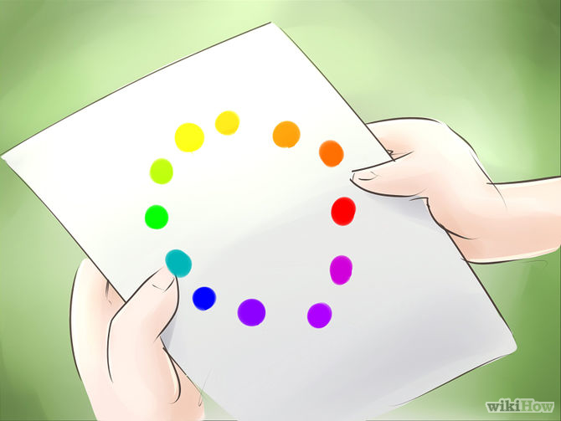

1. Learn about the color wheel. The color wheel is diagram of colors that provides a useful illustration of what colors match and what colors don't work well together.[1] The first color wheel was developed by Sir Isaac Newton in 1666, and variations on his design have been used as the basis of traditional color theory since then.[2] The color wheel is divided into the following parts:
Primary colors: red, blue and yellow. These are the colors that can't be mixed using any other colors.
Secondary colors: Green, orange and purple. These colors are made by mixing primary colors in different combinations.
Secondary and tertiary colors: Yellow-orange, red-orange, red-purple, blue-purple, blue-green and yellow-green. These are created by mixing a primary color with a secondary color.

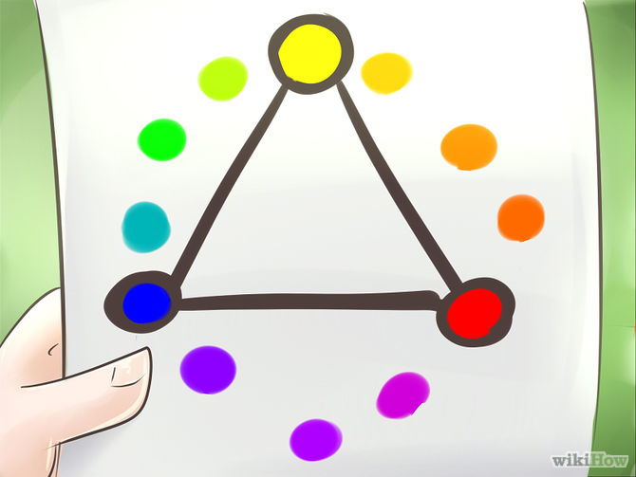

2. Match primary colors with other primary colors. The concept of matching is also called "color harmony," which is achieved when colors create a pleasing effect. Red, yellow and blue always harmonize. These colors are bold and eye-catching, and they never really go out of style. Whether you're putting together a palette for your wardrobe, a painting or your dining room, you can depend on primary colors to lend your project a cheerful and bright appearance.
Primary colors are often associated with kids, since they're so bold and saturated. Consider a primary palette if you're decorating a room for a child.
If you want your project to look more sophisticated, you might want to consider using just one or two of the primary colors, rather than all three.
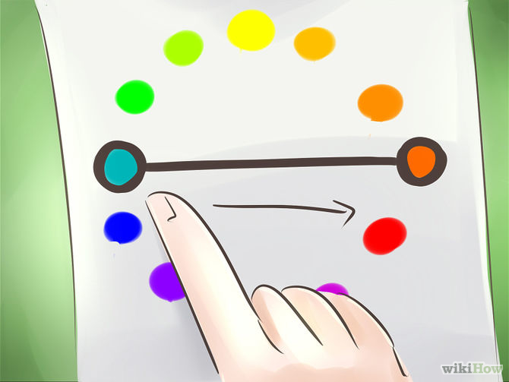

3. Match complementary colors. Look at the color wheel and pick any color, then move your finger to the color just opposite. Colors opposite on the wheel are complementary colors. When you place them next to each other, they help each other stand out and the combination looks appealing.
Popular complementary combinations include blue and orange, purple and yellow, and green and pink.
When you choose two colors from random spots on the wheel, they may clash instead of matching (although that line is sometimes hard to find). But complementary colors will always match.

4. Match analogous colors. These are the colors that are next to each other on the color wheel, like blue and indigo. Using varying shades of colors in the same family creates a nuanced look that has a beautiful, pleasing effect. Matching analogous colors is an easy way to create a pretty wardrobe without having to try hard to find exact complementary shades.
Pick a favorite color and match it with a color to the right or left. Red goes with pink, yellow with orange, and so on. Any gradations in the same family will match.
Limit yourself to one color family; going outside the family will create a rainbow effect.

5. Learn about warm and cool colors. Warm colors like yellow, orange, and red are on one side of the color wheel, and cool colors like blue, green, purple are on the other side. Any color can have an element of warmth or coolness depending on what's mixed in. For example, if you mix basic purple with red, you end up with a warm, vibrant reddish purple. If you mix purple with blue, you end up with a cool, calming violet purple. When it comes to matching colors, temperature matters.[3]
When you're creating a color palette to use in your wardrobe or to decorate a room and you want a coherent effect, pair warm colors with other warm colors, and cool colors with other cool colors. For example, you might choose a rust-colored dress, a creamy mustard yellow scarf and a cognac purse.
On the other hand, mixing warm and cool colors in the same palette results in an effect that can be either fun and funky or a little jarring, depending on how you look at it.[4]

6. Consider earth tones. These are natural, muted colors that match most other colors. They're reminiscent of natural elements like sand, soil and rock. Brown, cream, white, grey, and slate fall into this category. When it comes to fashion and decorating, you'll see these easy-to-match colors referred to as neutrals.[5]
When you're deciding what neutrals match your color palette, you need to take color temperature into account. For example, if your color palette is cool, your neutral could be a bright white or a blue black; warmer neutrals would clash. For a warmer palette, you might choose a brownish grey or cream.

Method 2 of 3: Matching Colors in Your Wardrobe

1. Try a monochrome look. Wearing the same color from head to toe is a striking look. The classic monochrome look is an all-black or all-white outfit, a sophisticated choice that lends an air of dressiness to your outfit. If you want to really turn heads, try a monochrome look in a brighter color, like red or green.
The key to making a monochrome look work is finding items in the exact same color. Wearing a bright white top with cream pants is going to clash, but if you find two pieces in the same color, you're golden.
To make a monochrome outfit look less extreme, break it up with some neutrals, like beige heels or a brown belt.

2. Wear an accent color. If you’re headed to a formal meeting that requires wearing a navy or black suit, you can still add some personality to your look with an accent color. Just make sure the accent color you choose is similar in temperature to your neutral basics. For example,
If you're wearing a black suit, try a red or turquoise camisole or blouse.
If you're wearing a navy suit, try a yellow or pink camisole or blouse.

3. Learn to match prints. Once you gain the confidence to match colors effectively, you can start creating really stylish outfits by pairing unlikely items in your closet. You aren't limited to matching solids with solids. Branch out and start matching your stripes, polka dots, florals and animal prints with each other to completely reinvent your wardrobe.
If you’re wearing a print, match it to a solid. This is relatively easy to do. If you have a black skirt with a small floral print, pair it with a green top that matches the color of the leaves.
Match two prints with the same color. A bit more difficult, but it produces striking results. The key is to find one like color across two prints. For example, if you have an orange-striped blouse, you can match it with a leopard-print skirt that has the same color.
Match prints in the same color family. You can match prints that don't have the exact same color by keeping things in the same color family. A pair of ikat shorts with beige and cream tones can go with a brown polka-dotted blouse.

4. Know your neutrals. They're the items in your closet that go with almost everything, so you can never really have too many. Neutrals are easy to incorporate, but you should still put a little effort into making sure they match the other items you're wearing. Here are a few popular neutrals:
Denim. Goes with everything, right? Just remember to take the wash into account. A saturated dark wash matches different colors than a light blue faded denim.
Camel or brown. Perfect for a muted, earth-toned palette.
Navy. Looks beautiful with jewel-toned hues.
White and cream. Brightens any outfit, as long as you keep the temperature in mind.

5. Use accessories to play with color. If you're just starting out in your quest to match more colors in your wardrobe, try playing around with accessories. Experiment to find out what looks good and what doesn't by wearing more belts, flats, jewelry, and scarves. Wearing accessories is also a fun way to learn more about mixing prints without splurging on expensive clothes that might not end up matching.

Method 3 of 3: Choosing Colors to Decorate Your House

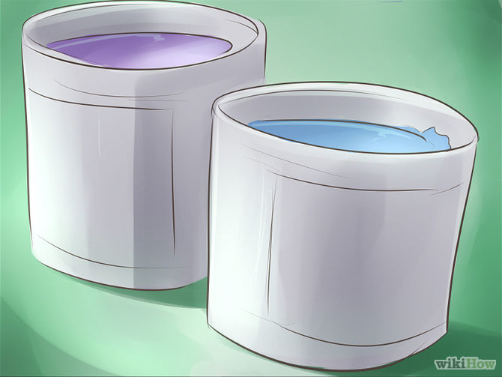

1. Pick different colors for your paint and fabrics. Don’t match a wall and couch with the exact same color. While these items will technically "match," they won't help each other stand out and look beautiful. Instead, the color of both the wall and the couch will look understated. here are a few ideas you can try instead:[6]
Go with colors in the same family. If you have a blue wall, try a blue-green couch. If your wall is yellow, choose a red and orange color scheme for the furniture. The colors will harmonize instead of canceling each other out.
Or choose a contrasting color for a bigger splash. Buy an overstuffed violet armchair to put in your sunny yellow room, or try a bright coral sofa to offset your light turquoise walls.

2. Consider having an accent wall. Many people hesitate to paint an entire room one bold color, and with good reason. Oversaturated colors can overpower a room and have an effect on your emotional state. A bright red room might make you feel nervous, and a dark grey one might give you the blues. That doesn't mean you have to stick exclusively to muted neutrals, though. Having an accent wall gives you the chance to play with color without worrying about your emotional state. Here's how to do it:
Pick a smaller wall in the room, like the area around your front door or above the kitchen counter. Paint it a bright color that matches the room's neutral.
Or use a contrasting color for the trim. Painting borders in a contrasting color gives a room an eclectic, fun look. You could also create a stenciled trim in a different color.
Keep in mind that color temperature can affect a room's mood. A blue room can have a sedative effect, while a bright yellow room can be overstimulating. Using just a splash of intense color can give the room the feel you want without being overwhelming.
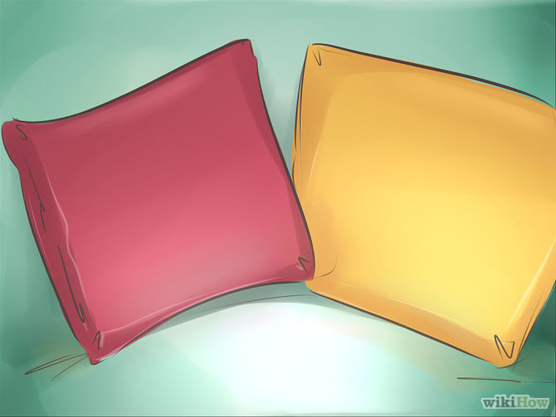

3. Experiment with colorful decorations. If you don't want to commit to painting your walls pink or buying a bright yellow couch, you can still add color to your decorating scheme through decorations. Throw pillows, vases, clocks, flowers, bookshelves, and other smaller items can add bursts of color that liven up a room. Just keep these thoughts in mind when you're decorating:
Pick colors in the same family. Have a few decorations that match each other so that the room looks pulled together. For example, try a bookcase painted green, a pair of sea-green vases on the mantel and a collection of turquoise and green throw pillows and blankets.
Don’t use too many colors in the same room, though. Keep things streamlined or else the room will take on a mismatched appearance.

