Terminology
ch | chain
dc | double crochet (treble crochet for UK/Aus)
hdc | half double crochet (half treble crochet for UK/Aus)
sc | single crochet (double crochet for UK/Aus)
sl st | slip stitch
st | stitch

You will need…
- A suitably sized crochet hook*
- Small amount of yarn* in a floral colour (e.g. white, pink, red, purple, yellow, orange, cream) plus green for the calyx and optional stem
- Yarn needle
- Optional: bamboo skewer, pipe cleaner, or floral wire for the stem
* Hook and yarn sizes: This pattern will work with any size yarn, provided you choose a suitable hook size for your yarn. For a lifesize carnation, I recommend worsted or DK weight yarn.
For my carnations, I used a light worsted weight yarn (Bernat Satin) and a size H (5mm) hook, which produced a 2.25″ (5.5cm) diameter flower. (Your gauge and yarn choice will affect the finished size slightly.)

Gauge
Gauge is unimportant for this pattern, but if your hook is too small you may find the final row difficult to complete, so try moving up to a larger hook to make the fabric of the flower less stiff. Use the recommended hook size on your yarn’s ball band as a starting point.

Crochet Instructions
Terminology Note: The green part at the base of the flower is called the calyx.
Colour Changing: Always change colour in the last loop of the stitch before the colour change: www.planetjune.com/colour
With green, ch 7.
Row 1: dc in fourth chain from hook (first 3 chains count as a st), 2 dc in each remaining chain. (8 st)
With petal colour:
Row 2: ch 3, turn, 2 dc in first st (at base of chain), 3 dc in each remaining st. (24 st)
Row 3: ch 1, turn, sc in first st, ch 1, (hdc, ch 1) three times in each st across to turning chain, rotate work to crochet down side of turning chain, (sc, ch 1, sc, ch 1, sl st) around turning chain.
Fasten off and cut yarn, leaving a long end of each colour for stitching the carnation together.
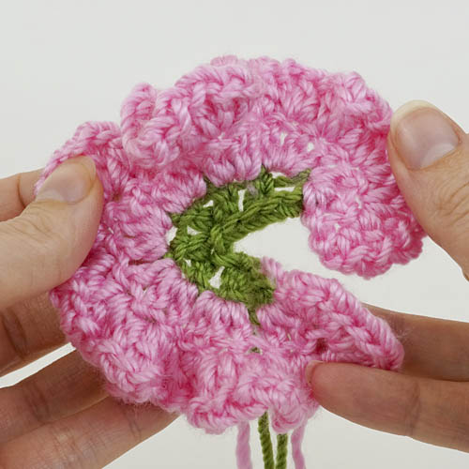
After you finish crocheting, your carnation should look like this (except the petals won’t lie straight like this – I’m holding it flat for the photo!)
Starting at the opposite end of your work to all the yarn ends, roll the end of the petals tightly (below, left). When you reach the start of the green calyx, roll the carnation so the green stitches are rolled as tightly as possible and the edge between the calyx and petals stays aligned as you go (below, right). Ignore the wide edge of the petals as you roll the flower; just concentrate on keeping the green end tightly rolled and the tops of the green stitches lined up with each other, and let the petals splay out however they want to.
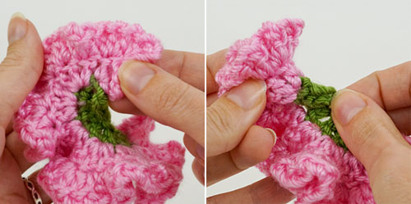
When the whole flower has been rolled up, the green calyx will form a tightly-rolled clump of stitches at the base of the flower. Holding the flower tightly by the calyx so it can’t unroll, thread the long petal-coloured yarn end onto a yarn needle and use it to anchor the end of the final petal in place by stitching it to the petal beneath it, just above the green stitches (below, left). Pass the needle through the centre of the flower to the other side, just above the green stitches, to keep all the layers together.
Thread the long green yarn end onto the yarn needle and pass the needle through all the layers of the calyx from one side to the other (below, right). Rotate the calyx and pass the needle back through in a different direction. Repeat several times until the stitches of the calyx feel like they’re all locked together.
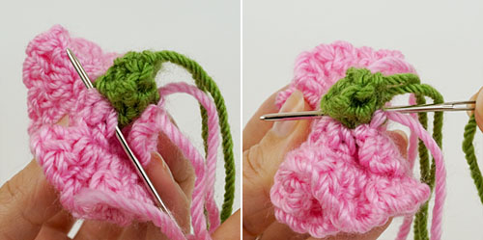
Fasten off securely and weave in all the ends.

Optional: Stem
I used yarn-covered bamboo skewers to make my carnation stems. If you prefer, you may omit the stem altogether, or wrap yarn around, or crochet over, floral wire or pipe cleaners to make a stem (see my Basic Rose pattern for details).
To make a yarn-wrapped skewer stem:
- With the end of the yarn, leave a short yarn tail and tie a single knot tightly around the skewer, about 2cm (3/4″) from the top (below, left).
- Lay the short yarn tail against the skewer, pointing down, and begin to wrap the yarn around both the skewer and the yarn tail (below, right).
- Continue wrapping the yarn all the way to the bottom of the skewer. Once the yarn is well-anchored to the skewer, and the tail is covered, you may find it faster to rotate the skewer so the yarn is wrapped onto it, pausing to push the turns of yarn together if you notice any gaps between them.
- Knot the yarn around the bottom end of the skewer, and secure the knot in place with glue before cutting the yarn.
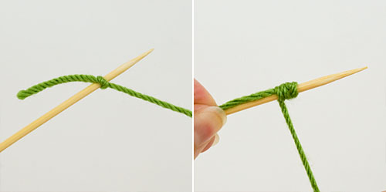

Assembly
Twist the pointed tip of the skewer into the bottom of the carnation’s calyx (below), until the exposed tip of the skewer is completely hidden.
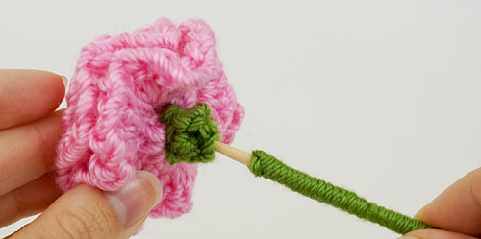
To keep the flower head from falling off, pull the skewer out most of the way again, apply some white glue to the skewer, push it back into the calyx, and hold it in place for a minute until the glue dries.
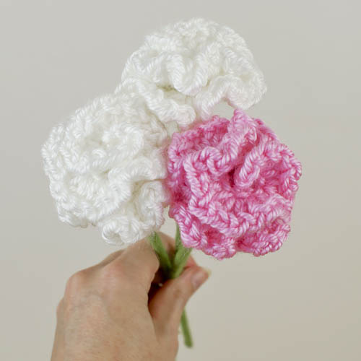
I hope you enjoy this pattern. Pleas

