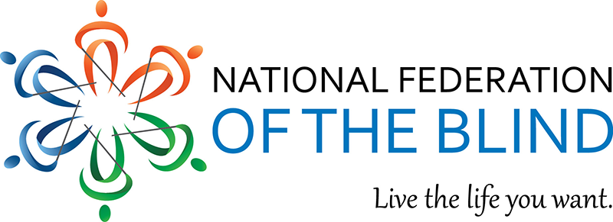

NFB WRITERS’ DIVISION
2022 WRITING CONTEST GUIDELINES
The annual Youth and Adult Writing Contests, sponsored by the NFB Writers’ Division, will open January 1^{st,} 2022, and close April 30^{th,} 2022. This contest is open to all aspiring writers, whether blind, sighted or visually impaired.
***
Adult Contest Categories
- Short Fiction
- Nonfiction, including personal essay and memoir
- Poetry

***
Youth Contest Categories
Youth Contest categories are Short Fiction and Poetry. The Youth Contest is divided into groups by grade level:
- Elementary (1st through 4th grade)
- Middle School (5th through 8th grade)
- High School (9th through 12th grade)
***
Winners
In both the Adult and Youth contests, there may be up to three prize winners (1st, 2nd, and 3rd). In addition, one or more entries may receive an Honorable Mention.
Prize winning entries may be published in the Writers’ Division’s magazine, Slate & Style.
All contest winners will be announced during the 2022 national convention, location to be determined.
***
Prizes
Youth Contest winners will receive cash prizes of:
- 1st place - $30.00
- 2nd place - $20.00
- 3rd place - $10.00

***
Adult Contest winners will receive cash prizes of:
- 1st place - $75.00
- 2nd place - $50.00
- 3rd place - $25.00

***
SUBMISSION GUIDELINES

YOUTH CONTESTS
Youth Contest Braille Requirement
- This is a contest for students up to age 18 who use Braille.
- Entries must be submitted in hand-embossed Braille, either with a slate and stylus or a Perkins Braille writer; there are no exceptions.
- Submissions must be Brailled by the entrant.
- All submissions, no matter the grade level, must be in contracted Braille.
- Indicate whether you already know contracted Braille or are still in the process of learning it.
- Indicate if you have chosen to use UEB or not.

***
Youth Contest Entry Information
Hard-copy Brailled Entry and Cover Letter may be sent to:
Ms. Chelsea Cook
901 Englewood Parkway, Apt. J304
Englewood, CO 80110
Each entrant must provide an identical electronic copy of the cover letter and contest entry as a Microsoft Word file [.doc] or as a Rich Text Format (.rtf file). Attach the electronic copies to an email and send them to Ms. Shelley Alongi at Queenofbells@outlook.com.
***
Youth Contest Cover Letter
Each entry must be accompanied by a cover letter containing the following information:
- Name
- Mailing address
- Phone number
- E-mail address
- Titles of all submissions, including the category in which they are being entered
- School and grade level

***
Youth Contest Requirements
- We will consider only unpublished original entries. Please do not submit entries that have been previously submitted to a web site or blog.
- Youth short fiction stories submissions cannot exceed 1,000 words.
- Poetry should not exceed 50 lines.
- Please review entries for spelling and grammatical errors.
- Use Braille paper so the Braille is easy to read.

***
Youth Contest Multiple Submissions
Authors of either poetry or fiction are encouraged to submit multiple pieces.
***
Youth Contest Entry Fees
None.

***
ADULT CONTEST
This contest is for everyone 18 years of age or older. One need not be blind to enter.
- We will consider only unpublished original entries. Please do not submit entries that have been published on a website or blog.
- Fiction and nonfiction categories can be of any mainstream genre and may not exceed 3,000 words.
- Poetry may be any kind of poetry and of any length.
- Submit all poetry, fiction, and nonfiction entries as attachments to an e-mail message in either
Microsoft Word (.doc) or Rich Text Format (.rtf).

***
Adult Contest Multiple Submissions
Authors are encouraged to submit multiple pieces.

***
Contest Requirements
- Fiction and nonfiction should be written in a normal prose style, with paragraphs being left justified, lines being single-spaced, and in Arial regular 14-point font.
- Be sure to double-check all entries for spelling and grammatical errors.
- No hard-copy submissions will be accepted.

***
Cover Letter
Along with your entry or entries, include a cover letter providing the following information:
- Name
- Mailing address
- Phone number
- E-mail address
- Titles of all submissions, including the category in which they are being entered
- Method of payment for the entry fee (check or PayPal)
The cover letter could be your e-mail message, or a separate document attached to your submissions. E-mail submissions should be sent to Shelley Alongi, President of the NFB Writers’ Division at: Queenofbells@outlook.com.

CONTEST ENTRY FEES PAYMENT AND METHODS
Adult Contest Fees
- Short story entry fee: $15.00 for members, $20.00 for non-members.
- Non-fiction entry fee: $15.00 for members, $20.00 for non-members.
- The base fee for poetry will cover up to three poems, provided that the combined line-count of all three pieces does not exceed 108 lines. Additional poems require a second fee, following the same fee payment scheme. Base fees are $15.00 for members and $20.00 for non-members.

PAYMENT METHODS
PayPal
You may use PayPal from the Writers’ Division website, http://writers.nfb.org
Check
A check made payable to the NFB Writers’ Division, with a note in the memo referring to the contest, may be mailed to:
Mr. Shawn Jacobson
19541 Olney Mill Road
Olney, MD 20832

Questions
Any additional questions may be sent via email to the NFB Writers’ Division President, Ms. Shelley Alongi, at Queenofbells@outlook.com.

Best of luck to all applicants!
Make your voices heard!

