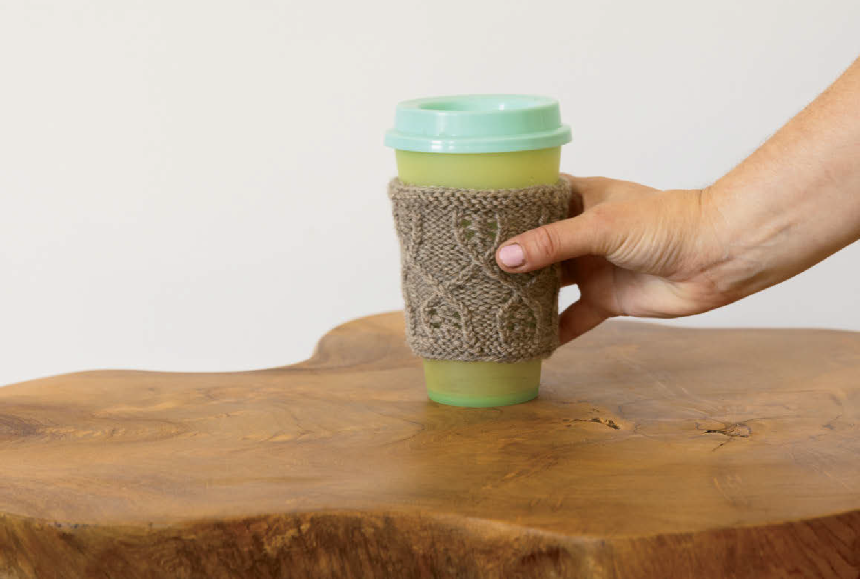

CALAIS COFFEE CUP COZY
by Maria Molodova
56317

FINISHED MEASUREMENTS
8.75 (10)" circumference at widest point × 3.75" height

YARN
Wool of the Andes™ (sport weight, 100% Peruvian Highland Wool; 137 yards/50g): Mink Heather 25275,
1 skein

NEEDLES
US 4 (3.5mm) DPNs or two circular needles for two circulars technique or 32" or longer circular needles for Magic Loop technique, or size to obtain gauge

NOTIONS
Yarn Needle Stitch Markers
2 Cable Needles

GAUGE
25 sts and 33 rows = 4" in Cable Pattern, blocked

©Copyright Knit Picks®. All rights reserved.
For private, non-commercial use only. Please see our website for terms of use. www.knitpicks.com. 1 (800) 574-1323

Calais Coffee Cup Cozy
Notes:
The coffee cup cozy features an elegant cable and lace pattern, while protecting fingers from heat and keeping coffee hot for longer.
The cozy is worked in the round from the bottom up. The increases are worked mid-height to achieve a better fit. There are two sizes: for a small coffee cup (8oz) and for medium/large coffee cups (12oz/16oz).
Chart is worked in the round; read each chart row from right to left as a RS row.
LPT (1 over 1 Left Twist, Purl back)
Sl1 to CN, hold in front; P1, K1 TBL from CN.
RPT (1 over 1 Right Twist, Purl back)
Sl1 to CN, hold in back; K1 TBL, P1 from CN.
1/1/1 LPT (1 over 1 over 1 Left Twist, Purl back)
Sl1 to CN, hold in front; Sl1 to second CN, hold in back; K1 TBL, P1 from back CN, K1 TBL from front CN.
Cable Pattern (in the round over a multiple of 8 sts; from Rnd 16 over a multiple of 9 sts)
Rnd 1: K all.
Rnds 2–3: P all.
Rnd 4: K all.
Rnd 5: (K1, P3) to end.
Rnd 6: (K1 TBL, P3) to end.
Rnd 7: (K1 TBL, YO, Sl1, K2tog, PSSO, YO, K1 TBL, P3) to end.
Rnds 8–9: Rep Rnds 6–7.
Rnds 10–11: Rep Rnd 6.
Rnd 12: (LPT, P1, RPT, P3) to end.
Rnd 13: (P1, K1 TBL, P1, K1 TBL, P4) to end.
Rnd 14: (P1, 1/1/1 LPT, P4) to end.
Rnd 15: Rep Rnd 13.
Rnd 16: (RPT, YO, P1, LPT, P3) to end. 1 st inc.
Rnd 17: (K1 TBL, P1, P1 TBL, P2, K1 TBL, P3) to end.
Rnd 18: Remove M, K1 TBL, PM, (P4, LPT, P1, RPT) to end.
Rnd 19: (P5, K1 TBL, P1, K1 TBL, P1) to end.
Rnd 20: (P5, 1/1/1 LPT, P1) to end.
Rnd 21: Rep Rnd 19.
Rnd 22: (P4, RPT, P1, LPT) to end.
Rnd 23: (P4, K1 TBL, P3, K1 TBL) to end.
Rnd 24: (P4, K1 TBL, YO, Sl1, K2tog, PSSO, YO, K1 TBL) to end.
Rnds 25–26: Rep Rnds 23–24.
Rnd 27: Rep Rnd 23.
Rnd 28: (P4, K1 TBL, P3, K1 TBL) to last 8 sts, P4, K1 TBL, P3,
move M here. Rnd 29: K all. Rnds 30–31: P all.

DIRECTIONS
CO 48 (56) sts. Join to work in the rnd, being careful not to twist sts; PM for BOR.
Work Cable Pattern using chart or written instructions until all rnds of chart have been worked. 54 (63) sts. BO loosely.

Finishing
Weave in ends, wash, and block to measurements or as desired.

B

C

A

- circumference at narrowest point 7.75 (9)"
- circumference at widest point 8.75 (10)"
- height 3.75"

Cable Pattern LEGEND
10 9 8 7 6 5 4 3 2 1
31 No Stitch

30 Placeholder—no stitch made
29
28 Knit Stitch
27
26
25 Purl Stitch
24
23 K TBL
22 Knit stitch through the back loop
21
20 P TBL
19 Purl stitch through the back loop
18
17
16 YO
15 Yarn over
14
13 SK2P
12 Slip 1 knit-wise, K2tog, pass slip stitch over K2tog
11
10 Right Twist, TBL, Purl back (RPT-TBL)
9 Sl1 to CN, hold in back; K1 through
8 back loop, P1 from CN
7
6
5 Left Twist, TBL, Purl back (LPT-TBL)
4 Sl1 to CN, hold in front; P1,
3 K1 through back loop from CN
2
1 1 over 1 over 1 Left Twist, Purl back (1/1/1 LPT)
Sl1 to CN, hold in front; Sl1 to second CN, hold in back; K1 TBL, P1 from back CN, K1 TBL from front CN

work this st in first repeat only, reposition marker to after this st omit this st in final repeat, reposition marker to before this st
Pattern Repeat

About the Designer
Maria Molodova is a knitwear and crochet designer living in the Netherlands. She tries to achieve a good balance between decorative elements and functionality in her designs. She has a passion for natural fibers and select natural yarns for her designs.
Ravelry portfolio: ravelry.com/designers/maria-molodova; Instagram: @maria.molodova. For pattern support, please contact m.molodova@gmail.com.

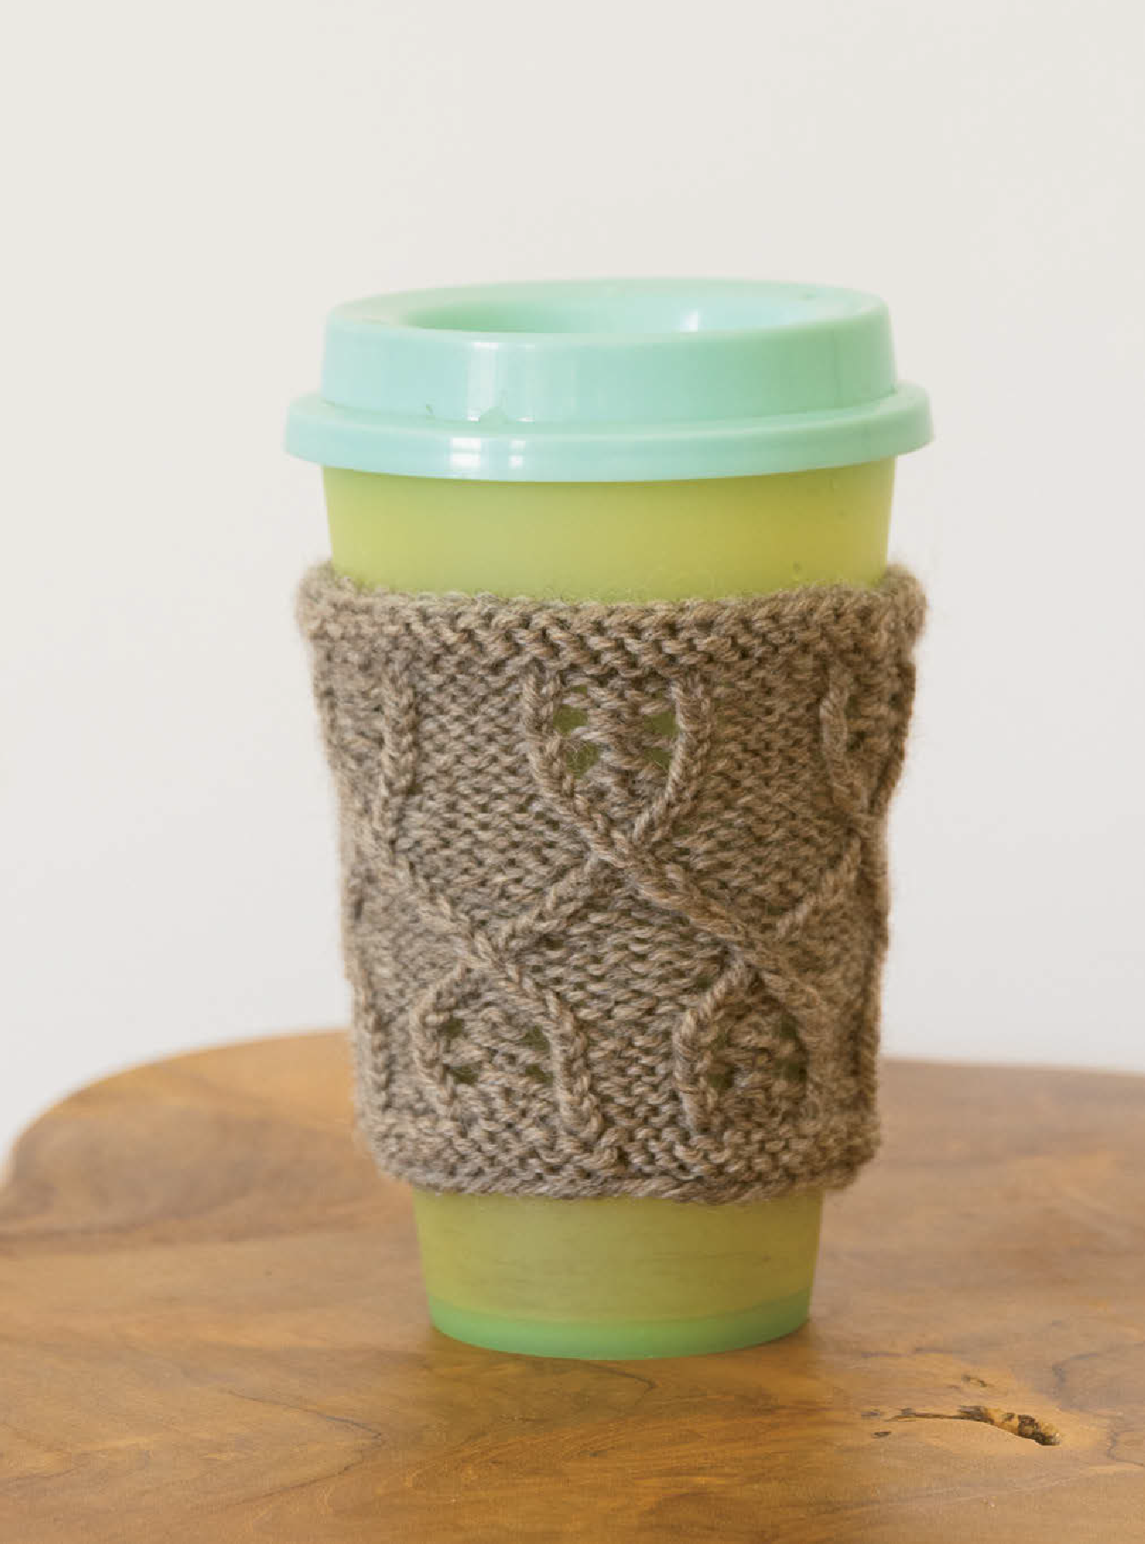

Glossary

Common Stitches & Techniques

Slipped Stitches (Sl)
Always slip stitches purl-wise with yarn held to the wrong side of work, unless noted otherwise in the pattern.

Make 1 Left-Leaning Stitch (M1L)
Inserting LH needle from front to back, PU the horizontal strand between the st just worked and the next st, and K TBL.

Make 1 Right-Leaning Stitch (M1R)
Inserting LH needle from back to front, PU the horizontal strand between the st just worked and the next st, and K TFL.
Slip, Slip, Knit (SSK)
(Sl1 K-wise) twice; insert LH needle into front of these 2 sts and knit them together.

Centered Double Decrease (CDD)
Slip first and second sts together as if to work K2tog; K1; pass 2 slipped sts over the knit st.
Stockinette Stitch (St st, flat over any number of sts) Row 1 (RS): Knit all sts.
Row 2 (WS): Purl all sts. Rep Rows 1–2 for pattern.
St st in the round: Knit every rnd.
Rev St st is the opposite—purl on RS, knit on WS.
Garter Stitch (in the round over any number of sts) Rnd 1: Purl all sts.
Rnd 2: Knit all sts.
Rep Rnds 1–2 for pattern.
Garter Stitch flat: Knit every row.
(One Garter ridge is comprised of two rows/rnds.)
1x1 Rib (flat or in the round, over an even number of sts) Row/Rnd 1: (K1, P1) to end of row/rnd.
Rep Row/Rnd 1 for pattern.
2x2 Rib (flat over a multiple of 4 sts plus 2) Row 1 (RS): K2, (P2, K2) to end of row.
Row 2 (WS): P2, (K2, P2) to end of row. Rep Rows 1–2 for pattern.
2x2 Rib (in the round over a multiple of 4 sts) Rnd 1: (K2, P2) to end of rnd.
Rep Rnd 1 for pattern.

Knitting in the Round
The Magic Loop technique uses one long circular needle to knit around a small circumference. The Two Circulars technique uses two long circular needles to knit around
a small circumference. Photo and video tutorials for these, plus using DPNs and 16" circular needles, can be found at knitpicks.com/learning-center/knitting-in-round.

Backwards Loop Cast On
A simple, all-purpose cast on that can be worked mid-row. Also called Loop or Single Cast On. A tutorial can be found at knitpicks.com/learning-center/backwards-loop-cast-on.

Long Tail Cast On
Fast and neat once you get the hang of it. Also referred to as the Slingshot Cast On. A tutorial can be found at knitpicks.com/learning-center/learn-to-knit.

Cable Cast On
A strong and nice looking basic cast on that can be worked mid-project. A tutorial can be found at tutorials.knitpicks
.com/cabled-cast-on.

Knitted Cast On
A basic cast on that can be worked mid-project. A tutorial can be found at knitpicks.com/learning-center/knitted-cast-on.

3-Needle Bind Off
Used to easily seam two rows of live stitches together. A tutorial can be found at knitpicks.com/learning-center
/3-needle-bind-off.

Abbreviations
approx BO BOR CN
C (1, 2...) CC
CDD
(dec 2)
approximately bind off
beginning of round cable needle
color (1, 2...) contrast color
centered double decrease (see above)
cast on continue decrease(es)
double pointed needle(s)
increase(s) knit
knit 2 stitches together
knit 3 stitches together
KFB
(inc 1) K-wise LH
M M1
(inc 1)
M1L
(inc 1)
M1R
(inc 1)
knit into front and back of stitch
knit-wise left hand marker make 1 stitch
(work same as M1L)
make 1 left-leaning stitch (see above)
make 1 right- leaning stitch (see above)
main color purl
purl 2 stitches together
purl 3 stitches together
place marker
purl into front and back of stitch
PSSO
(dec 1)
PU
P-wise rep
pass slipped stitch over
pick up purl-wise repeat
SSP
(dec 1)

SSSK
(dec 2)
Rev St st reverse stockinette
stitch (see above)
St st
CO
cont dec(s)
DPN(s)
RH
rnd(s) RS
Sk SK2P
(dec 2)
inc(s) K
K2tog
(dec 1)
K3tog
(dec 2)
MC P
P2tog
(dec 1)
P3tog
(dec 2) PM PFB
(inc 1)
SKP
(dec 1)
Sl SM SSK
(dec 1)
right hand round(s) right side skip
slip K-wise, knit 2 together, pass slipped stitch over
slip K-wise, knit, pass slipped stitch over
slip (see above) slip marker
slip, slip, knit these 2 stitches together (see above)
st(s) TBL TFL
tog
W&T
WE WS WYIB WYIF YO
(inc 1)
slip, slip, purl these 2 stitches together through back loop slip, slip, slip, knit these 3 stitches together (like SSK)
stockinette stitch
(see above) stitch(es)
through back loop through front loop together
wrap & turn
(see next page) work even wrong side
with yarn in back with yarn in front
bring yarn over needle from front up over to back

Cables
Tutorials for different kinds of cables, including 1 over 1 and 2 over 2, with and without cable needles, can be found at knitpicks.com/learning-center/guides/cables.
Felted Join (to splice yarn)
One method for joining a new length of yarn to the end of one that is already being used. A tutorial can be found at tutorials.knitpicks.com/felted-join.

Mattress Stitch
A neat, invisible seaming method that uses the bars between the first and second stitches on the edges. A tutorial can be found at tutorials.knitpicks.com/mattress-stitch.
Provisional Cast On (crochet method)
Used to cast on stitches that are also a row of live stitches, so they can be put onto a needle and used later.
Directions: Using a crochet hook, make a slip knot, then hold knitting needle in left hand, hook in right. With yarn in back of needle, work a chain st by pulling yarn over needle and through chain st. Move yarn back to behind needle, and rep for the number of sts required. Chain a few more sts off the needle, then break yarn and pull end through last chain. (CO sts may be incorrectly mounted; if so, work into backs of these sts.) To unravel later (when sts need to be picked up), pull chain end out; chain should unravel, leaving live sts.
A video tutorial can be found at tutorials.knitpicks.com
/crocheted-provisional-cast-on.
Provisional Cast On (crochet chain method)
Same result as the crochet method above, but worked differently, so you may prefer one or the other.
Directions: With a crochet hook, use scrap yarn to make a slip knot and chain the number of sts to be cast on, plus a few extra sts. Insert tip of knitting needle into first bump of crochet chain. Wrap project yarn around needle as if to knit, and pull yarn through crochet chain, forming first st. Rep this process until you have cast on the correct number of sts.
To unravel later (when sts need to be picked up), pull chain out, leaving live sts. A photo tutorial can be found at tutorials.knitpicks.com/crocheted-provisional-cast-on.

Judy’s Magic Cast On
This method creates stitches coming out in opposite directions from a seamless center line, perfect for starting toe-up socks. Directions: Make a slip knot and place loop around one of the two needles; anchor loop counts as first st. Hold needles tog, with needle that yarn is attached to on top. In other hand, hold yarn so tail goes over index finger and yarn attached to ball goes over thumb. Bring tip of bottom needle over strand of yarn on finger (top strand), around and under yarn and back up, making a loop around needle. Pull loop snug. Bring top needle (with slip knot) over yarn tail on thumb (bottom strand), around and under yarn and back up, making a loop around needle. Pull loop snug. Cont casting on sts until desired number is reached; top yarn strand always wraps around bottom needle, and bottom yarn strand always
wraps around top needle. A tutorial can be found at tutorials.knitpicks.com/judys-magic-cast-on.

Stretchy Bind Off
Directions: K2, *insert LH needle into front of 2 sts on RH needle and knit them tog—1 st remains on RH needle. K1; rep from * until all sts have been bound off. A tutorial can
be found at tutorials.knitpicks.com/go-your-own-way-socks- toe-up-part-7-binding-off.
Jeny’s Surprisingly Stretchy Bind Off (for 1x1 Rib) Directions: Reverse YO, K1, pass YO over; *YO, P1, pass YO and previous st over P1; reverse YO, K1, pass YO and previous st over K1; rep from * until 1 st is left, then break working yarn and pull it through final st to complete BO.
Kitchener Stitch (also called Grafting)
Seamlessly join two sets of live stitches together.
Directions: With an equal number of sts on two needles, break yarn leaving a tail approx four times as long as the row of sts, and thread through a blunt yarn needle. Hold needles parallel with WSs facing in and both needles pointing to the right.
Perform Step 2 on the first front st, then Step 4 on the first back st, then continue from Step 1, always pulling yarn tightly so the grafted row tension matches the knitted fabric:
Step 1: Pull yarn needle K-wise through front st and drop st from knitting needle.
Step 2: Pull yarn needle P-wise through next front st, leaving st on knitting needle.
Step 3: Pull yarn needle P-wise through first back st and drop st from knitting needle.
Step 4: Pull yarn needle K-wise through next back st, leaving st on knitting needle.
Rep Steps 1–4 until all sts have been grafted together, finishing by working Step 1 through the last remaining front st, then Step 3 through the last remaining back st. Photo tutorials can be found at knitpicks.com/learning- center/learn-to-knit/kitchener.

Short Rows
There are several options for how to handle short rows, so you may see different suggestions/intructions in a pattern. Wrap and Turn (W&T) (one option for Short Rows)
Work until the st to be wrapped. If knitting: Bring yarn to front, Sl next st P-wise, return yarn to back; turn work, and Sl wrapped st onto RH needle. Cont across row. If purling: Bring yarn to back of work, Sl next st P-wise, return yarn to front; turn work and Sl wrapped st onto RH needle. Cont across row. Picking up Wraps: Work to wrapped st. If knitting: Insert RH needle under wrap, then through wrapped st K-wise; K st and wrap tog. If purling: Sl wrapped st P-wise onto RH needle, use LH needle to lift wrap and place it onto RH needle; Sl wrap and st back onto LH needle, and P tog.
A tutorial for W&T can be found at tutorials.knitpicks.com
/short-rows-wrap-and-turn-or-wt.
German Short Rows (another option for Short Rows) Work to turning point; turn. WYIF, Sl first st P-wise. Bring yarn over back of right needle, pulling firmly to create a
“double stitch” on RH needle. If next st is a K st, leave yarn at back; if next st is a P st, bring yarn to front between needles. When it’s time to work into double st, knit both strands tog. A video tutorial for German Short Rows can be found at knitpicks.com/video/german-short-rows.

