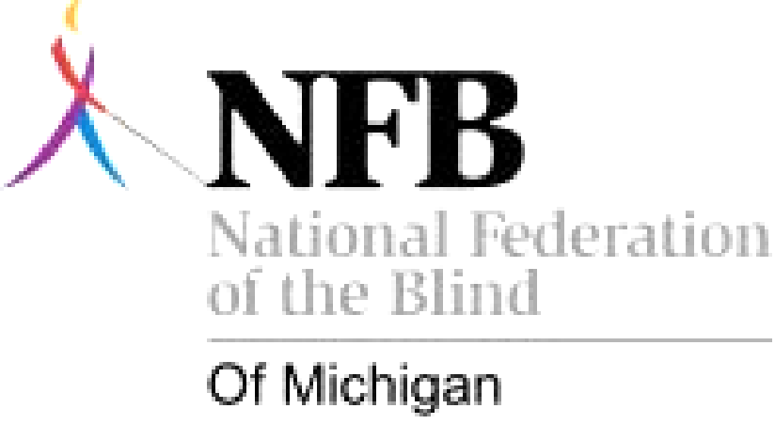
National Federation of the Blind of Michigan
1212 North Foster Ave.
Lansing, Michigan 48912
(517) 482-1800
www.nfbmi.org
A 501cC3 Charitable Organization EIN# 51-0136079

September 24, 2009

Dear Friend,

Thank you for your interest in the National Federation of the Blind of Michigan. As part of the largest national organized group of blind individuals, we strive to change negative attitudes about blindness. On November 6, 2009, we will be holding our state convention at the Radisson Riverfront in Grand Rapids, Michigan. We are seeking your support for our convention in the form of door prizes, food items and cash donations. Please direct your questions and your generous donations to:

Donna Posont
15429 Prospect Street
Dearborn, MI 48126
(313) 220-8140
Donnabutterfly50@gmail.com

Thanks so much for your kindness,
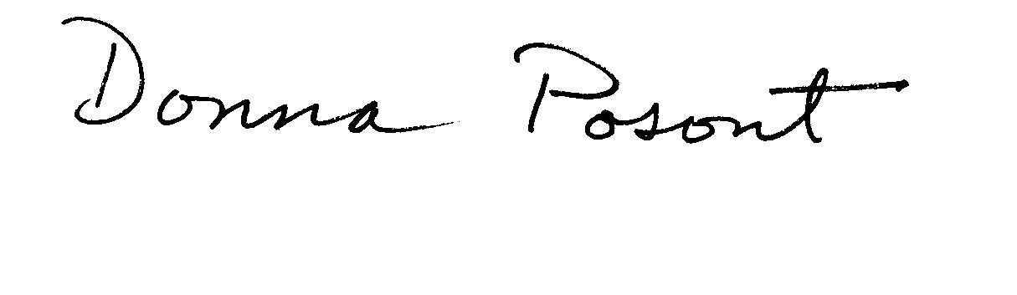

Donna Posont
Door Prize Chair
National Federation of the Blind of Michigan

