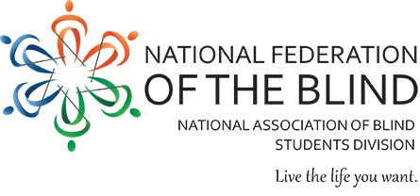
National Federation of the Blind: Kalamazoo Chapter
“Dog Daze of Summer Picnic”

An Advocacy-Oriented Event to Introduce, Empower, and Showcase the Multitude of Guide Dog Teams in the Kalamazoo and Portage Community.

Discussions Include: The Importance of Obedience Training for Handlers, The Effect that Public Etiquette Towards Teams has on Mobility Performance, and the Difference Between Guide Dogs and Fraudulent Service Animals.

- When: June 15, 2019
- Time: 1pm
- Where: Fairmont Dog Park
1108 N. prairie Avenue
Kalamazoo, MI 49006

For more information, follow our Facebook page “NFB of Kalamazoo.”
Questions? Contact Robert Parsons, President, at 804.801.7674

Interested in donating? Contact Taylor Arndt, Event Chair, 616.255.7357

