The Son of the Monster Mash



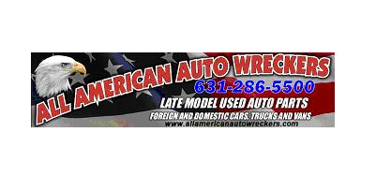
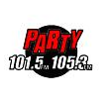
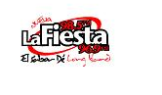
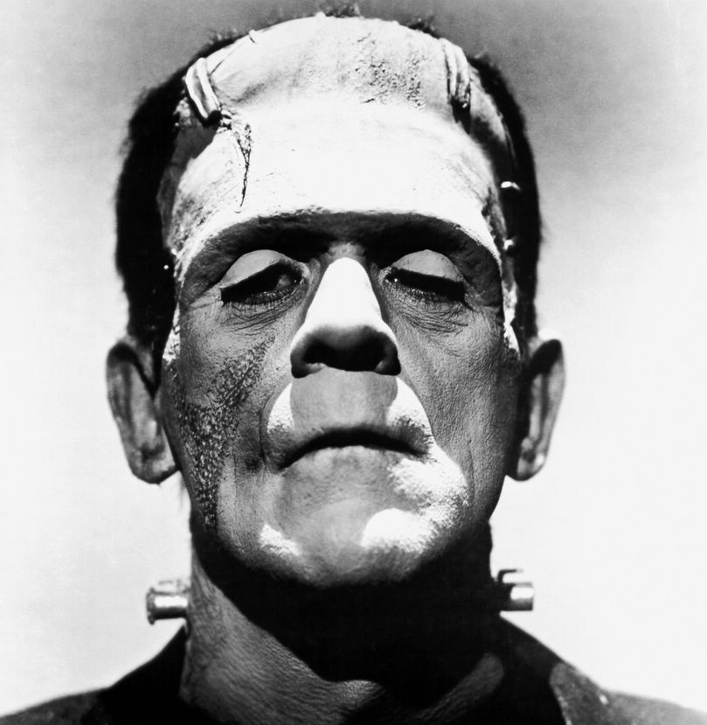
Judged Car Show

Farmingville Holtsville Lions Club
13th Annual Car Show/ Swap Meet/ Flea Market/ Antique Motorcycle Show
TO BENEFIT THE BLIND & HEARING IMPAIRED IN
FARMINGVILLE HOLTSVILLE AREA
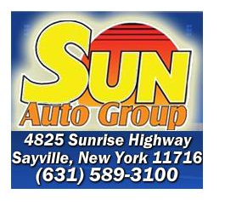


SUNDAY, OCTOBER 25TH, 2009
At Bald Hill/ Brookhaven Amphitheater
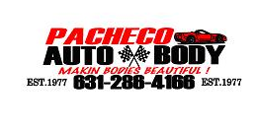
LIE Exit #63 NORTH
8:00 AM – 4:00 PM

*Rain Date November 1st, 2009
All cars Past to Present are welcome.
Motorcycles 25 years or older.
Vendors, Tony Tunes DJ, Party 105.3 and Food Concessions will be at the show.
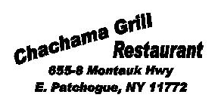
Kids Costume Contest
Over 130 Trophies
*Live Band*
SOMETHING FOR EVERYONE
DON’T MISS OUT ON THE FUN!!!!
The FIRST 150 pre-registered Show Cars or Motorcycles will receive a Limited Edition T-Shirt & Goodie Bag

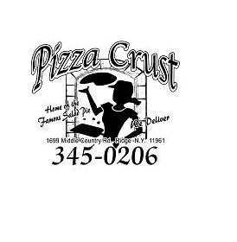
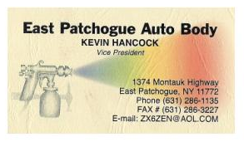
* * REGISTRATION FORM * *
- Gate opens 6:30am for Vendors
- 8am for the General Public
- General Admission $5.00 per person

Children under 12 FREE
- Show Cars/Motorcycles (pre-register) - $10.00


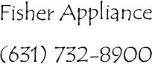
Day of Show - $15.00
- Vendors (pre-register) - $25.00
Day of Show - $30.00
- Vendors selling used Car/Motorcycle Parts - $15.00
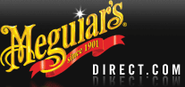
Send Registration Forms To:
Mike Dickson
97 Camille Lane
East Patchogue, NY 11772
Stoner Inc.

*MAKE CHECKS PAYABLE TO FARMINGVILLE HOLTSVILLE LIONS CLUB*
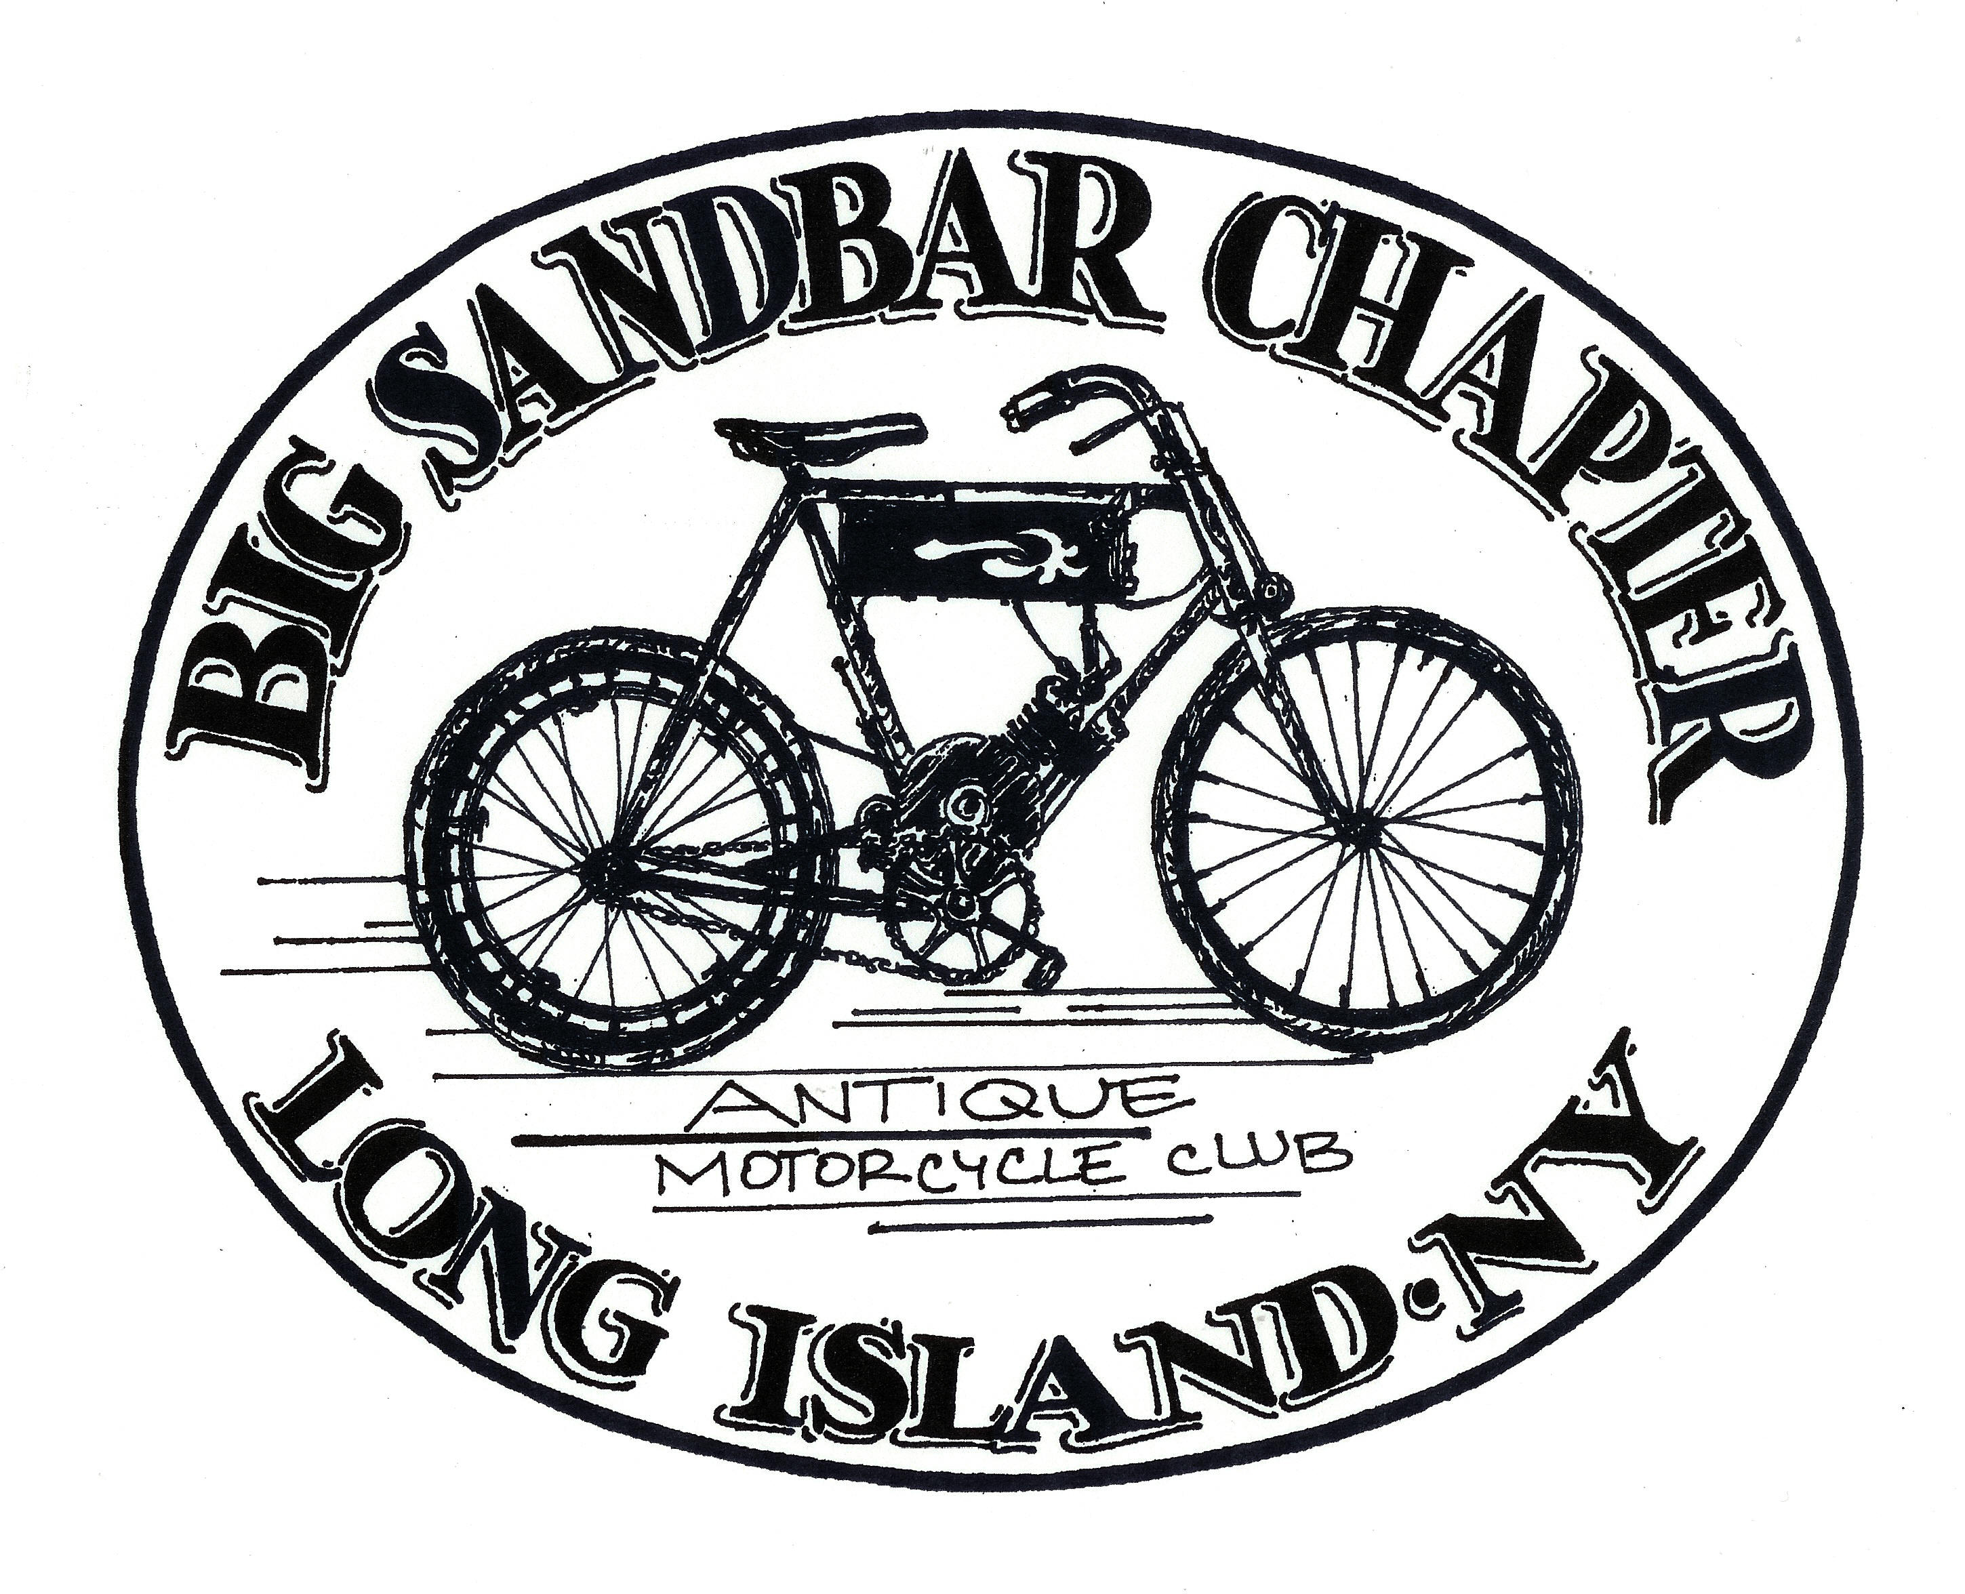
ANY QUESTIONS CONTACT MIKE DICKSON
AT (631) 447-2869
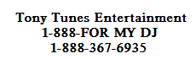

SHOW CAR / MOTORCYCLE REGISTRATION

Name:
Address:
City: State: Zip:
Year / Make / Model:

Circle One: STOCK or MODIFIED Email:

VENDOR REGISTRATION

Name:
Address:
City: State: Zip:
Product: Email:

