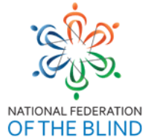
NATIONAL FEDERATION OF THE BLIND
IN LIONS
NFB-LIONS MISSION STATEMENT AND PURPOSE
May 15, 2021

Mission statement: Build the National Federation of the Blind through community service.

Purpose:

- To educate fellow Lions about the philosophy, projects, and programs of the National Federation Of the Blind with the goal of recruiting Lions into the organization.

- To facilitate connections between Federation members who are already Lions, or who are interested in becoming Lions through invitation or sponsorship.

- To offer support, perspective, and education to new blind Lions.

- To encourage new blind Lions to take an active role in local clubs and districts.

- to help those club and districts to select and carry out projects for the blind that are respectful and truly helpful to the blind.

Approved by NFB-Lions May 15, 2021

