IVY GREEN
BIRTHPLACE OF HELEN KELLER

The Keller home was built on a 640-acre tract of land in 1820 by David and Mary Fairfax Moore Keller, grandparents of Helen Keller. The main house is of Virginia-cottage construction, with four large rooms on the first floor bisected by a wide hall. Each room has an individual fireplace. Upstairs there are three rooms connected by a hall.
Kate Adams Keller (Helen's mother) was reared in Memphis, Tennessee, a descendant of the Adams family of New England. Arthur Henley Keller (Helen's father) served as a Captain in the Confeder­ate Cavalry, was the editor and publisher of a weekly newspaper. The North Alabamian, an attorney and farmer. During the War Be­tween the States, the Keller Home was used as a hospital.
The birthplace cottage is situated east of the main house, It con­sists of a large room with a lovely bay window and playroom. Originally the small structure was an office, but when Captain Keller brought his second bride -Helen's mother - to Ivy Green, he furnished it as a bridal suite.
The famous well pump is located between the main house and the birthplace. The buildings are surrounded by English boxwood - over 150 years old - magnolia, mimosa, and other trees, as well as ivy, roses, honeysuckle and smilax.
In 1954, through the efforts of the Helen Keller Property Board and the State of Alabama, Ivy Green was made a permanent Shrine and is included in the National Register of Historic Sites.
The homes contain much of the original furniture of the Keller Family and hundreds of mementos of Miss Keller's life including her library of Braille books and old Braille typewriter.

WHAT TO SEE AT IVY GREEN
Main House
Master Bedroom
Captain Arthur H. and Kate Adams Keller's bedroom. (Helen's parents). Quilt, made by Helen's aunt, Miss Eveline Keller over 100 years old. Clothing in wardrobe: Helen's and Mrs. Keller's. Hand­made Chinese Rug, a Christmas gift, 1949, to Helen from Hajji Baba Club, New York City. Photograph over mantel; Helen at age 13, Photograph on dresser: Phillips Brooks Keller (Helen's brother). Helen also had one sister, Mildred, and two half-brothers, James and Simpson.
Parlor
Photographs: On round table, Helen, age 7; over red sofa, Helen's great- great-great-grandparents, Alexander Spottswood and wife, Annie Butler Brayne. He was an early Colonial Governor of Virginia.
Hall
Photographs: Left of Parlor Door: Helen's parents, Captain Arthur H. and Kate Adams Keller; Helen, age 8, reading Braille; Teacher, Annie Sullivan (arrived in Tuscumbia, March 3, 1887); Helen and sister, Mildred. Right of Parlor door: Helen, on her last visit to Tuscumbia, 1954. Over fainting couch: Helen reading Braille. Other items of note: petticoat table, hall tree.
Dining Room
China and Silver pieces, family owned, Sugar Chest to left. Usually only two shipments of sugar arrived in a year, so sugar was kept under lock and key. Jackson press, right of fireplace, held silver, linens and beverages.
Museum
Browse here at your leisure. Touch Braille books and flag.
Upstairs
East bedroom: The boy's room. West bedroom: Annie Sullivan's and Helen's room. Trunk room.
Cottage
Originally an office where plantation books were kept, the cottage was built in the yard near the Main House. Later a dressing room and porch were added. When Captain Keller brought his second bride home the Cottage was daintily furnished for them as a bridal suite. Here Helen Keller was born, a normal child, on June 27, 1880. At the age of 19 months an illness left Helen blind and deaf. Helen's toys are displayed in playroom. Since Helen's parents catered to her every whim, Teacher soon realized she would have to get Helen away from her parents in order to be able to control her tantrums and teach her, so this cottage served as the schoolhouse.
Kitchen Building
Kitchen and cook's bedroom. Utensils and other articles.
The Pump
At which Helen learned her first word, "water'', located behind the main house. Annie wrote these words later that historic night, "she has learned that everything has a name, and that the manual alphabet is the key to everything she wants to know:”
Ice House
This building was constructed in 2009 with the help of the State of Alabama. In the 1800's Captain Keller would travel 6 miles to the Tennessee River in late January or early February to harvest ice for the summer. The ice plow was a weighted, horse drawn contrivance with a row of sharp teeth, which cut a narrow furrow 6 inches deep. Ice was hauled to the icehouse by horse and wagon. Layer by layer the ice was placed in the icehouse, sprinkling sawdust between each layer. This made it easier to separate when the ice blocks were taken out. After the last layer was stored, it was covered with a thick layer of sawdust to help keep the ice throughout the summer. Servants would use a ladder to go down into the icehouse to store the ice, and also to retrieve ice for everyday use. A drain at the bottom of the icehouse kept the ice free of melted water as moisture melts ice as quickly as heat.
The Gardens
The Shoals Master Gardeners design, build, and maintain the flowering beds on the grounds. Using examples from Helen's writings, they seek to capture Helen's memories of the gardens by using her favorite plants. The rose garden, between the house and cottage, contains heirloom roses and fragrant plants: the herb bed, by the kitchen, contains aromatic culinary and medicinal herbs, and edible plants: and the butterfly garden, in the back yard, has plants that attract birds, bees and butterflies. The Japanese garden showcases the Japanese lantern, one of the many gifts she received.
Lion's International Memorial Garden
From fountain to brick fence. Displayed are gifts given to the Keller Shrine in honor of Miss Keller from many different countries.
The Clearing
Through the iron gates, is the Alabama Federated Garden Clubs, District I, tribute to Helen Keller. Included are many native trees and shrubs, a log cabin, gazebo, and "moon tree" a pine tree grown from a seed flown to the moon in U.S. spaceship.
The City of Tuscumbia acquired the Birthplace of Helen Keller, which is situated on aten acree tract of land, in 1951. The Dedication Ceremony was held June 27, 1952.
Helen graduated from Radcliffe College in 1904 with Teacher by her side at all times. Helen was actively identified with The American Foundation for the Blind from 1924 until her death June 1, 1968. Anne Sullivan Macy was Teacher and Companion to Helen from March 3, 1887. until her death October 20, 1936. After that Polly Thomson who had been their secretary since 1914, became her companion.
"The Miracle Worker"
''The Miracle Worker'', the play written by William Gibson, is produced each summer on the grounds of Ivy Green. It is now the official outdoor drama of Alabama. The Helen Keller Festival takes place annually the last weekend in June at Tuscumbia's Spring Park and in downtown Tuscumbia.
Gazebo
In 1981 the Southern Dames of America built the Gazebo to honor Helen Keller, who was made an honorary member of the National Society Southern Dames of America during the 1964 National Assemble held in Washington, DC. The Gazebo is located in the "Clearing."

WELCOME
TO
IVY GREEN

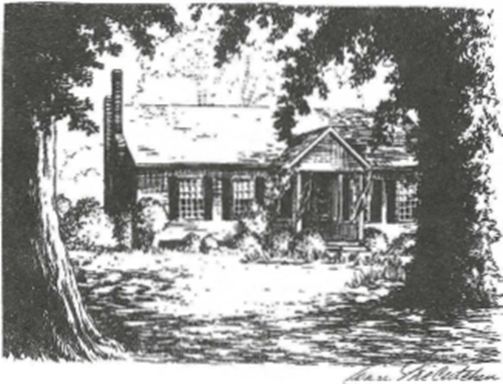

****
BIRTHPLACE OF HELEN KELLER TUSCUMBIA, ALABAMA

