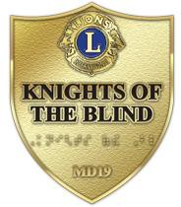

The Lions Of MD19
Knights Of The Blind Committee
HELEN KELLER VISION MONTH
Planning And Help Kit

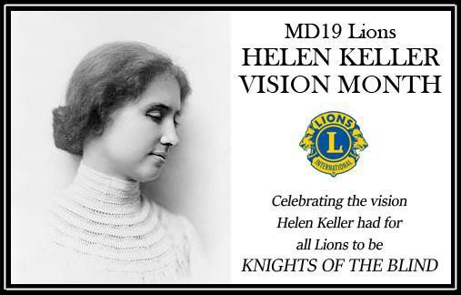

LIONS MD19 HELEN KELLER VISION MONTH

The purpose of this month long event is
➔ to follow up with the 1971 Lions Club International establishment of a special day in June to honor Helen and her importance to the blind, deaf and disabled people. Note, we chose a month instead of a day so clubs throughout Multiple District 19 could be flexible in their events schedule. We also are calling it Lions Helen Keller Vision Month. This change separates us from other groups who may host a similar event. Note that Helen Keller was born in June, died in June and delivered her famous speech to Lions at the June Lions international convention.
➔ to remind members and the public who Helen Keller was and her challenge to Lions to commit to be the
"... knights of the blind in the crusade against darkness."
➔ to encourage clubs to do something within their community and to recognize the importance of Helen Keller.
➔ to promote the Lions MD19 Knights Of The Blind Committee and their work

The following pages are a Planning Kit for clubs filled with ideas and information for a successful Helen Keller Vision Month.
Please use the kit and enjoy the celebration.

Thanks need to be included for our Helen Keller Vision Month committee. They go out to:
- Vivian Huschke
- JR Kinnison
- Colette Arvidson
- Andy Arvidson

THANK YOU,
Art Ruben, Chair of the committee

Helen Keller Vision Month

PLANNING AND PRESS KIT

INDEX
INTRODUCTION 2
INDEX 3
HELEN KELLER BIOGRAPHY 4
FACTS ABOUT HELEN KELLER 8
QUOTES OF HELLEN KELLER 10
PHOTOS 11
IDEAS FOR YOUR CLUB TO CELEBRATE 12
PRESS RELEASE 13
PROCLAMATION 15
LIONS MD19 KNIGHTS OF THE BLIND COMMITTEE 16

Helen Keller Vision Month
HELEN KELLER BIOGRAPHY
On this page is a biography of Helen Keller from the American Foundation For The Blind. There

are numerous books and stories about her life including an auto-biography available on-line.

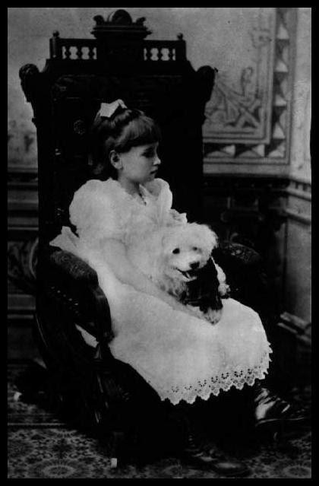
Helen Adams Keller was born a healthy child in Tuscumbia, Alabama, on June 27, 1880. Her parents were Kate Adams Keller and Colonel Arthur
Keller.
On her father's side she was descended from Colonel Alexander Spottswood, a colonial governor of Virginia, and on her mother's side, she was related to a number of prominent New England families. Helen's father, Arthur Keller, was a captain in the Confederate army. The family lost most of its wealth during the Civil War and lived modestly.
After the war, Captain Keller edited a local newspaper, the North Alabamian, and in 1885, under the Cleveland administration, he was appointed Marshal of North Alabama.
At the age of 19 months, Helen became deaf and blind as a result of an unknown illness, perhaps rubella or scarlet fever. As Helen grew from infancy into childhood, she became wild and unruly.

When Did Helen Keller Meet Anne Sullivan?
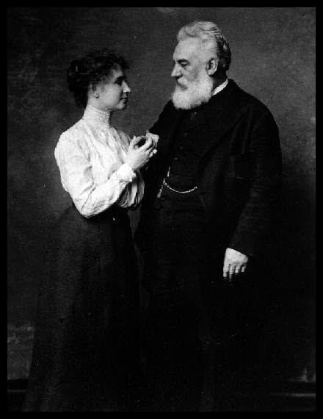
As she so often remarked as an adult, her life changed on March 3, 1887. On that day, A nne Mansfield Sullivan came to Tuscumbia to be her teacher.
Anne was a 20-year-old graduate of the Perkins School for the Blind. Compared with Helen, Anne couldn't have had a more different childhood and upbringing. The daughter of poor Irish immigrants, she entered Perkins at 14 years of age after four horrific years as a ward of the state at the Tewksbury Almshouse in Massachusetts.
She was just 14 years older than her pupil Helen, and she too suffered from serious vision problems. Anne underwent many botched operations at a young age before her sight was partially restored.
Anne's success with Helen remains an extraordinary and remarkable story and is best known to people because of the film The Miracle Worker. The film correctly depicted Helen as an unruly, spoiled—but very bright—child who tyrannized the household with her temper tantrums.
Anne believed that the key to reaching Helen was to teach her obedience and love. She saw the need to discipline, but not crush, the spirit of her young charge.

As a result, within a week of her arrival, she had gained permission to remove Helen from the main house and live alone with her in the nearby cottage. They remained there for two weeks.
Anne began her task of teaching Helen by manually signing into the child's hand. Anne had brought a doll that the children at Perkins had made for her to take to Helen. By spelling "d-o-l-l" into the child's hand, she hoped to teach her to connect objects with letters.
Helen quickly learned to form the letters correctly and in the correct order, but did not know she was spelling a word, or even that words existed. In the days that followed, she learned to spell a great many more words in this uncomprehending way.

What Were Helen Keller's First Words?
On April 5, 1887, less than a month after her arrival in Tuscumbia, Anne sought to resolve the confusion her pupil was having between the nouns "mug" and "milk," which Helen confused with the verb "drink."
Anne took Helen to the water pump outside and put Helen's hand under the spout. As the cool water gushed over one hand, she spelled into the other hand the word "w-a-t-e-r" first slowly, then rapidly. Suddenly, the signals had meaning in Helen's mind. She knew that "water" meant the wonderful cool substance flowing over her hand.
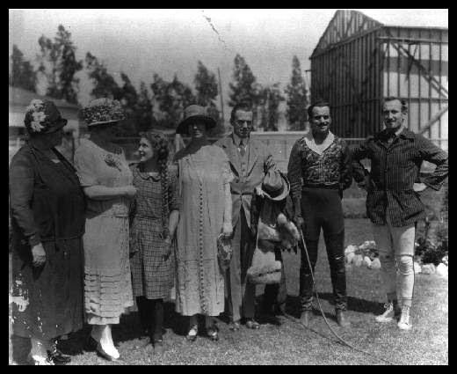
Quickly, she stopped and touched the earth and demanded its letter name and by nightfall she had learned 30 words.
Helen's early writing, completed seven days before she turned seven (the page is dated June 20th, 1887)
Helen quickly proceeded to master the alphabet, both manual and in raised print for blind readers, and gained facility in reading and writing. In Helen's handwriting, many round letters look square, but you can easily read everything.
In 1890, when she was just 10, she expressed a desire to learn to speak; Anne took Helen to see Sarah Fuller at the Horace Mann School for the Deaf and Hard of Hearing in Boston. Fuller gave Helen 11 lessons, after which Anne taught Helen.
Throughout her life, however, Helen remained dissatisfied with her spoken voice, which was hard to understand.
Helen's extraordinary abilities and her teacher's unique skills were noticed by Alexander Graham Bell and Mark Twain, two giants of American culture. Twain declared, "The two most interesting characters of the 19th century are Napoleon and Helen Keller."
The closeness of Helen and Anne's relationship led to accusations that Helen's ideas were not her own. Famously, at the age of 11, Helen was accused of plagiarism. Both Bell and Twain, who were friends and supporters of Helen and Anne, flew to the defense of both pupil and teacher and mocked their detractors. Read a letter from Mark Twain to Helen lamenting "that 'plagiarism' farce."

Helen Keller's Education and Literary Career
From a very young age, Helen was determined to go to college. In 1898, she entered the Cambridge School for Young Ladies to prepare for Radcliffe College. She entered Radcliffe in the fall of 1900 and received a Bachelor of Arts degree cum laude in 1904, the first deafblind person to do so.
The achievement was as much Anne's as it was Helen's. Anne's eyes suffered immensely from reading everything that she then signed into her pupil's hand. Anne continued to labor by her pupil's side until her death in 1936, at which time Polly Thomson took over the task. Polly had joined Helen and Anne in 1914 as a secretary.
While still a student at Radcliffe, Helen began a writing career that was to continue throughout her life. In 1903, her autobiography, The Story of My Life, was published. This had appeared in serial form the previous year in Ladies' Home Journal magazine.

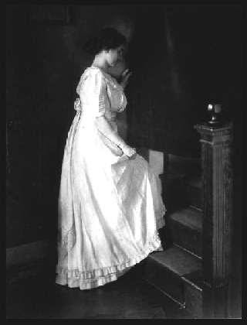
Her autobiography has been translated into 50 languages and remains in print to this day. Helen's other published works include Optimism, an essay; The World I Live In; The Song of the Stone Wall; Out of the Dark; My Religion; Midstream—My Later Life; Peace at Eventide; Helen Keller in Scotland; Helen Keller's Journal; Let Us Have Faith; Teacher, Anne Sullivan Macy; and The Open Door. In addition, she was a frequent contributor to magazines and newspapers.
The Helen Keller Archives contain over 475 speeches and essays that she wrote on topics such as faith, blindness prevention, birth control, the rise of fascism in Europe, and atomic energy. Helen used a braille typewriter to prepare her manuscripts and then copied them on a regular typewriter.

Helen Keller's Political and Social Activism
Helen saw herself as a writer first—her passport listed her profession as "author." It was through the medium of the typewritten word that Helen communicated with Americans and ultimately with thousands across the globe.
From an early age, she championed the rights of the underdog and used her skills as a writer to speak truth to power. A pacifist, she protested U.S. involvement in World War I. A committed socialist, she took up the cause of workers' rights. She was also a tireless advocate for women's suffrage and an early member of the American Civil Liberties Union.
Helen's ideals found their purest, most lasting expression in her work for the American Foundation for the Blind (AFB). Helen joined AFB in 1924 and worked for the organization for over 40 years.
The foundation provided her with a global platform to advocate for the needs of people with vision loss and she wasted no opportunity. As a result of her travels across the United States, state commissions for the blind were created, rehabilitation centers were built, and education was made accessible to those with vision loss.

Helen's optimism and courage were keenly felt at a personal level on many occasions, but perhaps never more so than during her visits to veteran's hospitals for soldiers returning from duty during World War II.
Helen was very proud of her assistance in the formation in 1946 of a special service for deaf-blind persons. Her message of faith and strength through adversity resonated with those returning from war injured and maimed.
Helen Keller was as interested in the welfare of blind persons in other countries as she was for those in her own country; conditions in poor and war-ravaged nations were of particular concern.
Helen's ability to empathize with the individual citizen in need as well as her ability to work with world leaders to shape global policy on vision loss made her a supremely effective ambassador for disabled persons worldwide. Her active participation in this area began as early as 1915, when the Permanent Blind War Relief Fund, later called the American Braille Press, was founded. She was a member of its first board of directors.
In 1946, when the American Braille Press became the American Foundation for Overseas Blind (now Helen Keller International), Helen was appointed counselor on international relations. It was then that she began her
globe-circling tours on behalf of those with vision loss.

Helen Keller's Worldwide Celebrity
During seven trips between 1946 and 1957, she visited 35 countries on five continents. She met with world leaders such as Winston Churchill, Jawaharlal Nehru, and Golda Meir.
Helen Keller and Polly Thomson in Japan, 1948
In 1948, she was sent to Japan as America's first Goodwill Ambassador by General Douglas MacArthur. Her visit was a huge success; up to two million Japanese came out to see her and her appearance drew considerable attention to the plight of Japan's blind and disabled population.

In 1955, when she was 75 years old, she embarked on one of her longest and most grueling journeys: a 40,000-mile, five-month-long tour through Asia.
Wherever she traveled, she brought encouragement to millions of blind people, and many of the efforts to improve conditions for those with vision loss outside the United States can be traced directly to her visits.
Helen was famous from the age of 8 until her death in 1968. Her wide range of political, cultural, and intellectual interests and activities ensured that she knew people in all spheres of life.
She counted leading personalities of the late nineteenth and early twentieth centuries among her friends and acquaintances. These included Eleanor Roosevelt, Will Rogers, Albert Einstein, Emma Goldman, Eugene Debs, Charlie Chaplin, John F. Kennedy, Andrew Carnegie, Henry Ford, Franklin D. Roosevelt, Dwight D. Eisenhower, Katharine Cornell, and Jo Davidson to name but a few.
She was honored around the globe and garnered many awards. She received honorary doctoral degrees from Temple and Harvard Universities in the United States; Glasgow and Berlin Universities in Europe; Delhi University in India; and Witwatersrand University in South Africa. She also received an honorary Academy Award in 1955 as the inspiration for the documentary about her life, Helen Keller in Her Story.

Helen Keller's Later Life
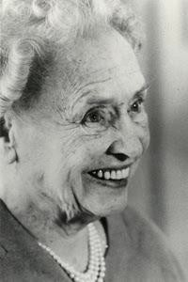
Head and shoulder portrait of a beaming Helen on her 80th birthday, June 1960.
Helen suffered a stroke in 1960, and from 1961 onwards, she lived quietly at Arcan Ridge, her home in Westport, Connecticut, one of the four main places she lived during her lifetime. (The others were Tuscumbia, Alabama; Wrentham, Massachusetts; and Forest Hills, New York).
She made her last major public appearance in 1961 at a Washington, D.C., Lions Clubs International Foundation meeting. At that meeting, she received the Lions Humanitarian Award for her lifetime of service to humanity and for providing the inspiration for the adoption by Lions Clubs International Foundation of their sight conservation and aid to blind programs.
During that visit to Washington, she also called on President John F. Kennedy at the White House. President Kennedy was just one in a long line of presidents Helen had met. In her lifetime, she had met all of the presidents since Grover Cleveland.
Helen Keller died on June 1, 1968, at Arcan Ridge, a few weeks short of her 88th birthday. Her ashes were placed next to her companions, Anne Sullivan Macy and Polly Thomson, in St. Joseph's Chapel of Washington Cathedral.
Senator Lister Hill of Alabama gave a eulogy during the public memorial service. He said, "She will live on, one of the few, the immortal names not born to die. Her spirit will endure as long as man can read and stories can be told of the woman
who showed the world there are no boundaries to courage and faith."

Helen Keller Vision Month

FACTS ABOUT HELEN KELLER

you may not have known

➔ Today, the Helen Keller Museum in Tuscumbia, Alabama sits on 10 acres called "Ivy Green" because of the ivy growing on trees. The original site was a 160 acre cotton plantation that her family owned. Helen was born and raised at Ivy Green.

➔ Helen Keller visited 39 counties in her travels. She came to Everett, WA in June of 1914 to speak in favor of women's voting rights. Later in life she visited Spokane and Olympia, and vacationed in Vancouver, B.C. Helen loved travel and may have visited other local communities. If you know of any other Washington, northern Idaho or BC sites she visited, let the MD19 Knights Of The Blind Committee know..

➔ Helen wrote 12 books plus an autobiography which became the basis for the movie, The Miracle Worker. In 1954 her biography became a documentary that won the Best Documentary classification at the Academy Awards in 1956. We don't know if she attended the Oscar celebration to help accept the award.

➔ Helen Keller attended and graduated magna cum laude from Radcliffe College in Massachusetts. She became the first deaf blind student in the U.S. to receive a BA degree.

➔ She had a boyfriend who was her secretary. Because of laws at the time concerning people with disabilities they could not marry.

➔ The city of Tuscumbia, AL has about 9,000 people. Each year thousands of residents and visitors turnout for the Helen Keller Festival that features a fair, parade and the summer live production of the play, The Miracle Worker. Proceeds from the play go to help fund the museum. The museum by itself has about 40,000 visitors a year and is one of Alabama's top tourist attractions.
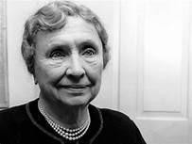

➔ Helen Keller was honored with a special day by President Jimmy Carter (who is a Lion). That day is June 27th. It was the same year that the Lions Clubs International Board of Directors established June 1st as Helen Keller Day. The Lions Knights Of The Blind Committee chose to honor her during the entire month of June to allow clubs to have flexibility in scheduling. Helen was born in June and died in June. She also challenged the Lions to be Knights Of The Blind in June. June is Lions Helen Keller Vision Month.

➔ As a world traveler and figure, Helen was friends with kings and presidents. She met with all presidents of the U.S. from Cleveland to Johnson. She was also friends with notable people like Alexander Graham Bell, Charlie Chaplin and Mark Twain.

➔ Her awards and honors were many . They included the Presidential Medal of Freedom, one of the highest honors a president can bestow and the Legion of Honor. Her likeness has appeared on U.S. postage and currency. There is a beautiful statue of her in a statuary hall in the U.S. Capitol. There are schools, museums, foundations, organizations, literature, movies and parks created in her honor. She has become the symbol of overcoming adversity.

➔ The vision Helen Keller had in 1925 for the Lions to be the Knights Of The Blind has become one of the major focuses for Lions, the world's largest service organization. Over the years her Lions challenge has done so much, for and with the blind and visually impaired, and for the prevention of blindness.
Millions of people have been screened for vision problems, used the white cane, assisted by a service animal, received free eyewear and apparatus and hearing devices, helped overcome blindness with an education, had their life enriched with activities, received the benefits of vision research, saw the world with new corneas, and inspired Lions Clubs worldwide to work together to solve vision related problems. This is why "We Serve" and why we are proud to say "We are Lions!". Thank you Helen Keller!

"Alone we can do so little: together we can do so much."
Helen Keller

Helen Keller Vision Month

QUOTES OF HELEN KELLER
Use these quotes and others of Helen Keller to brighten and cheer others in newsletters during Helen Keller Month and throughout the year.

“It all comes to this: the simplest way to be happy is to do good.”

"Your success and happiness lies in you. Resolve to keep happy, and your joy and you shall form an invincible host against difficulties.”

“The only thing worse than being blind is having sight but no vision.” “Knowledge is love and light and vision.”
“Keep your face to the sun and you will never see the shadows.” “No one has the right to consume happiness without producing it.” “Life is short and unpredictable. Eat the dessert first.”
“We are never really happy until we try to brighten the lives of others.” “When one door of happiness closes, another opens."
“Although the world is full of suffering, it is full also of the overcoming of it.”

“I long to accomplish a great and noble task, but it is my chief duty to accomplish small tasks as if they were great and noble.”

“A happy life consists not in the absence, but in the mastery of hardships.”

Helen Keller Vision Month

PHOTOS

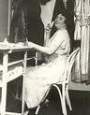
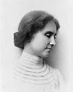
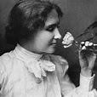
- Use for press releases and newsletters. More photos are available on-line.

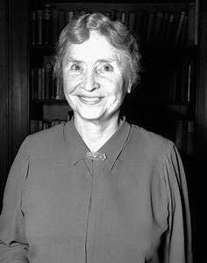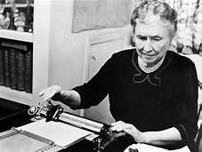

Helen Keller Vision Month

IDEAS FOR YOUR CLUB TO CELEBRATE

Here are some ideas for your club to consider using to make Helen Keller Month a success.

➔ Use Inspiring quotes of Helen Keller in your club bulletins and newsletters. See QUOTES in this kit.
➔ Use little known FACTS about Helen Keller in newsletters, speeches or have your Tale Twister use them. A list of facts page is included in this kit.
➔ Contact local mayors / executives to proclaim June as Lions Helen Keller Month. See sample PROCLAMATION in this kit.
➔ Invite your District Representative of the KNIGHTS OF THE BLIND COMMITTEE to speak to your club, zone, district, conference.
➔ Hold a Helen Keller ESSAY or speech contest.
➔ Offer a SCHOLARSHIP in Helen Keller's name to a blind or hearing impaired student.
➔ Talk to the local LIBRARY or school about hosting Helen Keller Day with book readings and book displays.
➔ Invite local BLIND ORGANIZATIONS at your meetings.
➔ Show Helen Keller MOVIES/documentaries on Zoom.
➔ PLANT a tree, rose or sensory garden in a park or arboretum in honor of Helen Keller.
➔ Set up an INFORMATION TABLE or display or booth in a public location like a library, shopping mall, school or fair.
  - Suggested items on display....
    - a story board about Helen Keller.
    - display of Helen Keller books, etc.
    - Leader Dog display or demonstration.
    - free vision screenings.
    - display and giveaway samples of Braille.
    - white cane travel demonstrations including blindfolding volunteers and them to follow a trail.
    - pamphlets about deafness with sign language illustrations. Do sign language demonstrations.
    - collect used eyeglasses for LERC
    - collect donations for vision projects.
    - have a costumed Lion on hand to attract kids.
    - make up Helen Keller coloring sheets for kids.

FINALLY, 2025 will be the 100th ANNIVERSARY of Helen Keller's speech to Lions.. That will only be 4 years away in June. We should plan on including that centennial as a part of our events.

QUESTIONS OR IDEAS? Contact Art Ruben of the Knights Of The Blind Committee at since1965@aol.com

Helen Keller Vision Month

PRESS RELEASE

- See SAMPLE PRESS RELEASE below. Contact your local newspapers and ask them to use the following sample press release. Be sure to fill in the blanks and answer any questions they may have. Make this press release your club's press release. Make any changes you like. This is a guide.

If you need assistance or questions contact Art Ruben at since1965@aol.com

Why the Lions Club is celebrating June as Helen Keller Vision Month
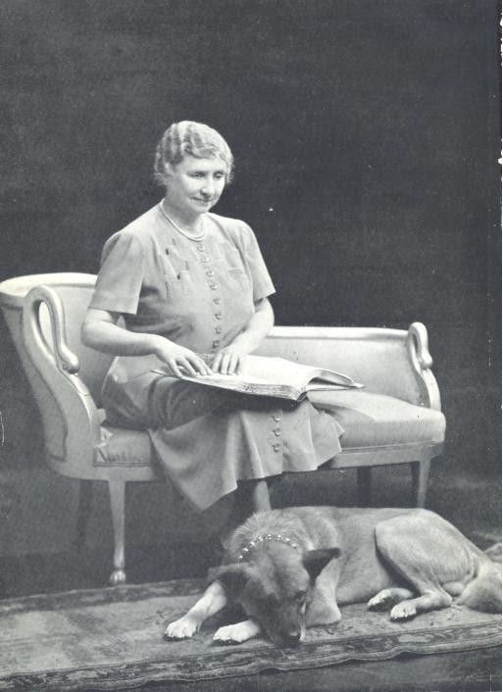

Helen Keller was born in 1890 in Tuscumbia, AL; died in 1962. She overcame adversity all her life. Her early blindness and deafness left her mute and little chance for a normal life. She became a worldwide celebrity authoring 13 books, writing newspaper columns, having speaking engagements, and was in an Oscar-winning documentary about her life. But for members of Lions it was Helen Keller's speech to them in 1925 at the Lions Clubs International Convention that resounds today. During her speech she challenged the Lions to become "Knights Of The Blind". Since then Lions have served and worked with the blind and continue to work to prevent blindness. You may have noticed the collection boxes to collect and recycle used eyeglasses, or donated guide dogs, or watch a blind person walk with a White Cane or know of someone who had a cornea transplant. These are a few of the projects that Lions around the world* have been involved in. The Lions continue today to meet the Helen Keller challenge she made to them almost 100 years ago. The challenge to be the "Knights Of The Blind".

The Lions Club will celebrate the life of Helen Keller in June and learn how she turned disabilities into abilities and became a great symbol of hope, so needed today. Their celebration will remind the public of one of Lions main focuses, vision, but it is not their only focus. The Lions are also continuing to try to stop hunger, fight diabetes and pediatric cancer, and help our environment. Local clubs also help (list local projects).

For more information contact (representative name) at (contact info).

*There are over 46,000 Lions Clubs in 200 plus countries with close to 1.5 million members making Lions the world's largest service organization.

TO THE EDITOR
For more information about this press release contact of the Club at
.

FOR IMMEDIATE RELEASE

Helen Keller Vision Month

PROCLAMATION

- Here is a sample proclamation to take to your mayor or top official for their completion and signature. Use in newspaper and newsletter.

PROCLAMATION

WHEREAS,
today's turmoil and grief created by Covid19 pandemic gives us cause to look back to find strength and hope for the future.

WHEREAS,
that hope comes to us from Helen Keller who overcame adversity all her life. Her early blindness and deafness left her mute and little chance for a normal life.

WHEREAS,
Helen overcame adversity and became a worldwide symbol of hope through periods of social change and injustice, two world wars, economic depressions and a massive worldwide pandemic.

WHEREAS,
even though mute, her words of inspiration through her writings made her well known. She became the icon the world followed. Her vision of a positive life and future gives us all strength to move forward.

WHEREAS,
her awards and honors were many. They included the Presidential Medal of Freedom, one of the highest honors a president can bestow and the Legion of Honour. Helen's likeness has appeared on U.S. postage and currency. There is a statue of her in the U.S. Capitol Statuary Hall. Schools, museums, foundations, organizations, literature, movies, and parks were created in her honor. Her recognition came from her abilities and less from her disabilities. Helen Keller deserves our remembrance today more than ever. Her story is a reason for hope.

President Jimmy Carter summed it up best when he proclaimed Helen Keller Day in 1980:
"Stories of brave individuals battling seemingly insurmountable odds fire our imagination and pride as human beings. So it is with the remarkable life of Helen Keller. Her incredible fight against, and eventual triumph over, the multiple handicaps of deafness and blindness made her a world-famous symbol of hope..."

"HOPE SEES THE INVISIBLE, FEELS THE INTANGIBLE, ACHIEVES THE IMPOSSIBLE."
Helen Keller

THEREFORE,
I , I declare the month of June as

HELEN KELLER VISION MONTH

Date

LIONS MD19 KNIGHTS OF THE BLIND COMMITTEE
Note, the information for this section is from a press release issued prior to the election of leadership. The results of the election are as follows:

Chair Andy Arvidson
Vice Chair Danette Dixon
Secretary Colette Arvidson
In addition, there are nine Knights Of The Blind Representatives. Each one represents a different district in MD19.

For more information about setting up a Helen Keller Vision Month
project or questions about this kit contact Art Ruben at since1965@aol.com

- On October 18, 2020 the Lions Multiple District 19 Council Of Governors voted to accept the Lions KNIGHTS OF THE BLIND as an official committee of MD19. The council, made up of District Governors from Washington, British Columbia and northern Idaho districts all agreed that a committee devoted to Lions working with and for the blind made sense to help meet Helen Keller's challenge to Lions to be the knights of the blind.

The Knights committee has currently about 25 members and are from the 3 regions. PDG Art Ruben said the idea of a Lions committee devoted to the blind and visually impaired came to him recently when he was reminded that Lions in MD19 do a good job to improve and preserve vision, but they come up short helping and working with those who had lost their sight. He wondered why clubs didn't do more to involve the blind and partially sighted and why there weren't more blind members in Lions. "We are the knights of the blind", he said. He knew of few clubs that were involved in projects for the blind like his Everett Central club that has held over 75 salmon fishing derbies for the blind. Over the years he has sponsored seven members who are blind including the current and immediate past president.

Art contacted Council Chair Al Hedstrom about developing a Knights Of The Blind Committee. Al loved the idea and told him to come back with a mission statement, goals and committee members. Art worked with Colette Arvidson of the Anacortes Lions Club and the Washington Council of the Blind Families Committee. They formulated the mission statement, goals and found Lions and other people to be on the committee. All but three were blind or visually impaired. Three committee members were non-Lions and have agreed to apply

for membership. The "Blind" committee has met twice virtually and agreed to the mission statement and goals that were presented at the Council. The committee currently meets on the first Tuesday of each month virtually. The current Chair is Andy Arvidson and the Secretary is his wife, Colette. Both are members of the Anacortes Lions Club.

Below is the mission statement and goals of the Knights Of The Blind Committee of MD19.

Our mission statement:

To accept and act upon the Helen Keller challenge made to Lions to become the "Knights Of The Blind," which includes the improvement of the quality of life for people who are blind and visually impaired.

Our Goals:

- To actively interact with blind and visually impaired individuals in our local communities and listen to their needs.
- To partner with organizations of and for the blind and visually impaired.
- To increase membership and support blind and visually impaired in Lions.
- To assist where possible to obtain tools, devices, information and services to improve access for the blind and visually impaired.
- To educate and raise awareness of blindness and visual impairment in our local communities.

The committee will reach out to all MD19 clubs to find members who are blind or visually impaired and sighted Lions who are interested in their mission. Among the ideas the committee is to publish a list of events or projects for the blind that clubs are involved with. One of the main objectives of the committee is to encourage all clubs to not only sponsor events with and for the blind but to involve the blind in existing programs and projects and to work with blind organizations on their programs.

For more information about the MD Knights Of The Blind Committee contact Chair, Andy Arvidson at arvidsonandy@gmail.com,

