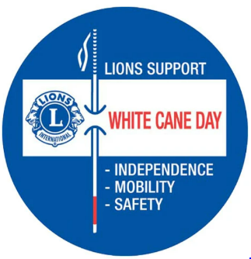
White Cane Awareness Day
October 15
Will You Join the Celebration?

To many, the image of a curved handled white cane has become the symbol of a plea for support of a disabled community in need. A symbol used by Lions Clubs and others to raise money for important services to prevent blindness or assist people who are blind. But for those who are blind October 15, White Cane Safety Day, as it was named by the US Congress in 1964, or Blind Americans Equality Day as it was designated by President Barack Obama (2014), the meaning is best exemplified by the updated logo/label you can purchase from LCI: A solid blue circle with a current-day straight white cane with a White Cane Day banner attached noting “Lions Support” above the banner, and the words “Independence, Mobility, Safety,” below the banner. Whether a blind person uses a white cane or a guide dog to improve their access to and independence in the world, White Cane Day is a celebration of the abilities and achievements of the blind and a commitment to inclusion, accessibility, and safety, locally and internationally.₁

As we approach that day, the MD19 Lions Knights of the Blind Committee (KOTB) encourages all Lions Clubs, Zones and Districts to join in the celebration to increase Awareness of the meaning and importance of the White Cane among our Lions Clubs and within our communities! A variety of ideas and links to resources can be found on the LCI webpage by searching for White Cane Safety Day | Lions Clubs International .

Here are LCI’s suggestions:

Mobilize your club to partner with local blindness experts, schools, and organizations for the blind to plan your International White Cane Awareness Day activity.

- Arrange for a person who is blind to demonstrate the use of the white cane and its benefits and share his or her accomplishments and aspirations with the community or your club.
- Invite a representative from a local school for the blind or a low vision clinic to speak about white cane, orientation and mobility and white cane laws in your community.
- Work with your local government officials to create a White Cane Safety Day Proclamation for your event.
- Work with local news media to convey your community’s white cane laws to the public.
The webpage also includes links to resources on obtaining a free white cane from National Federation of the Blind; what to do when you meet someone who is blind, including someone with a guide dog; history of the white cane and white cane laws, and information on more ideas and assistance in planning your activities for your Club or your Community, don’t hesitate to contact your KOTB District Leadership: Andy Arvidson, KOTB Chair, arvidsonandy@gmail.com (425-218-0190) or Danette Dixon, KOTB Vice-Chair, danettedixon63@gmail.com (425-238-4560). They will connect you with your designated KOTB District Representative.

¹ On a related note, for our Canadian Lions--years ahead of the US and the rest of the world--on February 3, 1946, the Canadian National Institute for the Blind (CNIB) and Canadian Council of the Blind (CCB) jointly proclaimed the first White Cane Week in Canada. To this day, White Cane Week has occupied the same space on the calendar, the first full week of February, and it has also maintained its original purpose: publicizing the abilities of the blind and partially sighted rather than emphasizing the disability blindness itself presents.

