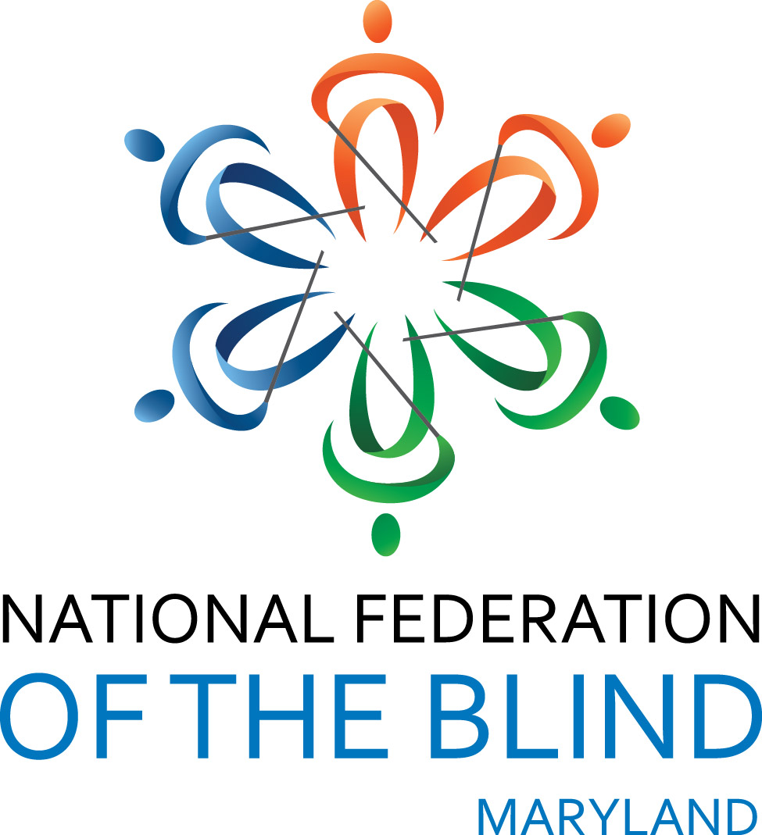 NFB of Maryland Internship PROGRAM

NATIONAL FEDERATION OF THE BLIND OF MARYLAND
INTERNSHIP PROGRAM

The National Federation of the Blind of Maryland (NFBMD) is committed to assisting the blind in obtaining meaningful employment by offering an internship performing meaningful work for the National Federation of the Blind of Maryland. Note internships may be performed during either the spring, summer, or fall of a particular year. Interns are expected to work a minimum of 150 hours over a ten to fifteen week period. Interns will receive a stipend of $1,500.
NFBMD will sponsor up to three interns to perform meaningful work during the year. Interns will be assigned work in support of the National Federation of the Blind of Maryland.

This program is designed to help blind jobseekers get past the "you have little or no experience" barrier to future employment. As an intern, the blind person can build up a resume, gaining experience to become competitive in today's marketplace.
All internships should be geared toward ultimate employment goals. NFBMD will fund 150 hours over a ten to fifteen-week period, or in any configuration approved by the committee. Of course, interns may work more hours if they choose to volunteer or obtain additional funding elsewhere.

Criteria: All internships are awarded on the basis of academics, leadership ability, and service to the community. To be eligible for an NFBMD internship, an applicant must be a legally blind resident of or student in Maryland. Applicants must be: 1) enrolled full-time as a junior or senior in high school, or in a regular accredited two-year, four-year, or graduate college or university program; or a recent student in one of the programs referenced above. Winners must commit to attend the National Federation of the Blind of Maryland State Convention in the Fall.

To apply:
- Complete an application online at nfbmd.org;
- Submit all documents listed on the application via e-mail in MS Word format to:
Ronza Othman, President, National Federation of the Blind of Maryland
President@NFBMD.org
If e-mail is not possible, send to:
Ronza Othman
15 Charles Plaza, #3002
Baltimore, MD 21201
Direct questions to: (443) 426-4110.

NATIONAL FEDERATION OF THE BLIND OF MARYLAND
INTERNSHIP PROGRAM APPLICATION

Name:

Date of Birth:

Home address:

Home phone number:

Cell phone number:

Email Address:

Please check off the following which apply to you. If any do not apply to you, you are ineligible for an NFBMD internship at this time.

___ I am legally blind.

___ I am a resident of or attending school in Maryland.

___ I commit to attend the entire National Federation of the Blind of Maryland state convention.

Cumulative grade point average:

Institution being attended in spring semester with class standing (freshman, sophomore, etc.):

Institution to be attended in fall with class standing:

On a separate sheet please provide the following information:
1. All post-secondary institutions you have attended with highest class standing attained and cumulative grade point average,
2. High school attended and cumulative grade point average, and
3. Community Service.

Please attach the following documents to your completed application:
1) Personal Essay. Along with your application, introduce yourself to the committee in a brief essay or self-portrait. Consider the essay an opportunity to tell the committee who you are. Describe your strengths, achievements, and aspirations. What is important to you? Who do you hope to become? Has a particular person or experience changed your life? How has your blindness affected you? How do you handle it at school, on the job, and in interpersonal relationships? Include information about your goals for this internship.
2) One current letter of recommendation.
3) Transcripts. Provide a current transcript from the institution you are attending as well as transcripts from all post-secondary institutions you have attended. If you have not attended an institution of higher learning or have not completed one year of study at such an institution, provide a high school transcript.

EMAIL APPLICATION AND SUPPORTING DOCUMENTS TO (Preferred):
President@nfbmd.org, with Subject heading: Internship Application
OR SEND COMPLETED APPLICATION AND SUPPORTING DOCUMENTS TO:
Ronza Othman, NFBMD, 15 Charles Plaza, #3002, Baltimore, MD 21201

