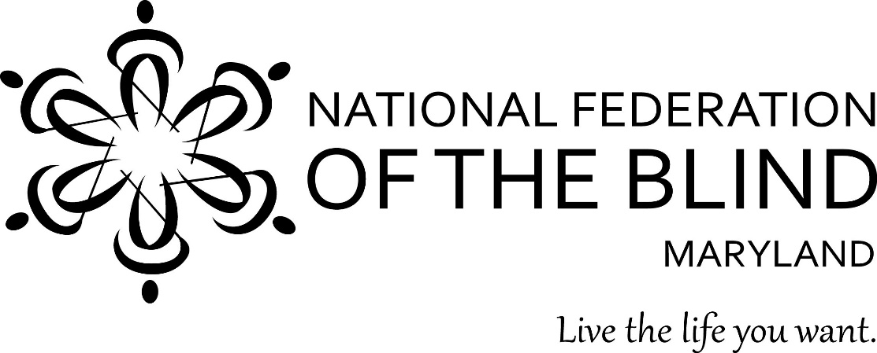

National Federation of the Blind of Maryland
2021 Annual Convention
Focus Forward!

The State Convention is Coming!

Get ready for a weekend of fun and fellowship. Come and be part of celebrating our accomplishments and planning for the future!

- Date: November 12 to 14, 2021
- Place: Holiday Inn Baltimore Downtown Inner Harbor
105 W Fayette Street
Baltimore, MD 21201
- Keynote Speaker: Julie Deden
Executive Director
Colorado Center for the Blind
- Explore opportunities through special workshops for parents and teachers of blind children, blind merchants and entrepreneurs, and students. Check out our technology workshops and more.
- Examine new products at the exhibit hall on Friday.
- Help us raise expectations for ourselves and for officials who manage services for the blind.

See enclosed registration form for more information.
Highlights from Last Year
Can a blind person successfully manage a small business? How do blind students excel in school? What are NFB training centers, and why should you get training? At last year’s convention, we met and heard from blind people who are experts in these areas and more. What interesting stories from blind people will we hear at the 2021 convention?

Benefits of Convention Networking
Do you want to meet seniors who are living the lives they want despite losing their vision later in life? Do you want to meet blind people who are successfully employed in everything from electrical engineering to clerical work? Do you want to meet blind people who own and operate their own businesses? By networking at the convention, you will meet all these people and more.

Banquet and Keynote Speaker
The banquet on Saturday evening is the highlight of every convention. Our keynote speaker, Julie Deden, has been actively involved in the National Federation of the Blind for more than 40 years. She serves as the executive director of the Colorado Center for the Blind. You will not want to miss her inspirational address. We also will award scholarships and recognize a variety of achievements at the banquet.

The National Federation of the Blind knows blindness is not the characteristic that defines you or your future. Come to the convention to find out how you can make sure that blindness does not hold you back. For the latest information, go to www.nfbmd.org/convention.

Donate through GreenDrop:

GreenDrop is pleased to turn your lightly used clothing and household items into funding for the National Federation of the Blind! GreenDrop is a professional solicitor that raises funds through the collection of donated clothing and household items. These items are converted into critical dollars needed to assist the NFB in their mission to support blind and low-vision Americans. For more information visit http://www.nfbpickup.org/

HOTEL INFORMATION
Holiday Inn Baltimore Downtown Inner Harbor
105 W Fayette Street • Baltimore, MD 21201

**Note: If you wish to reserve a sleeping room at the Crown Plaza Baltimore Downtown Inner Harbor for this convention, you must contact the hotel directly at 410-347-5707 before October 15.

Convention Room Rates:
Standard Room - $94 per night + tax, based on single or double occupancy
Children younger than 17 do not incur an additional cost if staying with an adult
Tax on sleeping rooms is 17.5%. These room rates will be available from Thursday, November 11 through Sunday, November 14, 2021 (Monday morning checkout).

NATIONAL FEDERATION OF THE BLIND OF MARYLAND
2021 CONVENTION AND DONATION FORM

With this form, you can register for the convention, buy your banquet and luncheon tickets, pay for your transportation to and from Baltimore, sign up for childcare, and make a donation to the NFB of MD!

Please return completed form by October 15 to:
National Federation of the Blind of Maryland
NFBMD State Convention
1800 Johnson Street, Suite N1
Baltimore, MD 21230

You will be able to fill out this form and make credit card payments at www.nfbmd.org/convention.

Please complete this page even if you do not plan to attend; it will help us with our record-keeping.

Name: ______________________
Address: City/State/ZIP: ____
Telephone: Email:_________________________________

_____ Yes, I will attend the 2021 convention.

_____ No, I will not attend the 2021 convention, but will make a donation.

Donations are very much appreciated. Please make checks payable to NFBMD.
My Donation to the NFB of Maryland: $____________

EARLY REGISTRATION

Take advantage of the early registration fee of $20 per person. After October 15, you will have to register at the convention and pay the convention registration fee of $25 per person.

Please list names of all people, including yourself, you wish to register in the spaces below. If any of the listed registrants do not reside at your address, list their addresses and phone numbers in the space provided. Registration fees will not be charged for children 16 or younger when accompanied by a parent or guardian. However, please list their names so we may obtain an accurate registration count.

I am paying the special registration fee of $20 per person for ______ people.
Additionally, I am registering ______ children at no cost.

Your Name:

2nd Name: Age 17 or younger? Yes or No (circle)
Address: City: State: ___ Zip: ____
Phone: ( )

3rd Name: Age 17 or younger? Yes or No (circle)
Address: City: State: ___ Zip: ____
Phone: ( )

4th Name: Age 17 or younger? Yes or No (circle)
Address: City: State: ___ Zip: ____
Phone: ( )

5th Name: Age 17 or younger? Yes or No (circle)
Address: City: State: ___ Zip: ____
Phone: ( )
TRANSPORTATION, LUNCHEONS & BANQUET

Transportation:
Transportation ($35 per person, regardless of age) will be available from the New Carrollton Amtrak Station, 4300 Garden City Drive, New Carrolton, MD; to the Holiday Inn Baltimore Downtown Inner Harbor on Friday, November 12, returning Sunday, November 14; departure times to be announced. The $35 rate covers both one-way and round-trip transportation (no discounted price for only travelling one way).

I am paying for transportation at $35 per person for ____ people. Total $___________

Name _________________________________ Name _________________________________

Name _________________________________ Name _________________________________

Name _________________________________

Friday—Easy Boxed Lunch tickets: $16 each, must be purchased by October 15.
I am purchasing ______ number of boxed lunches at $16. $___________
Qty ___ Ham/Name(s): ___________________ Qty____ Chicken Salad/Name(s): __________________
Qty ___ Vegetarian/Name(s): _____________________

Friday—Picnic Dinner/Show: $18 each, must be purchased by October 15.
I am purchasing ______ number of meat meals at $18. $___________
Names: ____________________________________________________________

I am purchasing ______ number of vegetarian meals at $18. $___________
Names: ______________________________________________________________

Saturday—Parents’ Luncheon and Seniors’ Luncheon tickets:
$22 each if purchased by October 15 • $25 if purchased at convention. Specify vegetarian lunches below.
I am purchasing _____ number of Parents’ Luncheon tickets at $22 each. $___________
Of these, _____ will be vegetarian. (Name(s) ____________________________________)

I am purchasing _____ number of Seniors’ Luncheon tickets at $22 each. $___________
Of these, _____ will be vegetarian. (Name(s) ____________________________________)

Saturday— Banquet tickets:
$40 each if purchased by October 15 • $45 if purchased at convention. Specify vegetarian meals below.
I am purchasing _____ number of Banquet tickets at $40 each. $___________
Of these, _____ will be vegetarian. (Name(s) ____________________________________)
PAYMENT

With this form, I am enclosing a check made out to NFB of Maryland, in the TOTAL amount for donation, registration, luncheons, and banquet $__________.

Upon receipt of this form and full payment, we will send you a statement confirming your order. Present this statement when picking up your registration materials at the convention. No refunds will be provided for persons who have registered but do not attend the convention.

I understand that in order to qualify for the special hotel rate, I, and each person in my room, must register for the convention and pay the convention registration fee. The room rate does not include the cost of phone calls and other incidentals that I may charge to my room.

I understand that I and everyone in my party will be required to adhere to the NFB of Maryland In Person Events Policy, which may include mandatory masking, temperature checks, symptom screening, social distancing, and other requirements in the policy.

I understand that I and all members of my party are required to comply with the NFB Code of Conduct.

_________________________________________
Signature

Please mail this completed form and your payment to:

National Federation of the Blind of Maryland
NFBMD State Convention
1800 Johnson Street
Suite N1
Baltimore, MD 21230

If you have any questions, please contact Ronza Othman at 443-426-4110.

*To pay online with a credit card, go to www.nfbmd.org/convention to find the registration link and complete your form.

2021 CONVENTION CHILD CARE
Provided by the Maryland Parents of Blind Children

Childcare available:
Friday, November 12 | Saturday, November 13 | Saturday, November 13
8:30am to 5:30pm | 8:30am to 5:15pm | 6:30pm – 15 minutes after the banquet concludes

NFBMD Childcare Pricing:
$30 - single child $50 – two or more children
Pricing is a flat fee covering all the days and hours referenced above. Daily pricing is not available. Make childcare checks payable to MDPOBC. The MDPOBC makes every effort to provide childcare for members regardless of ability to pay. For information, please contact Garret Mooney at 480-433-8003 or James.Garret.mooney@gmail.com or. Visit www.nfbmd.org/convention to pay via PayPal

Mail this childcare form and childcare payment to:
William Jacobs, MDPOBC
1501 Langford Road
Gwynn Oak, MD 21207

Childcare for (name) __________________________________________ age_______
2nd Child __________________________________________ age_______
3rd Child __________________________________________ age_______
Please note any food allergies for the child(ren): ___________________________________________
Please specify from the below when you expect to need childcare:
_____ Friday, 8:30 am to 5:30 pm *Only for parents attending parent workshops
_____ Saturday, 8:30am to banquet end
-OR-
__8:30 am to noon | __ noon to 2pm | __2 to 5pm | __6:30 to banquet end
 | Luncheon attendees only |  | Includes dinner

Name of parent/responsible adults who are allowed to pick up child(ren). (No more than 2 names, please):

1._________________________________________ Email: __________________________________
Home phone: _____________________________ Cell phone: ___________________________
2._________________________________________ Email: __________________________________
Home phone: _____________________________ Cell phone: ___________________________
Special considerations we should know about your child(ren) (allergies, blind/low vision, etc.) ________________________________________________________________________________________________________________________________________________________________________

Ronza Othman, President Nonprofit Organization Nonprofit Organization
NFB of Maryland U.S. Postage Paid U.S. Postage Paid
1800 Johnson Street, Suite N1 Permit No. 109 Baltimore, MD
Baltimore, MD 21230
Address Service Requested
Phone: (443) 426-411
Email: President@nfbmd.org

