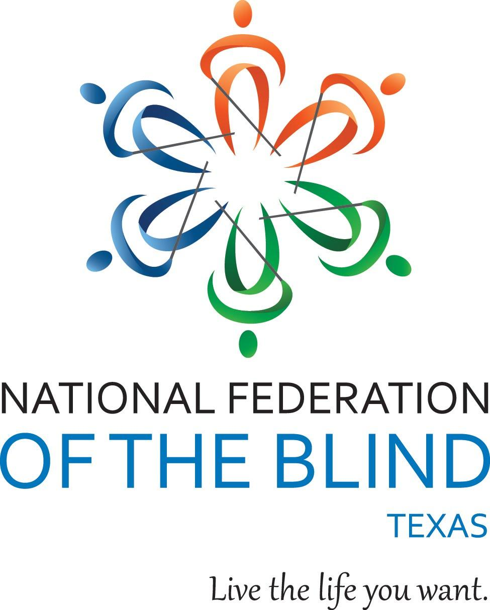

**NFB-NEWSLINE® Texas Presents:**

**A Better Way to Live: Habits to Improve Health and Wellness**

Date: Saturday, September 9, 2023

Time: 1:00-3:00 p.m. Central Time

Location: Zoom

Do you want to improve your physical fitness and mental wellbeing? Are you curious how blind people can lead active, healthy lives?

Join our panel of blind professionals working in health and fitness fields to learn how you can make better choices each day to cultivate a healthy lifestyle and meet your wellness goals.

Presentation highlights include:

* Discussions on living a healthy heart life with practical tips to improve your health lead by medical professionals
* interactive games about wellness and nutrition
* A tour of the health and wellness publications available for free on NFB-NEWSLINE®

Students, families, blindness professionals, and everyone welcome!

[Register now!](https://forms.gle/YPpZfzM9cwLjoCyA9)

Qualifying Texas residents will be registered for the free NFB-NEWSLINE® electronic information service.

For more information or to RSVP, contact:

Liz Wisecarver, NFB-NEWSLINE® Texas Coordinator

281-968-7634

lwisecarver@nfbtx.org