Albinism Families of NH

Summer Time BBQ

Sunday, June 13, 2010 12:00 PM

I have the pleasure of extending the Thomas Family’s BBQ invitation to all families of the Albinism community of NH. Come for fun and meeting new friends! Your biggest support lies right in your own community. Catch up with familiar faces and maybe meet some new ones, summertime is perfect to build long lasting friendships. Thank you so much to the Thomas family for the being the host of the first Albinism BBQ, with great hopes of more to come!

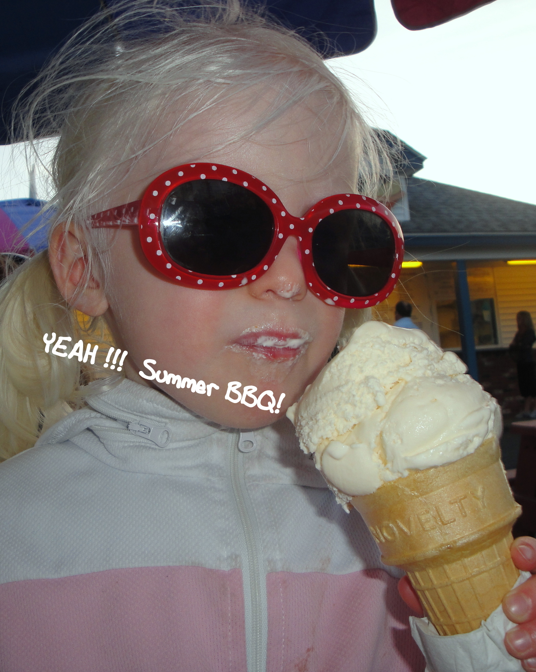
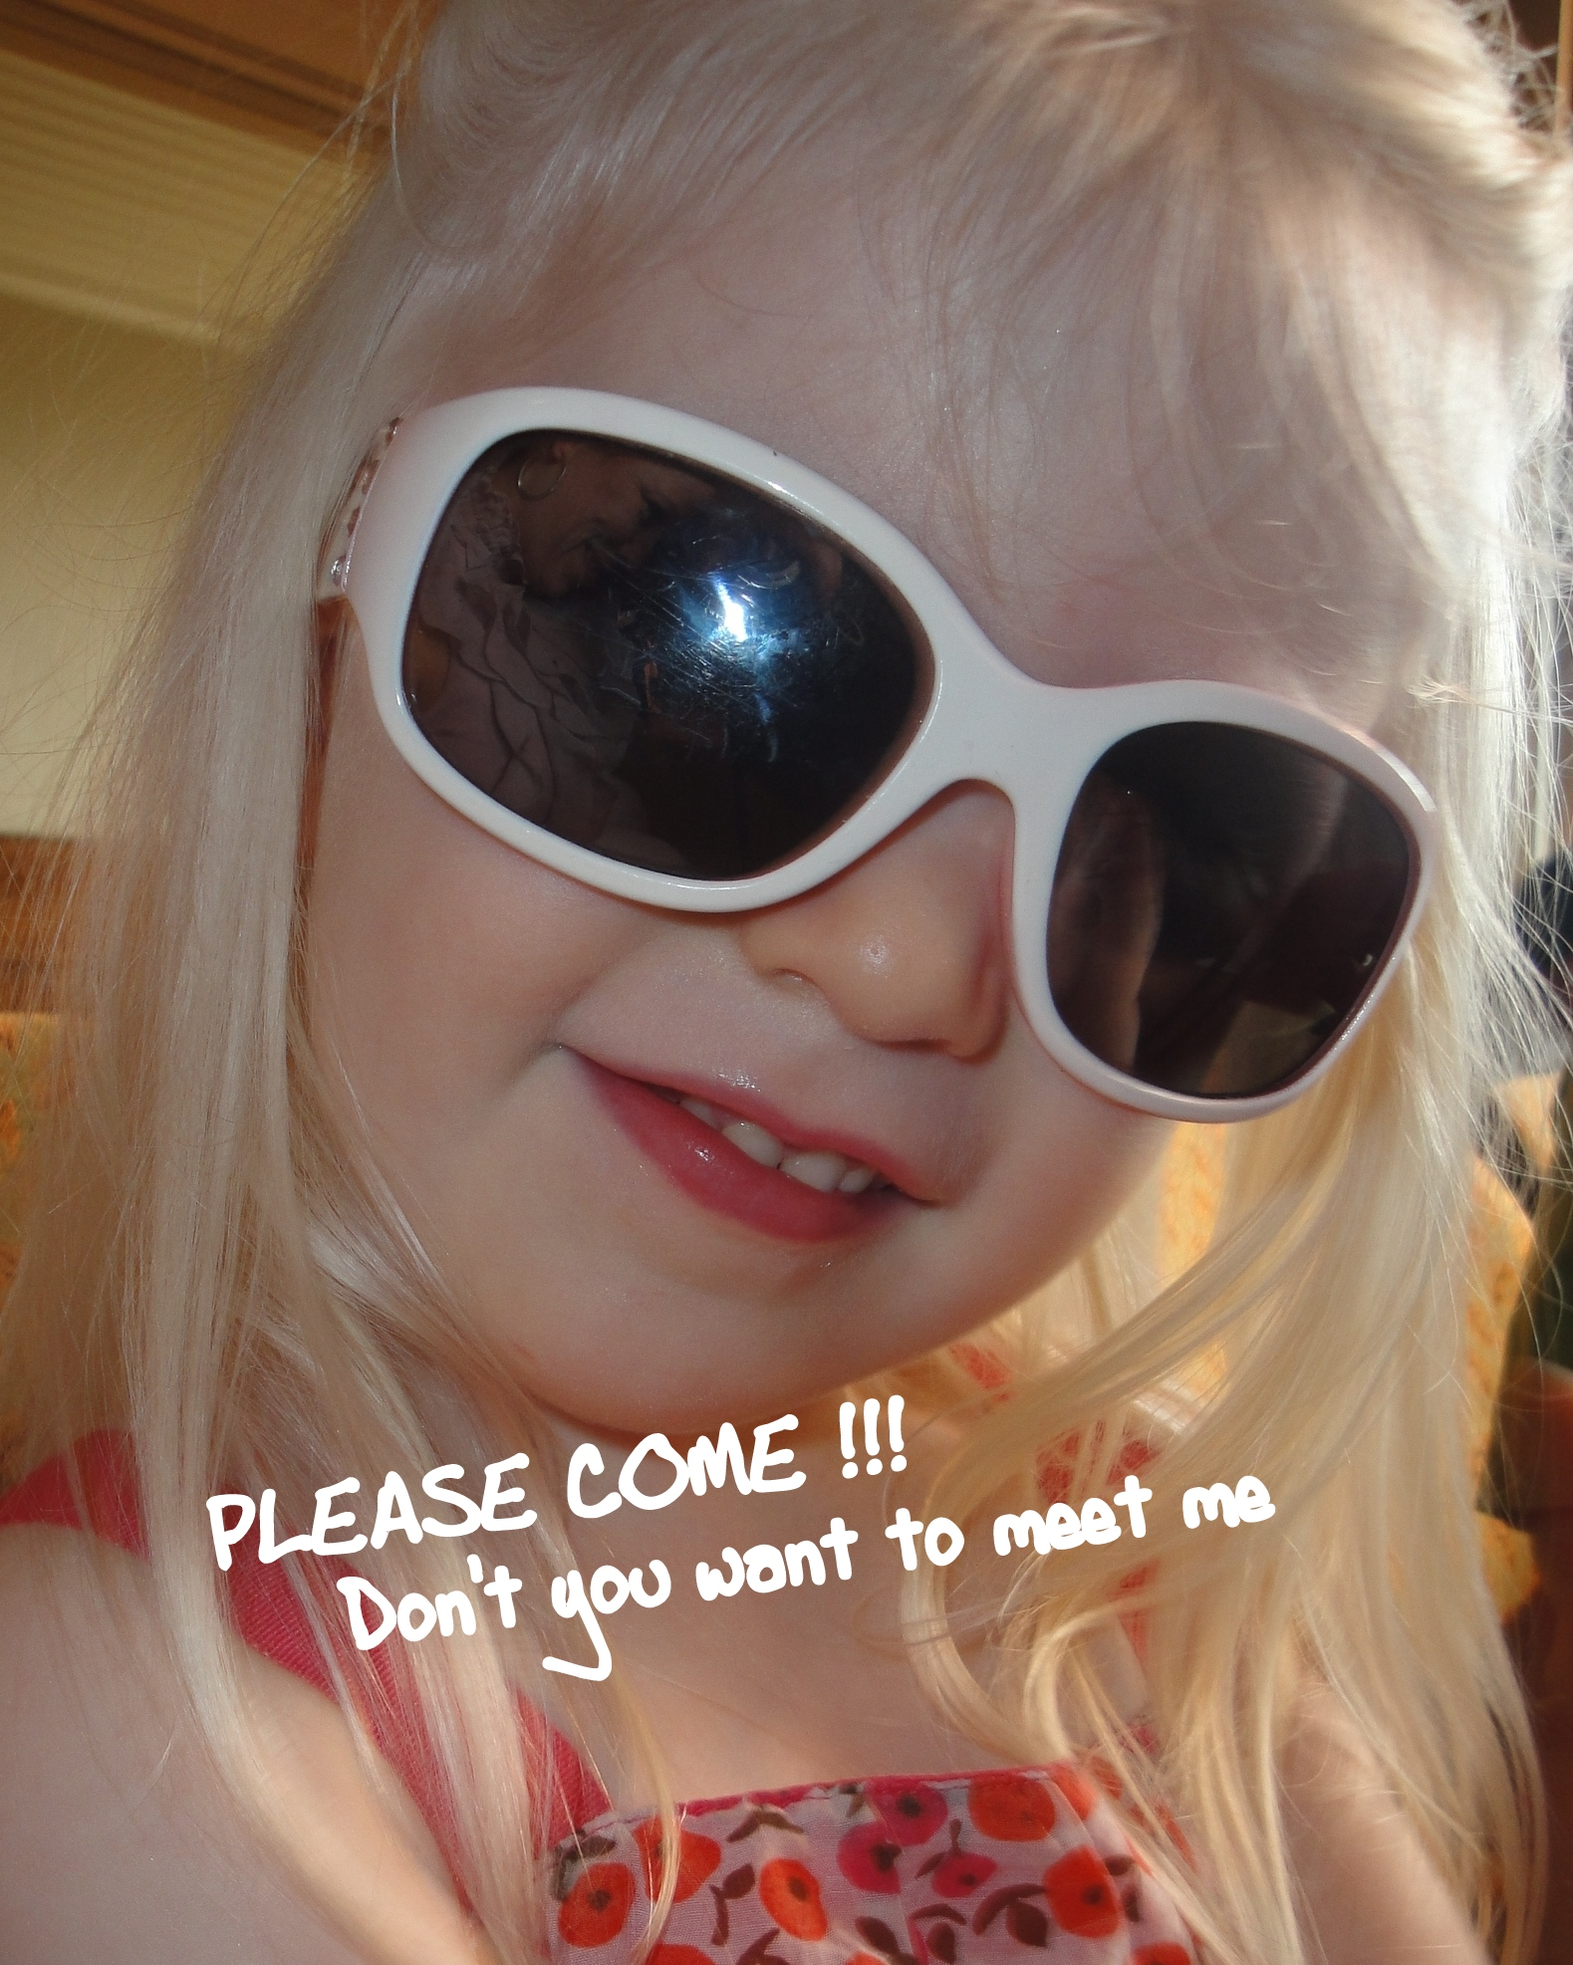
We hope you can join The Thomas family for a summer BBQ. They will provide hamburgers, hotdogs and lemonade.
Please bring a dish to share.
Drake says bring your bathing suit tooo!
Please RSVP by Monday, June 7th.
Thomas Family Home
279 Fremont Road
Sandown, NH 03873

Please contact with
You’re RSVP soon

Tricia Thomas
btt1@comcast.net
or
Tricia Roy
603-560-0546
tnd33@comcast.net

