**The Brain Injury Association of New Hampshire and the Governor's Commission on Disability**

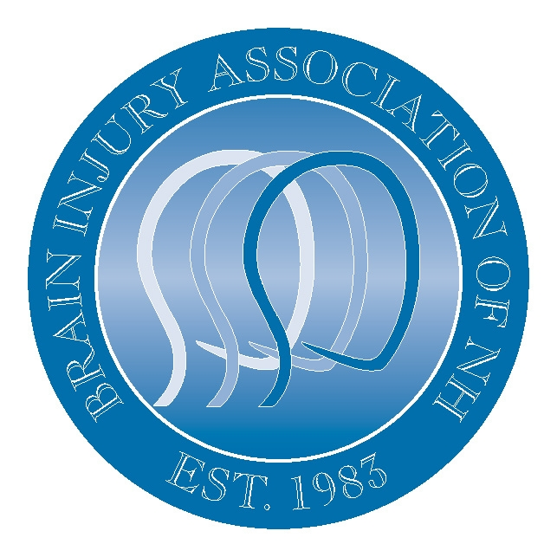

**Friday, April 25, 2014, 8:30 am – 3:00 pm**

**Legislative Office Building, Room 206-208**

**8:30 – 9:00 am** **Registration**

**9:00 –9:30 am** **Welcome-Freddi Gale, Vice-Chair of BIANH**

**- Public Policy Committee, Board Member**

**Chuck Saia, Executive Director**

**- Governor’s Commission on Disability**

**Introductions**

**9:30 – 10:00 am The Legislative Process;**

**How does a bill become a law?**

*-Ellen Edgerly, Community Organizer, BIANH*

*-John Richards, Consultant, BIANH*

**10:00 -11:00 am** **The Importance of Advocacy**

*-Robert Dunn, Devine Millimet Lobbyist*

**11:00 -12:00 pm** **Communicating with your Legislators**

*-Senator Sam Cataldo*

-*Representative Lisa DiMartino*

-*Representative Mariellen MacKay*

**12:00 -1:00 pm** **Lunch Provided – State House Cafeteria**

**1:00 –2:00 pm** **Legislative Process (Continued)/Managed Care** **Update**

*-John Richards, Ellen Edgerly*

**2:00 -3:00 pm** **Statehouse Tour**