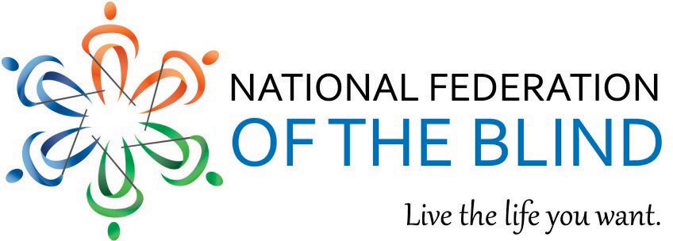

GREATER ACCESS AND INDEPENDENCE THROUGH NONVISUAL ACCESS TECHNOLOGY (GAIN) ACT (H.R. 3929)

Issue--Advanced digital interfaces create barriers that prevent blind individuals from independently operating essential devices that enhance the quality of life.

Home use medical devices, home appliances, and fitness equipment are becoming less and less accessible for blind Americans. The rapid proliferation of advanced technology is undeniable. Most new stoves, glucose monitors, and treadmills now require that consumers interact with a digital display, flat panels, and other user interfaces. This new technology is inaccessible to blind individuals and creates a modern-day barrier. Inaccessibility is not a mere inconvenience; it threatens the safety, health, and independence of blind Americans.
Advancements in technology have the potential to transform how people live in a society but are designed for those with no functional limitations.1 This flaw in product design limits options for blind Americans who need nonvisual access to important devices that are available to people without disabilities.2

Nonvisual access is achievable, as demonstrated by a number of mainstream products. Apple has incorporated VoiceOver (a text-to-speech function) into its touch-screen products, making the iPhone, iPod, and iPad fully accessible to blind people right out of the box. Virtually all ATMs manufactured in the United States are accessible, and every polling place provides a nonvisually accessible voting machine. Frequently, a simple audio output or vibrotactile feature can make a product fully accessible at minimal cost.

Current disability laws are not able to keep up with advancements in technology. Although the Americans with Disabilities Act and other laws require physical accessibility for people with disabilities (e.g., wheelchair ramps, Braille in public buildings), no laws protect blind consumers’ right to access technology such as home use medical devices, home appliances, or fitness equipment. The National Council on Disability concluded that accessibility standards lag behind the rapid pace of technology, which can interfere with technology access.3 This trend of inaccessibility won’t improve if accessibility solutions are ignored. Only a fraction of manufacturers incorporate nonvisual access standards into their product design while others resist solutions.

Solution--Greater Access and Independence through Nonvisual Access Technology (GAIN) Act:

Calls on the Access Board to conduct a nonvisual access standard review. The Access Board (an independent federal agency and leading source of information on accessible design) will review the current marketplace, consult with stakeholders and manufacturers, and will issue a report with findings and recommendations for a minimum nonvisual access standard for home use medical devices, home appliances, and fitness equipment.

Establishes a minimum nonvisual access standard for home use medical devices, home appliances, and fitness equipment. The Access Board will issue a final rule, not later than thirty-six months after the date of enactment of the act, to establish a minimum nonvisual access standard for home use medical devices, home appliances, and fitness equipment. The standard will go into effect two years after the final rule.

Authorizes the Food and Drug Administration (FDA) to enforce the nonvisual access standards for home use medical devices. Under its authority to ensure the safety, efficacy, and security of medical devices, the FDA will investigate and, when appropriate, assess civil penalties against manufacturers who fail to comply with the standard.

Authorizes the Federal Trade Commission (FTC) to enforce the nonvisual accessibility standards for home appliances and fitness equipment. Under its authority to investigate and enforce consumer protection matters, the FTC will investigate and, when appropriate, assess civil penalties against manufacturers who fail to comply with the standard.

GOAL--END THE DIGITAL DIVIDE FOR BLIND AMERICANS.

Cosponsor the Greater Access and Independence Through Nonvisual Access Technology Act.

To cosponsor H.R. 3929 in the House of Representatives, contact:
Syd Terry, Legislative Director for Congresswoman Jan Schakowsky (D-IL)
Phone: (202) 225-2111, Email: syd.terry@mail.house.gov

For more information, contact:
Stephanie Flynt, Government Affairs Specialist, National Federation of the Blind Phone: 410-659-9314, extension 2210
Email: sflynt@nfb.org
Visit: www.nfb.org.

1 See NATIONAL COUNCIL ON DISABILITIES, National Disability Policy Progress Report: Technology that enables access to the full opportunities of citizenship under the Constitution is a right at 19 (October 7, 2016), available at https://ncd.gov/progressreport/2016/progress-report-october-2016.
2 See Id.
3 See Id.

National Federation of the Blind

