National Federation of the Blind of New Mexico, Albuquerque chapter Agenda
March 9, 2017

1. Call to order
2. Introductions
3. Approval of agenda
4. Approval of the minutes from February 9, 2017
5. Treasurer’s Report—Sarah Villavicencio
6. Presidential Release highlights—Tara Chavez
7. Old Business:
A. Letter to Congresswoman Lujan-Grishem—Tara Chavez
B. Fundraising update—Lindsay Sloan/Ernie Esquibel
8. New Business:
A. Blind person in area sign—Discussion
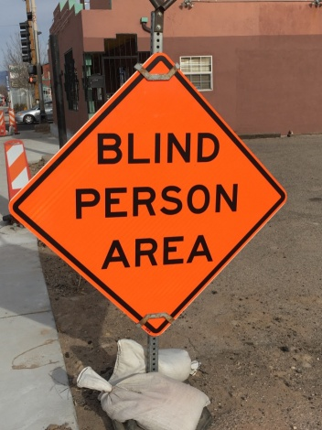
B. State Convention fundraiser—chapter raffle and Affiliate raffle
C. Meeting location—Tara Chavez
D. Surprise discussion topic
9. Announcements
10. Adjournment

