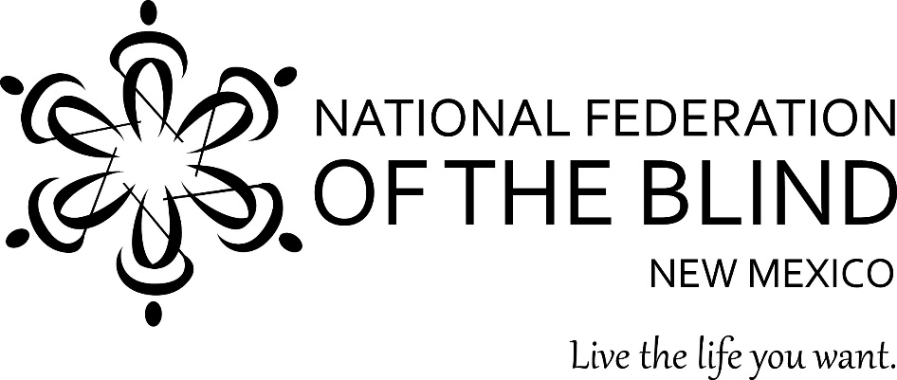
The Chapters of Albuquerque and West Mesa are happy to host the

2019 WHITE CANE BANQUET

Saturday, October 12, 2019
Noon to 2 pm

Crown Plaza Hotel
1901 University Blvd.
Albuquerque, NM

Each October, the National Federation of the Blind celebrates Meet the Blind Month. This year we celebrate with our banquet. For blind people, the white cane is an essential tool that gives us the ability to achieve a full and independent life. It allows us to move freely and safely from place to place-whether it's at work, at school, or around our neighborhoods.

Our guest speaker will be Fire Chief, Paul W. Dow, of the Albuquerque Fire Department. He was confirmed as Chief in January of 2018. Chief Dow has served with the Albuquerque Fire Department for over 19 years and has much to share with us.

Door prizes will be drawn during the banquet, and we a have fabulous prizes to award. A paid banquet ticket serves as an entry. To win, you must be in the room when your name is called. If you are a member, you will receive an extra entry per non membered guest that you bring.

Join us for an afternoon of fun and fellowship, we are looking forward to sharing this exciting event with you and your guests. For questions, please contact Caroline Benavidez at
(505) 350-3589.

The Registration deadline is September 23, 2019. Make checks payable to the NFBNM, West Mesa Chapter.

Please complete the required information below. You can enter the information electronically and then print it to be mailed, or print this page and fill in the information. Please include the names of all persons planning to attend. Your seat at the table will not be secured without a form of payment.
NFBNM Member (Y/N) If not, guest of whom:

Name: Phone:

Adult meal or child meal:

Meal choice (regular/vegetarian):

~~~~~~~~~~~~~~~~~~~~~~~~~~~~~~~~~~~~~~~~~~~~~~~~~~~~~~~~~~~~~~~~~~~~~~~~~~~~~~~~~~~

NFBNM Member (Y/N) If not, guest of whom:

Name: Phone:

Adult meal or child meal:

Meal choice (regular/vegetarian):

~~~~~~~~~~~~~~~~~~~~~~~~~~~~~~~~~~~~~~~~~~~~~~~~~~~~~~~~~~~~~~~~~~~~~~~~~~~~~~~~~~~

NFBNM Member (Y/N) If not, guest of whom:

Name: Phone:

Adult meal or child meal:

Meal choice (regular/vegetarian):

~~~~~~~~~~~~~~~~~~~~~~~~~~~~~~~~~~~~~~~~~~~~~~~~~~~~~~~~~~~~~~~~~~~~~~~~~~~~~~~~~~~

NFBNM Member (Y/N) If not, guest of whom:

Name: Phone:

Adult meal or child meal:

Meal choice (regular/vegetarian):

Total number of adults @ $25.00 each:
Total number of children @ $15.00 each:
Total amount enclosed: $

Mail your registration form and check to:
Bryce Hammond
11003 Marlowe Ct. NE,
Albuquerque NM 87113

Remember the deadline is September 23, 2019.

