Presale
West Mesa Chapter 2020 cookbook
$10 per book, 3 different formats (print, Braille or electronic) or Bundle any 2 formats for $15
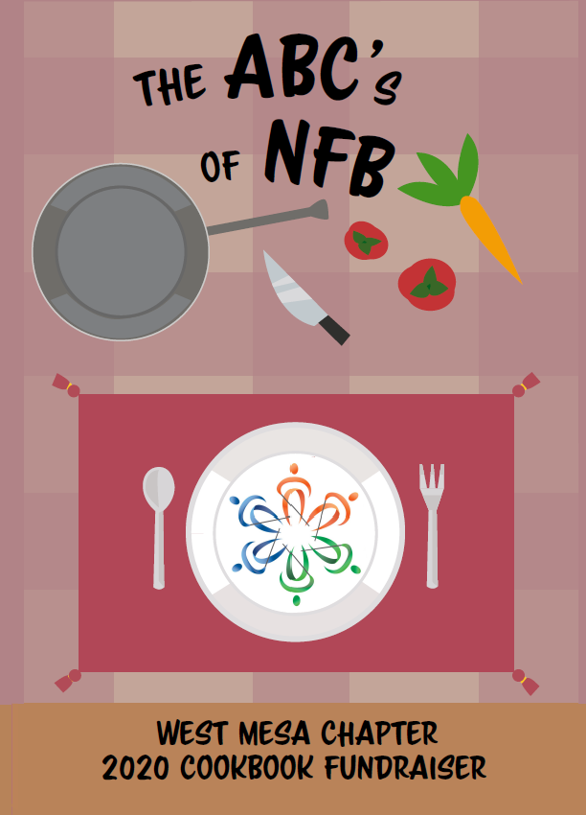
Image: Knife, fork, plate with NFB logo
To order, please contact:
German Benitez,
West Mesa Chapter President
phone: (505)702-5044 email: nfbnm.westmesachapter@gmail.com
or
Veronica Smith
phone: (505)269-1034 email: mad.tewe@gmail.com
Payment will be collected at the end of the preorder period

Cookbooks are 42 pages long with 40 total recipes donated by your NFB family members

