**NMCB Logo
**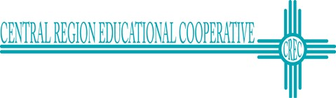

**Save the Date!**

**Webinar on Self-Advocacy: Voting as a Blind Youth –**

**Coming on September 29 and October 3, 2020**

The New Mexico Commission for the Blind, in collaboration with the Regional Education Cooperative 5, will present a webinar to address a mutual goal of improving self-advocacy skills for students with a disability.

Title: Self-Advocacy: Voting as a Blind Youth

Dates: September 29 at 7:00 - 8:00pm MT and

October 3, 2020 at 4:00- 5:00 pm MT

Description: First-time voters or recent voters may have questions about how to engage there right to vote and advocate for themselves throughout the voting process. This webinar is for students ages 17-21 to ask questions in a safe space. Talk surrounding party affiliation or attempts to influence candidate selection is strictly prohibited. The goal of the training is to help blind youth feel more empowered to exercise their right to vote!

Presentations will be given by our partners: Disability Rights New Mexico and the National Federation of the Blind of New Mexico. Students will also hear from youth who have exercised their right to vote and their experiences.

A Zoom registration email is forthcoming.

