Bake Sale

Friday, September 24, 2021
10:00 am - 2:00 pm

205 Silver Ave. SW
Alb., NM 87102
(outside Silver Street Market)

Proceeds help us provide support, information,
and encouragement to the blind.

Our Vision is to bring about security, equality,
and opportunity for all blind New Mexicans.

You can pay or contribute at
paypal.me/NFBofNewMexico

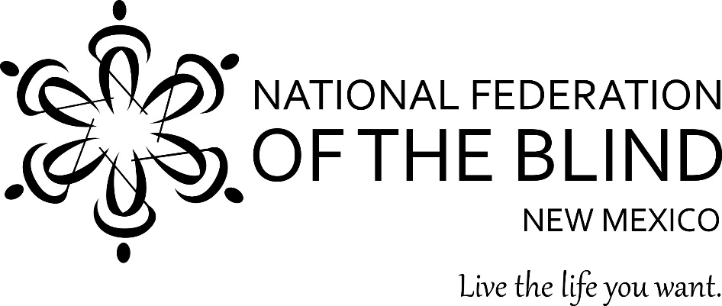
Visit us at www.nfbnm.org

