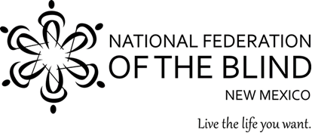
Blind Equality Achievement Month
BEAM
Date: Saturday, October 15, 2022
Time: 11:00 am - 3:00 pm
Place: Jerry Cline Park
7001 Constitution Ave., NE
Albuquerque, NM 87110

Learn about White Cane Awareness Day and meet the blind! Join us with your friends, family, neighbors and colleagues. Try a bit of Braille, pick up cooking tips and tricks, assistive technology demos, and observe cane travel. We will have hands-on learning exhibits for all to enjoy!

Hosted by the Albuquerque Chapter of the
National Federation of the Blind.

To make a donation, see us at Paypal.me/srv4NFB

