[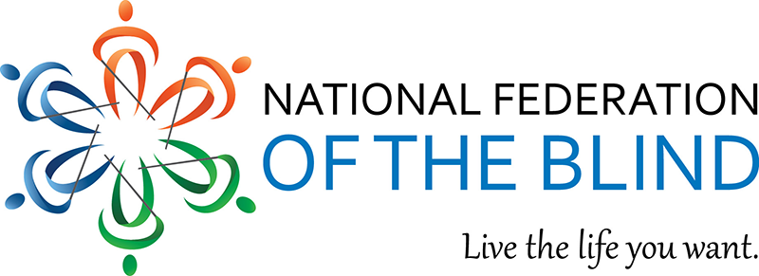](https://www.nfb.org/)

Save the Date

Make Plans to attend the

2024 National Federation of the Blind

New Mexico State Convention

October 24-27, 2024

Sheraton Albuquerque Uptown Hotel

More information will follow through

our NFBNM list serv.

If you would like to be added to listserv,

please email Tonia Trapp at

[nfbnewmexicosecretary@gmail.com](mailto:nfbnewmexicosecretary@gmail.com)

The planning team is working hard at having a safe, informative, and fun event.

Speakers, exhibitors and so much more.