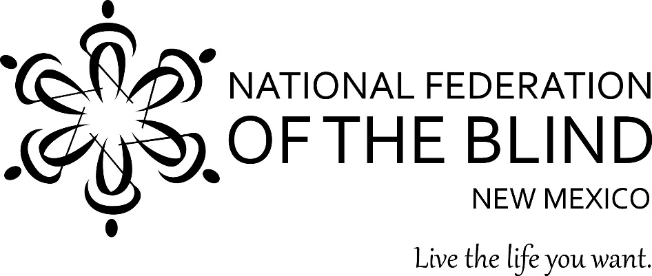**Biscochito Sale**

**$8.00 per dozen**

**Order now until**

**May 9, 2024**

**Orders will be ready May14, 2024**

Proceeds help us provide support, information,

and encouragement to the blind.

Our Vision is to bring about security, equality,

and opportunity for all blind New Mexicans.

**Call or text German Benitez at**

**505-702-5044**

You can pay cash, check payable to

NFB Albuquerque Chapter or find us on PayPal at

[www.paypal.me/srv4NFB](http://www.paypal.me/srv4NFB)