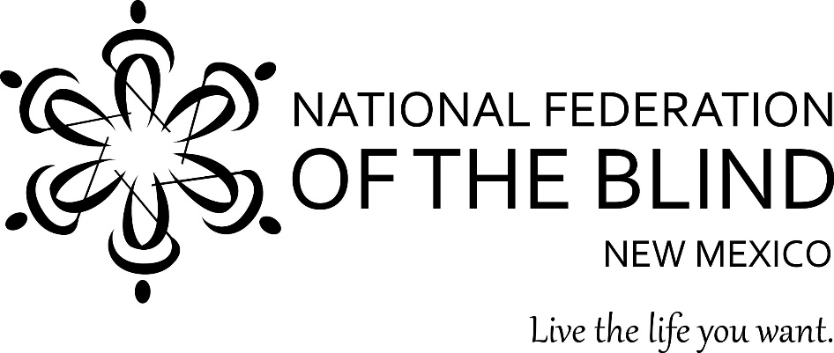

**Please Join the**

**At Large Chapter of the National Federation of the Blind of New Mexico**

**Tuesday, November 26, 2024**

**6:30-9:00pm**

**Mountain Standard Time**

**The National Federation of the Blind is a community of members and friends who believe in the hopes and dreams of the nation’s blind. Every day we work together to help blind people live the lives they want.**

**Social time starts at 6:30pm**

**Meeting starts promptly at 7:00pm**

**Join Zoom Meeting**

[**https://nfb-org.zoom.us/j/96009742920?pwd=aUpWQ2srVCtUTDEwd2RsM2lmOU1uQT09**](https://nfb-org.zoom.us/j/96009742920?pwd=aUpWQ2srVCtUTDEwd2RsM2lmOU1uQT09)

**Meeting ID: 960 0974 2920**

**Passcode: ALCNFB**

**---**

**One tap mobile**

**+12532050468,,96009742920#**

**---**

**Dial by your location**

**• +1 253 205 0468**

**Meeting ID: 960 0974 2920**

**Passcode: ALCNFB**

**contact Information:**

**Janet Montoya**

**Email:** **nfbnm.alc.president@gmail.com**

**Phone:** [**505-672-9626**](mailto:nfbnm.alc.president@gmail.com/505-672-9626)

**Suggested reading material: Kernel books** [Kernel Books | National Federation of the Blind](https://nfb.org/resources/jacobus-tenbroek-library/collections/kernel-books)

1. **Call to Order, Janet Montoya, ALC President**
2. **Rollcall and Introduction of Guests, Daphne Mitchell, Sec/Tres.**

**3. NFB pledge: Veronica Smith**

**I pledge to participate actively in the efforts of the National Federation of the Blind; to achieve equality, opportunity, and security for the blind; to support the policies and programs of the Federation; and to abide by its Constitution.**

**4.National Federation of the Blind Belief Message: Rafael Aguirre**

**The National Federation of the Blind advances the lives of its members and all blind people in the United States. We know that blindness is not the characteristic that defines you or your future. Every day we raise the expectations of blind people, because low expectations create obstacles between blind people and our dreams. Our collective power, determination, and diversity achieve the aspirations of all blind people.**

**5. Approval of agenda**

**6. Approval of the October Meeting minutes**

**7. Treasurer’s report, Daphne Mitchell, Sec/Tres**

**8. Presidential release,** [nfb.org/sites/nfb.org/files/08-2024/presidential_release_november_2024_chapter_version.mp3](https://nfb.org/sites/nfb.org/files/08-2024/presidential_release_november_2024_chapter_version.mp3)

**9. Discussion Topic facilitated by Larry Lorenzo: Why do you believe in the work of the National Federation of the blind?**

**10. Committee Reports**

* 1. **Legislature, Larry Lorenzo, committee chair**
  2. **Membership, German Benitez, committee chair**
  3. **Fundraiser, Martin Gallegos, committee chair**
  4. **Philosophy, Daphne Mitchell, committee chair**

**11. Birthdays**

## 12. Election of ALC Board of Directors for 2025

## ARTICLE V. BOARD OF DIRECTORS

The Board of Directors of this organization shall consist of the three (3) constitutional officers and two (2) additional members. The two (2) Board Members shall be elected at the same time and in the same manner as that prescribed for the election of officers. The Board shall meet at the call of the President or on request by any three (3) of the Board Members. The Board shall advise the President and shall have charge of the affairs of the organization between meetings. At least a majority of the members of the Board must be present at any meeting to constitute a quorum to transact business. The Board may be polled by telephone, electronic ballot, or mail ballot on any questions. A majority of the Board must be blind.

**13. Open discussion, next meeting will be held January 28th, 2025**

**14. Adjournment**