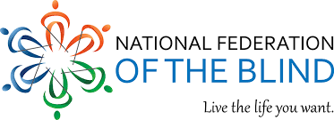

**2024 Ornament Fundraiser**

**Use the URL or QR Code to purchase these to help support our state affiliate**

https://64ouncebraille.com/products/nfb-christmas-ornament-fundraiser