**Enter for your chance to win!!!**

**Ray-Ban Meta Glasses**

* **Meta AI Chat with AI to get real-time suggestions, answers and reminders**
* **Open ear audio, listen to music and more without blocking the ambient noises around you.**
* **Built in HD camera, capture photos and videos hands free.**

**Just say, “Hey Meta, take a photo.”**

**$250 value**

**The winner has a choice of frame and lens color and will get the glasses shipped directly to you.**

**$5.00 per ticket or 5 tickets for $20.00**

**Need not be present to win.**

**The drawing will be held on October 25, 2025**

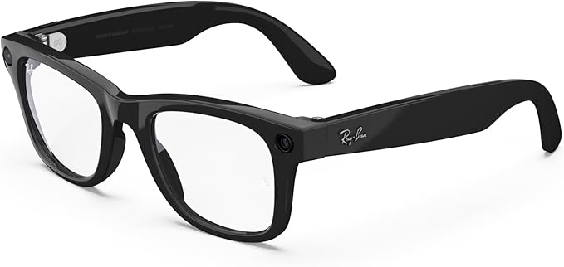**during our State Convention Banquet.**

**Proceeds benefit the National Federation of the Blind New Mexico Affiliate and help us provide support, information,**

**and encouragement to the blind.**

**Please contact German, fundraising chair at (505) 702-5044 or by email** [**nfbnm.treasurer@gmail.com**](mailto:nfbnm.treasurer@gmail.com) **to get your tickets. The tickets are in packages of 5.**