Ray-Ban Meta Glasses Raffle

# Enter for Your Chance to Win Ray-Ban Meta Glasses!

Don't miss your opportunity to win a pair of Ray-Ban Meta Glasses! These innovative glasses feature Meta AI, allowing you to chat with AI for real-time suggestions, answers, and reminders. Enjoy open ear audio, which lets you listen to music and more without blocking out the ambient noises around you. The built-in HD camera enables you to capture photos and videos hands-free simply say, “Hey Meta, take a photo.”

## Prize Details

* The winner will have the choice of frame and lens color.
* The glasses will be shipped directly to the winner.

## How to Enter

* Entries are $5.00 each.
* Purchase 5 entries for $20.00.
* You do not need to be present to win.
* The drawing will be held on October 25, 2025 during our State Convention Banquet.

## Proceeds and Contact Information

All proceeds benefit the National Federation of the Blind New Mexico Affiliate. Your participation helps us provide support, information, and encouragement to the blind community.

To purchase entries, please contact one of the following members:

* John Blake
* Tara Chavez
* Caroline Coon
* Gitana Curtis
* Juan Haro
* 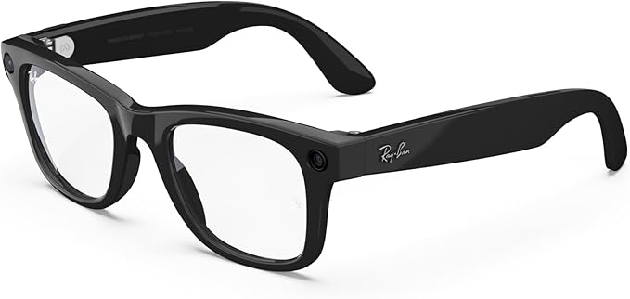Mario Hooee,
* Frank Maestas,
* Janice Maestas,
* Daphne Mitchell
* Janet Montoya
* Darlene Ortiz
* Jamie Sibson
* Veronica Smith
* Sarah Villavicencio
* Nicky Zolman
* German Benitez