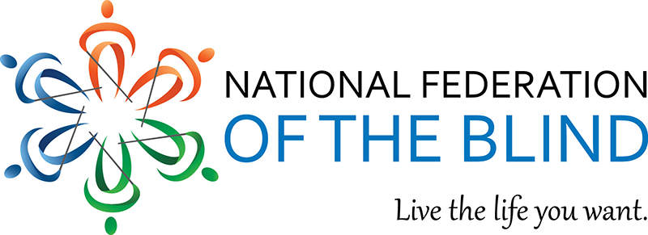

Courtesy Rules of Blindness
I am a blind person. Please say hello and get to know me! I want people to feel comfortable around me. Here are some simple tips.
Cane – My cane (or guide dog) is my independent travel aid. If you think I might need help, please just ask me.
Ordinary – Blind people are ordinary. It feels awkward if you think I am amazing when I accomplish ordinary tasks like walking or tying my shoes. I also like ordinary things and have ordinary hobbies. It is okay to be amazed if I do something really exceptional.
Understand – I may not recognize your voice if I don’t know you well. Please say, “Hi, it is Sue.”
Remember – I may have some sight, but use nonvisual techniques and tools like a cane because it works best for me. Sometimes people think I am “faking” because I see a little, but I am just picking techniques that are most efficient and safe in light of my vision.
Talk – Please talk to me rather than a companion, and there is no need to speak up so just use your normal speaking voice and talk with me like you would with other people.
Experience – I probably have years of experience using nonvisual techniques to live my life. Feel free to ask me how I do something, or how best you can assist me, if help is needed.
See – It’s ok to still use words such as see and look. I will talk with you like everyone else, although I may not be able to make direct eye contact.
Yield – In all 50 states, the law requires drivers to yield the right of way when they see my extended white cane or guide dog. Only the blind may legally carry white canes. I listen to traffic patterns to know when to cross streets and to keep a straight line when moving around.
Thanks for reading about me. I look forward to getting to know you! For more information about gifts, bequests, programs for the blind, or other matters concerning blindness or the blind, contact the local chapter in your area or contact: nfb@nfb.org or 410-659-9314.
(Revised April 2019)

