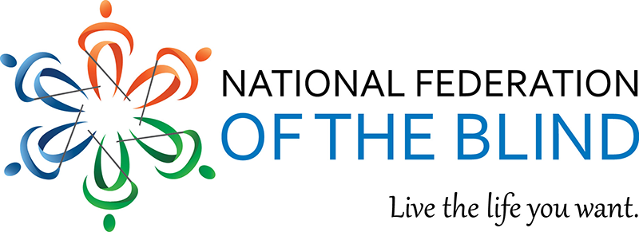
Save the Date

Celebrating 70 Years of Empowerment and Community
2026 National Federation of the Blind
New Mexico State Convention
October 22–25, 2026
Sheraton Albuquerque Uptown Hotel
Albuquerque, New Mexico

Join us as we celebrate 70 years of advocacy, connection, and progress with a safe, informative, and fun statewide event featuring:
• Inspiring speakers
• Engaging exhibitors
• Community connection
• And so much more

More information will be shared through the NFBNM listserv.
To be added to the listserv, email:
Tonia Trapp
nfbnewmexicosecretary@gmail.com
Come be part of our 70-year celebration!

