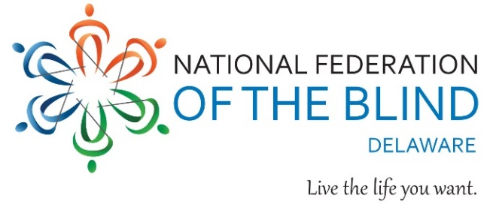

# **You’re Invited: Upcoming Event for Blind Children and Adults!**

National Federation of the Blind of Delaware Community Connections  
**Wednesday, May 21, 2025**  
10:00 AM to 2:00 PM Eastern   
Georgetown Public Library, 123 W. Pine St., Georgetown, DE 19947

Join the transformative organization of blind people who will share nonvisual tips for living the life you want. You don’t have to be a member to attend.

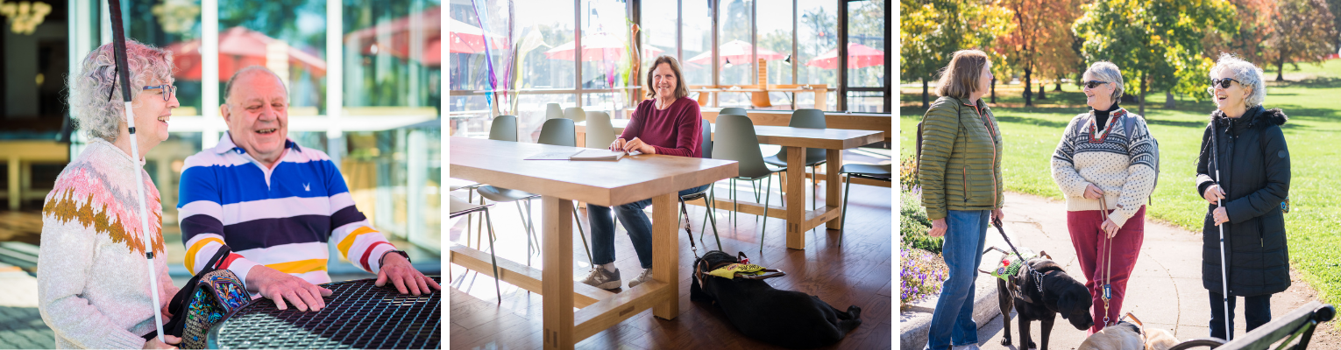

## **An Opportunity to Build Hope and Independence**

Learn about the National Federation of the Blind, which advances the lives of its members and all blind people in the United States. Basic resources such as free audio newspapers and magazines, tutorials on the basics of using smartphones, and free white canes will be available. **Lunch is provided to registered participants.**

Learn more and register at nfbde.org or scan the following QR code.  
NFB of Delaware President Sylvia Reid – 302-743-8811 Call Sylvia Reid for transportation by May 12, 2025.

