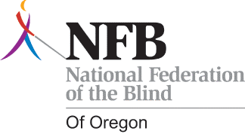
National Federation of the Blind of Oregon
M Member’s Seminar and Legislative Seminar

Saturday, March 2 – Monday, March 4, 2013

Double Tree Hotel
1590 Weston Court, NE
Salem, Oregon

Room Rates: $77 per night + tax (breakfast included)
Meal Package: $40 (includes lunch and dinner Saturday, lunch and dinner Sunday and sack lunch Monday)

Tentative Agenda

Saturday, March 2

12:00 Lunch
1:00 Leadership Development
6:00 Dinner
7:00 Game-A-Thon

Sunday, March 3

8:30 Goal Setting, Membership Fund Raising
11:00 Committee Work
12:00 Lunch
1:00 Legislative Issues in this Year’s Session
4:00 Assignments and Procedures for Capitol
Appointments
6:00 Dinner

Monday, March 4

8:00 – 4:00 Meetings with Legislators

Deadline for Room Reservations: February 15, 2013
Reservations should be made through the NFBO State Office at
541-653-9153 or email at admin@mainstreetmontessori.org.

Game-A-Thon

Saturday, March 2, 2013

Join us for a fun evening of socializing, playing your favorite games, and earning money to help blind children in Oregon brush up on their Braille skills! Similar to a walk-a-thon participants take pledges from family and friends, to be collected after the game-a-thon event. Bring your pledge forms, games and any money collected when you attend the seminar! Pledge forms can be found on our website @ nfbo-oregon.org.

