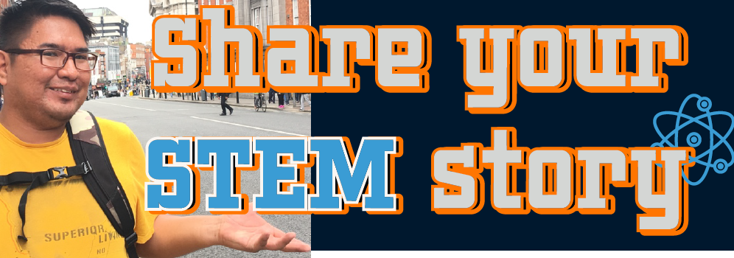
Share your STEM story. Join the Conversation.
The purpose of this focus group research project is to explore how young adults
with visual impairments reflect on their Science, Technology, Engineering and Mathematics (STEM) camp/program experiences and career goals.
We are recruiting individuals who:

(a) are between the ages of 13-23 years old
(b) live within the United States
(c) have a visual impairment (VI)
(d) has/had an Individualized Education Program (IEP) in middle or high school
(e) participated in a STEM camp/program for students with VI within the last 5 years
(f) participated in a STEM camp/program for students with VI for at least two days or 16 clock hours
(g) are willing to participate in approximately 10 hours of focus group meetings across 6-8 weeks
All participants will receive a $75.00 Amazon Giftcard
To learn more, scan the QR Code on the bottom left OR click the link OR contact the principal investigator, Garrison Tsinajinie at garrisot@email.arizona.edu or call 5203284888.
An Institutional Review Board responsible for human subjects research at The University of Arizona reviewed this research project and found it to be in accordance with applicable state and federal regulations and University policies designed to protect the rights and welfare of participants in research.

