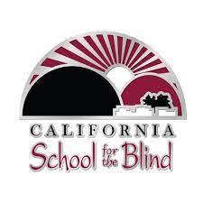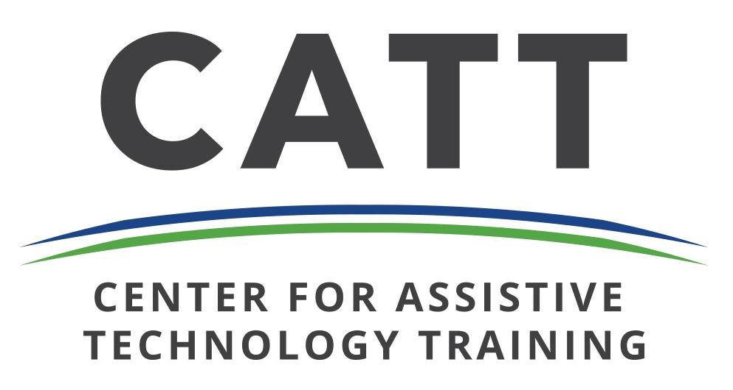

**SAVE THE DATE**

**Principals of Schools for the Blind (POSB),**

**California School for the Blind (CSB), and**

**Center for Assistive Technology Training (CATT-SW)**

***Present***

**The 8th Biennial POSB STEM Institute for Instruction**

**April 8 – 9, 2025 at the Fremont Event Center in Fremont, CA**

**with a tour of CSB on April 10, 2025**

**Please** [**RSVP**](https://forms.gle/wZCdwudH5R5cQdg78) **now. Official registration will start January 31, 2025.**

[**Call for Presenters and Vendors**](https://forms.gle/Uyrq7tbg5UCCdGsv5) **is NOW OPEN (Deadline is January 10, 2025).**

**Hotel Info:** [**Best Western Plus Garden Court Inn**](https://www.gardencourtinn.com/en/)**, We have a block for 30 rooms with the option to add more.**

**$95/night plus taxes and fees (includes free breakfast and has good access to Fremont downtown and CSB).**

**If the block fills up or if there are issues, please contact Veronica Gunn at** [**vgunn@csb-cde.ca.gov**](mailto:vgunn@csb-cde.ca.gov)**.**

**Available dates: Monday, April 7th-Friday, April 11th, 2025.** [**Best Western booking link**](https://nam10.safelinks.protection.outlook.com/?url=https%3A%2F%2Fwww.bestwestern.com%2Fen_US%2Fbook%2Fhotel-rooms.05224.html%3FgroupId%3DC82JJ8G1&data=05%7C02%7Cvgunn%40csb-cde.ca.gov%7C19d766d462974e3e8c2808dc873cf691%7C5d964075ab42404a9eb89d12b2ae2de9%7C0%7C0%7C638533943143375116%7CUnknown%7CTWFpbGZsb3d8eyJWIjoiMC4wLjAwMDAiLCJQIjoiV2luMzIiLCJBTiI6Ik1haWwiLCJXVCI6Mn0%3D%7C0%7C%7C%7C&sdata=yxdn9JTFXpuMW1aht2vKlspNBioiGVVydW%2F%2FgKI1sfc%3D&reserved=0)

***The Institute Occurs Just Prior to***

**CTEBVI, April 10-13, 2025, San Francisco Airport Marriott Burlingame, CA**

**What to Expect**

1. This is your chance to connect with other professionals around the country about teaching STEM content to the blind or visually impaired.
2. CTEBVI will take place starting April 10th, 2025 in Burlingame, if you would like to attend that also. Registration for CTEBVI will need to be made separately at <https://www.ctebvi.org/>. Registration usually opens a couple of months prior to the conference.

**Goals**

1. To build community and a support system among teachers of the visually impaired. Often, teachers feel isolated and don’t have easy access to other teachers for guidance and support.
2. To provide professional development opportunities. The “POSB Institutes for Instruction” would include a training component, focusing on a particular area of instruction to inspire teachers and provide them with tools to improve their instructional practices.
3. To establish online communities for individual disciplines in order to provide ease in communication and to share documents and other materials related to instruction.