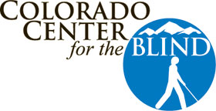
Colorado Center For The Blind Logo
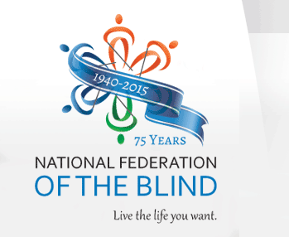
NFB Logo
May, 2015
SENIORS IN CHARGE NEWSLETTER
Connecting Blind Seniors Across Colorado

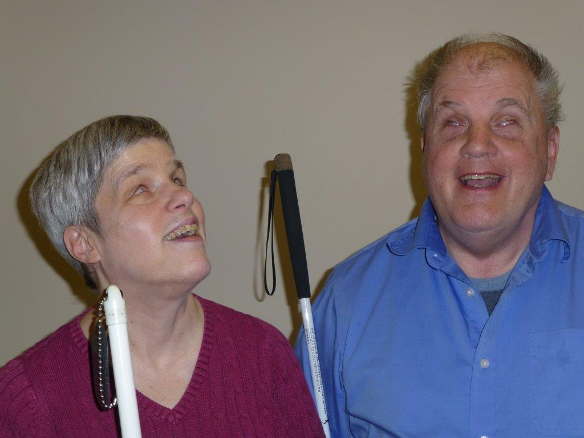
Tom & Linda Anderson

THANK YOU TOM AND LINDA!!

Tom and Linda Anderson arrived in Denver on 12-01-1987, when Tom became the first Braille instructor at the fledgling Colorado Center for the Blind. But, that is not where their story begins.

Linda and her twin sister Sandy were born in Pittsburgh, Kansas, in 1952. They were born prematurely and, as was the practice in those days, received too much oxygen, which caused their blindness. The condition is now called Retinopathy of Prematurity. Linda remembers her parents as being very nurturing, supportive and ready to sacrifice for the family. Because their home had no stairs, Linda’s father built a wooden staircase so that the twins could learn how to manage going up and down steps. As it turned out, their two older and sighted sisters, Patty and Sharon, were the ones who tripped on the stairs!

During Linda’s school years, her mother learned Braille so she could do some transcription and help the girls with their homework. She also worked hard to teach them the social skills they would need, but still tended to be overprotective. Linda’s oldest sister, Patty taught her how to do her hair and put on makeup.

Linda began her education in a public school where she was taught Braille, but by the time she was in third grade, she could not understand math. He parents realized she needed more blindness skills and they all moved so the twins could attend the Kansas School for the Blind, where they learned to use the slate and stylus and received more social skills, but not a lot of academics.

By the time she was ready for Junior High School, Linda went back to the public school where she could now use her slate and stylus. From the age of 3, Linda would come home from church and pick out the hymns on the piano. By age 6, she was taking regular piano lessons. While in 7th grade, she also attended a music camp, and after high school, she became a student at Kansas State and earned her Bachelor’s degree in Music Education.

Tom Anderson was also born in 1952 and had a twin sister who was sighted. Tom’s blindness was due to Retinitis of Prematurity. His paternal grandparents had immigrated to the United States from Norway in 1897. Tom was raised on a farm and admitted that his parents were also over-protective. When he attended the School for the Blind at age 6, he learned blindness skills as well as social skills, including how to deal with bullies. When he attended public high school, he and a blind friend were at times considered to be troublemakers. In college, Tom studied political science and music. He joined the National Federation of the Blind (NFB) in 1971 and was soon the president of the St. Cloud chapter.

In 1975, Tom and Linda first met at an NFB convention in Chicago where Dr. Kenneth Jernigan was forming a music committee. Tom and Linda, as well as others spoke up and stated why they thought they could head the committee. As it turned out, neither Tom nor Linda got the job, but they were happy because they got each other! They spent much of the convention together and were married in 1976.

Tom has worked as an investigator for human rights, as an aid to a congressman, as an intern in the government, and with the Vending Stand Program. He also tried law school, but decided that he didn’t want to live off of other people’s strife, and would rather live for the Lord. So, Tom and Linda attended a Bible School for two years,
a wonderful experience for them where they made some life-long friends.

The pastor told the students to go out and find jobs, which was an important part of their education. Tom found a job working with a lawyer, and Linda got a job with an ophthalmologist. They used their Braille skills as well as some recording devices. The pastor soon commented to the other students that Tom and Linda were blind, but were still able to find jobs – so what excuse did everyone else have for not finding a job?!

Tom was interviewed by Diane McGeorge, and became the Braille teacher at the new Colorado Center for the Blind. In 1987, Tom and Linda moved to Denver where he has worked ever since. He has taught Braille to many students who were then able to attend college, enter the working world, raise families, and become active participants in their communities.

Tom and Linda have been able to travel to different countries, (together or separately): to Zambia, Poland and Hawaii to teach blindness skills, and as missionaries to Pickle Creek, Ontario to live and work with the Cree Indians, and to Honduras,

When they arrived at the Colorado Center for the Blind, they were the first managers of the apartments for the CCB students. Linda remembers those early years as being hard, but the experience helped them learn and grow. Linda had some part-time training at the center, concentrated on home making and did some work with Mary Kay cosmetics. She currently volunteers to teach Braille to seniors at the center.

At this time, Tom has announced his retirement from the CCB. He and Linda plan to return to the Kansas City suburb of Overland Park, where they will be involved with their church, their family and continue to take part in NFB activities.

Linda would like to encourage those who are losing or have already lost their sight to “Hang in there! Blindness is not the end of the world. There are many ways to get your needs met.” Tom has often thought that if he had not been blind, he most likely would have become a farmer. As a blind person, he has had more opportunities in life. He believes that to be successful, we have to make the most of life as it is presented to us. Tom and Linda will be missed and will be hard to replace, but they will be remembered with gratitude and fondness for all they have done as members of our Colorado community.

Tom and Linda – your Colorado family wishes you
well in your continuing adventures in life!

NATIONAL CONVENTION
A TRIP TO FLORIDA!

This year the annual convention of the National Federation of the Blind will be held at the Rosen Centre Hotel in Orlando, Florida, from Sunday, July 5, 2015 to Friday, July 10. This year is the 75th anniversary of the National Federation of the Blind and will be a very special time for the blind community to come together, to get reacquainted and make new friends, to learn more about what other programs are going on in the country, to learn about new technologies and other alternative techniques for the blind, and to support, in may ways, this organization which lives to support all of us in achieving our goals in life.

Preregistration is open until May 31. The preregistration fee is $25 (or $30 at the convention), and the cost of a banquet ticket is $55 (or $60 at the convention.) You may preregister online at www.nfb.org or call the NFB office at 1-410-659-9314 for assistance. The travel, hotel and food are your biggest expenses. You may be able to get assistance from your local NFB chapters or offices.

The address of the Rosen Centre Hotel is: 9840 International Drive, Orlando, Florida, 32819. The hotel is giving us special rates. To make a reservation, please call the hotel at 1-800-204-7234 and be sure to tell them you are coming to the National Federation of the Blind convention, in order to get our room rates. The rates are: singles and doubles $82, triples and quads $89. There will also be a tax of 13.5%. A deposit of $95 is required at the time of making the reservation. If the reservation is cancelled before June 1, 2015, half of the deposit will be returned. Otherwise there will be no refunds. The hotel has many amenities, including a pool, fitness center, restaurants and a 24-hour deli.

The NFB will also have a Blind Camp for children 6 weeks to 12 years old! This is more than just childcare. It is an opportunity for our blind and sighted children to meet and develop life long friendships. There will be activities including games, crafts and special performances designed to entertain, educate and delight. For more information and to register for the NFB Blind Camp at the convention, please visit www.nfb.org/nfb-camp-registration-form or call the NFB at 1-800-659-9314.

You may also call the same 800 number or visit www.nfb.org to get more information about the convention, the schedule and the activities. We hope to see you there!

⌘ ⌘ ⌘ ⌘ ⌘ ⌘ ⌘ ⌘ ⌘ ⌘

IN MEMORIUM

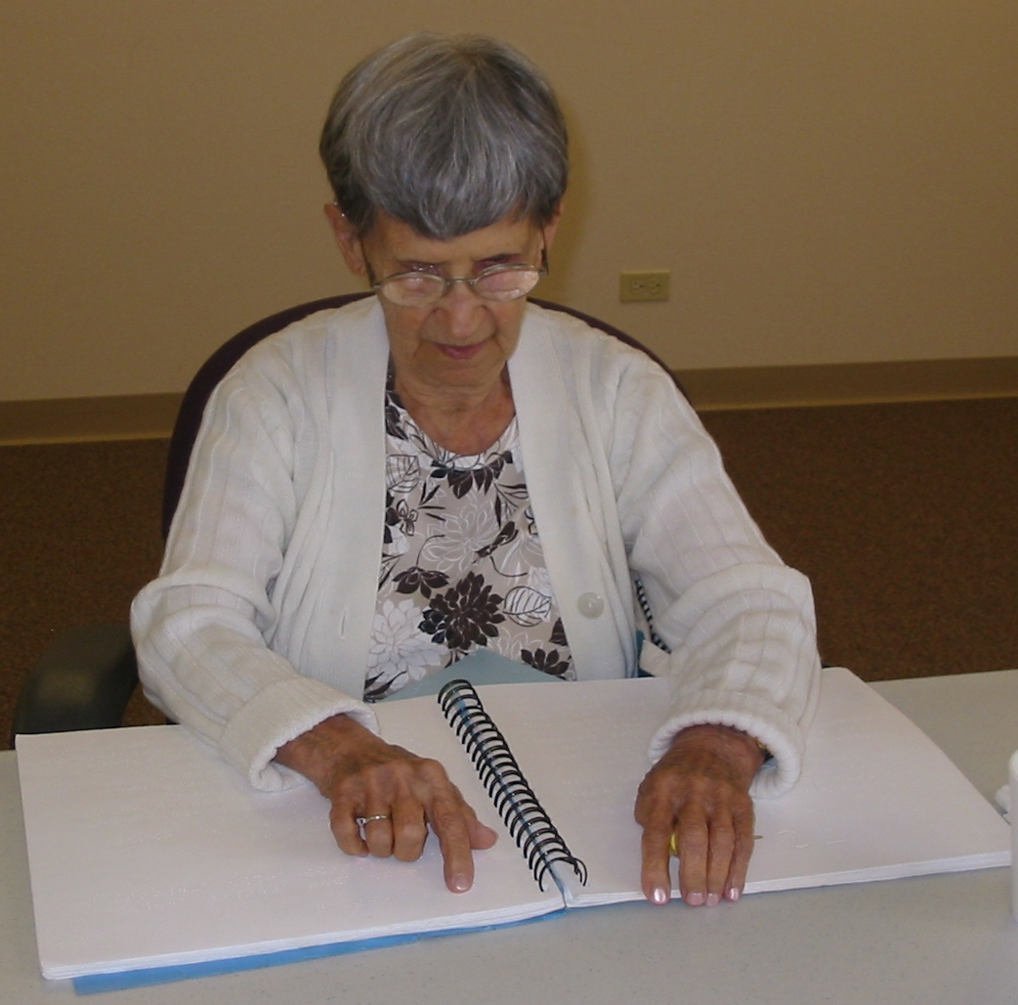
Picture of Marie Dambrosky
(Marie Dambrosky diligently studying Braille)
MARIE DAMBROSKY
Marie, at age 96, had participated in our senior program for almost ten years. She was one of the most inspiring women that I have ever met. Marie was so kind, always thinking about others. She was well read and often brought in books and articles to share with everyone. A couple of years ago she brought in directions to fix a faucet that had broken. She needed someone to read her the directions. That was all she needed and promptly went home and fixed the problem! Marie was always eager to fully participate in everything. One of the last classes she took was a self-defense class for blind people. She made the comment: “Even with my height of 4’7”, techniques will be helpful. When an assailant touches you, he’s not prepared for your (aggressive) touch!”
Friends recently commented about Marie:
“Marie was inspiring!”
“She had fun and was always positive.”
“She had endless energy.”
“She lived alone and independently.”
“She was always trying to improve her mind.”
“Marie always thought about others.”
“She did not make negative comments.”
“She was a Ham Radio operator.”
“She studied self defense, learned to use an I Phone, an I Pad, a computer and Braille.”
“She was amazing!”
“Marie was bright and interested in many things.”
“I want to be like Marie when I grow up!” (that comment from a teacher and a senior friend!)
“She kept going and kept learning and kept sharing.”

Marie said her personal challenges were just a bump in the road. She will be remembered as a friend and an example to us all.

Marie passed away on February 5th. We loved her and will miss her. She will live on in our hearts and inspire us all. If we can all be a little bit like Marie, we will live great lives!

⌘ ⌘ ⌘ ⌘ ⌘ ⌘ ⌘ ⌘ ⌘ ⌘

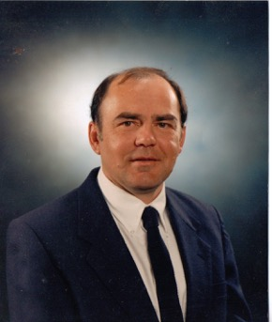
Picture of Gordon Wells
GORDON WELLS

Gordon was born at St. Luke's Hospital in Denver, CO on August 14, 1950. He and his family moved to Lakewood, CO where he graduated from Alameda High School in 1968. He went on to study airline mechanics and in 1970, married his high school sweetheart, Merlene.

Gordon was always interested in martial arts and enjoyed watching Bruce Lee and Chuck Norris movies. He studied Karate, Kung Fu and Tae Kwan Do and through the years obtained his 5th level black belt. Gordon also taught several martial arts classes to adults and kids and enjoyed judging numerous events involving his students.

He worked at Jepperson Sanderson as a graphic designer for 30 years, preparing world topographical maps for airlines until he retired in 2005.

Gordon was a faithful attender of the Colorado Center for the Blind and was highly regarded by his peers. Everyone loved his fun-loving spirit and his determination to learn.

Gordon passed peacefully in his sleep on April 23, 2015, and is survived by his wife Merlene, son Gordon James (J.R.), daughter Kellene Gale, grandson Nikos, sister Sandra, numerous nieces, nephews and cousins.

He was a kind and quiet person who is loved and will be extremely missed by all.

⌘ ⌘ ⌘ ⌘ ⌘ ⌘ ⌘ ⌘ ⌘ ⌘

WHY ATTEND CONVENTIONS?

The various conventions of the National Federation of the Blind offer many resources, information, inspiration and warm camaraderie with many other people, professionals and other members of the community who are also experiencing sight loss. Please try to join us at one or more of these conventions.

⌘ ⌘ ⌘ ⌘ ⌘ ⌘ ⌘ ⌘ ⌘ ⌘

MARK YOUR CALENDARS!!
NFB STATE CONVENTION
OCTOBER 29 – NOVEMBER 1

Please mark your calendars for the next State Convention to be held at the Antlers Hilton in Colorado Springs. To make a reservation, just call 1-866-299-4602 or 719-955-5600 and tell them you are with the NFB to get the special discounted rate. The room rate is $89 per night. For further information, visit www.nfbco.org.
More information to follow in the next newsletter

⌘ ⌘ ⌘ ⌘ ⌘ ⌘ ⌘ ⌘ ⌘ ⌘

SENIOR TOPICS – CONFERENCE CALLS

The National Federation of the Blind Senior Division has put together and sponsored several conference calls on specific topics of interest to blind and visually impaired seniors.

By the time you receive this newsletter, we will have had four of the calls on: “Cane Travel; “Braille – Can I learn Braille as a senior?”; “Organization – keeping track of banking, labeling, sorting and filing necessary documents, etc.”; and “Pursuing favorite hobbies and crafts.”

You may still have time to get in on the last one for this session. On Wednesday, June 10, 2015 at 2 pm Mountain Time, the conference call topic will be about “Leisure Time, dining out, movies, etc., and enjoying your favorite pastime activities.” The call is a long distance call, but you may already have long distance covered with your regular phone. The call lasts about one hour. The number to call is 1-712-432-1500. You will be asked for the access code, which is 759633 followed by the pound sign key on your phone.

Calls are being recorded so if you miss one, you can listen to each recording at a time of your choosing. To listen to a recording, dial 1-712-432-1202. This is a different number for the recordings. You will again be asked for an access code, which is the same 759633, followed by pressings the pound sign key on your phone. Then you will be asked for the reference number for the recording you want to hear.

The reference numbers are:
2, then the pound key – “Financial Management after Blindness” from 2014

3, then the pound key – “Blindness, a family dynamic” from 2014
4, then the pound key – “Cooking by Touch,” from 2014
7, then the pound key – “Cane Travel,” 2015
8, then the pound key – “Can Seniors Learn Braille?”

If you just press the pound key without a reference number, you will get the most current recording.

When you are first connected, you will hear some people check in and chatting, but don’t hang up! You will soon hear the introduction and instructions and then the conference will begin. Those of us who have heard these calls are very pleased and have learned a lot. We hope you enjoy and learn something new from these conference calls. You will also have the opportunity to ask questions and share your ideas.

We would greatly appreciate some feedback from you about the conference calls and also about the newsletter.

⌘ ⌘ ⌘ ⌘ ⌘ ⌘ ⌘ ⌘ ⌘ ⌘

HELLO COLORADO SENIORS

This is our third year of putting together and distributing this senior newsletter. We continue to share information, interviews, some history, technology, even jokes and recipes, in order to build a connection for blind and visually impaired Colorado seniors. We hope this newsletter can be an inspiration to you to continue to learn about many available resources and alternative techniques that will help you participate in life with more confidence and joy. And we hope to build friendships and share support as we all continue on this journey.

Please join us and participate in the newsletter by sending or calling in your suggestions, questions, comments or articles. If you do contact us about the newsletter, you will be included in our drawing for a Braille chocolate bar! We have had three winners so far and will draw another one for each issue. We will also have an alternate prize if you don’t care for the chocolate bar. Contact Duncan Larsen at the Colorado Center for the Blind at (303) 778-1130 X226

Our current winner is
JEFF CLARK!
Congratulations!!

⌘ ⌘ ⌘ ⌘ ⌘ ⌘ ⌘ ⌘ ⌘ ⌘

GET ACQUAINTED WITH DR. JACOBUS TENBROEK

Our past president of the National Federation of the Blind, Dr. Marc Maurer, made this statement in 1986: “Let me offer an ancient and wise proverb: If you give a person a fish, you can feed him or her for a day. If you teach that same person how to fish, you can feed him or her for a lifetime. No Individual in the history of the National Federation of the Blind has taught more blind people how to fish, worked harder, loved more or given more generously of time, talent, energy or resources than Dr. Jacobus tenBroak.”

When Jacobus tenBroek was born in 1911 in Alberto Canada, there was no national organization of blind people. At age 7, he lost part of his sight in a childhood accident with a bow and arrow. By age 14, he was totally blind.

His family moved to Berkeley so he could attend the California School for the Blind. It was there that he eventually partnered with Dr. Newell Perry and others to form the California Council of the Blind, which was a prototype for the N.F.B. that Dr. tenBroek founded in 1940.

When reading of the many speeches, books, organizations and movements he became involved with, it becomes evident that Dr. tenBroek recognized the absurdity of the idea that blindness means incapacity. As others often stated, “This man was not an ordinary blind person.” However what Dr. tenBroek recognized in himself was not that he was exceptional, but that he was normal – that his blindness had nothing to do with whether he could be a successful husband and father, do scholarly research, write a book, make a speech, guide students engaged in social action movements and causes, or otherwise lead a productive life.

Dr. tenBroek’s career took shape after he received his doctorate in jurisprudence from the University of California, completed a year as a Brandeis Research Fellow at Harvard Law School and was appointed to the faculty of the University of Chicago Law School. Two years later, he fulfilled his goal of returning to the University of California at Berkeley and eventually becoming a full professor as well as chairman of the department of Speech and professor of Political Science.

Throughout his life Dr. tenBroek frequently became involved in many other civil rights movements. He became active in support of Dr. Martin Luther King, Jr, and became a champion of the Japanese-Americans interned in camps during World War II and was involved in reversing the legality of such treatment.

As a law scholar, he contributed significantly to the Brown v. Board of education civil rights decision, and was instrumental in protecting the rights of students to hold sit-ins. He also directed efforts to require sheltered workshops to pay workers minimum wage.

In studying Dr. tenBroek’s papers and books, it also becomes apparent that he was more than a well-educated professional. He was also cheerful, enthusiastic and didn’t take himself too seriously. He began some of his letters with “Dear Gang,” and often used such personal phrases as “You did a bang up job!”

Dr. tenBroek’s lifelong and devoted wife, Hazel, worked inseparably with him in raising their 3 children and in his research, writing and academic and Federation concerns. After his death at age 56, in 1968, she continued to be an active member of the organized blind movement.

Dr. Kenneth Jernigan, another past president of the National Federation of the Blind, said the following: To the tens of thousands of blind Americans over a quarter of a century, he (Dr. tenBroek) was leader, mentor, spokesman, and philosopher. As time goes on, his work has made the organized blind movement the symbol of a cause barely imagined before his coming: the cause of self-expression, self direction and self sufficiency on the part of blind people.”

Though this article is long, it is only an introduction to the life of this productive teacher and guide to millions of blind people as well as the poor, disabled and other minority groups. More can be learned from the book “Blind Justice”, by Mattson.
(Much of the above information came from the National Federation of the Blind as well as authors Deborah Kendrick and Lou Ann Blake.)

⌘ ⌘ ⌘ ⌘ ⌘ ⌘ ⌘ ⌘ ⌘ ⌘

THE NFB IS A GREAT RESOURCE

The National Federation of the Blind (NFB) has several services and products available to help you in your journey with visual impairment and blindness.

You may request a free white cane simply by calling the NFB. Because the canes do wear out, you may order one every 6 months if necessary! You may also request a free slate and stylus, which are the tools that people use to write Braille. By calling the NFB at 1-410-659-9314, and pressing the number “1” to speak to someone, you can request printed forms to apply for these items. You may also apply on-line at www.nfb.org.

If you need assistance in using these items, the NFB may have the appropriate reference books or can give you resources where you can get that information.

The NFB also publishes the Braille Monitor, which is filled with personal stories, resource information, reports on events and much more. The Braille Monitor is available in Large Print, Braille, on line and on a thumb drive that you can use with your computer or digital player from the Talking Book Library.

There is no charge for the Braille Monitor, but because of the costs involved in producing it, the NFB suggests that members and non-members help by paying $40 a year to receive this publication. It is certainly well worth it! You may call the above number or check the web site to subscribe and/or get more information.

⌘ ⌘ ⌘ ⌘ ⌘ ⌘ ⌘ ⌘ ⌘ ⌘

DO YOU OR DID YOU ENJOY READING NEWSPAPERS?
DON’T STOP!

Many people find their newspapers to be an important part of their life. They learn about what’s going on in the world, in their communities, in politics and sports, and even what’s on TV tonight!

Those of us who have lost or are losing our vision find quite a vacuum in their day when they don’t see well enough to enjoy their newspaper or even a favorite magazine.

The National Federation of the Blind produces Newsline, which is a free service to any blind or print disabled person. With Newsline, you can listen to today’s news Today, on your telephone or online on your computer. Newsline carries over 300 newspapers from the New York Times and the Denver Post, to U.S.A. Today, magazines like Time, the Smithsonian and AARP.

If you are a member of a Talking Book Library, they can sign you up, or you can call NFB Newsline at 1-866-504-7300, and they will help you become a subscriber and explain how to use the service.

You can continue to learn what’s going on in the world and enjoy many newspapers and magazines with Newsline!
⌘ ⌘ ⌘ ⌘ ⌘ ⌘ ⌘ ⌘ ⌘ ⌘

KERNAL BOOK UPDATE

As mentioned in a pevious issue, the seniors at the Colorado Center for the Blind began distributing NFB Kernel books all over town – especially in waiting rooms where ever we go. The

purpose is to educate and inform the sighted public about how blind people live and work and enjoy their lives.

At this time we have distributed almost 700 books in the Denver Metro area. If you would like to join us in this outreach project, or just want a copy of one or two of the Kernel books – in large print or in Braille, you may call and request them from the NFB at 1-410-659-9314, or call Estelle at 303-789-7538 and I’ll even include a Braille Alphabet card and the Courtesy Rules of Blindness. The books are free of charge and are the NFB’s project to educate people about blindness and the resources that are available.

⌘ ⌘ ⌘ ⌘ ⌘ ⌘ ⌘ ⌘ ⌘ ⌘

FUN FACTS & QUOTES ABOUT HELEN KELLER!

FACTS
 Helen Keller wrote to eight Presidents of the United States, and received letters from all of them—from Theodore Roosevelt in 1903 to Lyndon B. Johnson in 1965.
 Helen Adams Keller was born on June 27, 1880, in Tuscumbia, a small rural town in Northwest Alabama, USA.
 Helen was an excellent typist. She could use a standard typewriter as well as a braille-writer. In fact, she was a better typist than her companions Ann Sullivan Macy and Polly Thomson.
 Helen loved animals, especially dogs. She owned a variety of dogs throughout her life. The first Akita dog in the United States was sent to Helen from Japan in 1938.
 Helen visited 39 countries around the world during her lifetime.
 Helen Keller was the first deaf and blind person to earn a college degree. She graduated from Radcliffe College, with honors, in 1904.
 Helen was friends with many famous people, including Alexander Graham Bell, inventor of the telephone, the writer Mark Twain, and U.S. President Franklin D. Roosevelt.
 Helen won an Oscar for the documentary about her life, “Helen Keller in Her Story.”
 Helen Keller loved Hot dogs!

QUOTES
❖ “We are never really happy until we try to brighten the lives of others.”
❖ “The best and most beautiful things in the world cannot be seen nor even touched, but just felt in the heart.” 1891
❖ “Life is either a daring adventure or nothing.” 1941
❖ “I believe humility is a virtue, but I prefer not to use it unless it is absolutely necessary.” 1916
❖ “What a strange life I lead—a kind of Cinderella-life—half glitter in crystal shoes, half mice and cinders!” 1933
❖ “If I, deaf, blind, find life rich and interesting, how much more can you gain by the use of your five senses!” 1928
❖ “The most beautiful world is always entered through imagination.” 1908

Read a chronology of Helen Keller’s Life at http://braillebug.afb.org/hkfacts.asp under the facts and quotes.

⌘ ⌘ ⌘ ⌘ ⌘ ⌘ ⌘ ⌘ ⌘ ⌘

WANT TO KNOW THE LATEST?
TRY THE INFORMATION HOT LINE!

The Information Line is a free service to anyone with a telephone! By dialing 1-408-752-8052 (a long distance call which you may have covered with your regular phone service) you can get a weather report for your home town or other cities, and updates on news, sports, traffic, stock quotes, driving directions to just about anywhere and much more!
Now that’s a handy service we can all use! Try it out!
⌘ ⌘ ⌘ ⌘ ⌘ ⌘ ⌘ ⌘ ⌘ ⌘

BRAILLE IS MY IRA!

My I.R.A. is an Independence Retirement Account! By learning and using Braille, I am preparing for my Retirement from vision use! As I am aging and losing more sight, I still want to keep some of my Independence and be able to read! Braille is giving me the opportunity to continue reading, which Accounts for my greater peace of mind as I enter this new chapter in my life!

P.S. The other alternative methods of daily
living are also a big part of my I.R.A.!

⌘ ⌘ ⌘ ⌘ ⌘ ⌘ ⌘ ⌘ ⌘ ⌘

My Brailler is Sick!

Do you own a Perkins Brailler that doesn’t seem to perform properly? We have a gentleman in Denver who can clean and repair your Brailler for a very reasonable charge. If you live outside of Denver,
he may still be able to help you.

For more information, please call Kirk McCall at 303-274-4640.

⌘ ⌘ ⌘ ⌘ ⌘ ⌘ ⌘ ⌘ ⌘ ⌘

SILLY STUFF

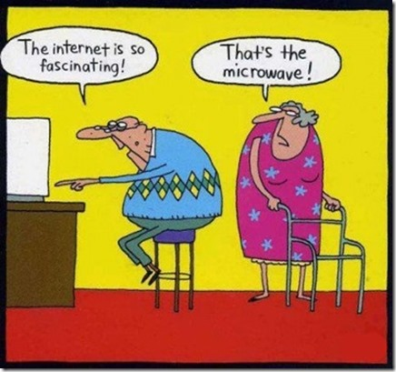
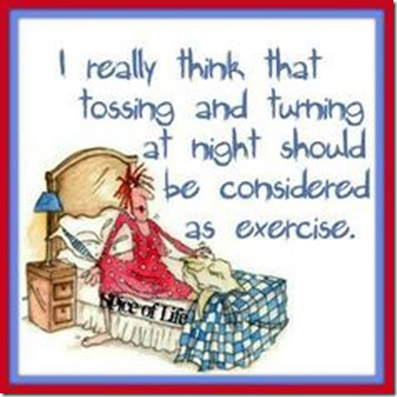

⌘ ⌘ ⌘ ⌘ ⌘ ⌘ ⌘ ⌘ ⌘ ⌘

HOOTENNANY PANCAKES

(This recipe has been a family favorite for over 40 years and was originally a firehouse recipe. We have taken it on camping trips or just enjoyed it with friends. We hope you will like it as much as we do. Rich Schiavone)

1 cube butter or margarine
6 eggs
1 cup flour
1 cup milk
1 teaspoon salt
syrup

Preheat oven to 350 degrees. Melt butter and pour into a 13 X 9 baking pan. In a bowl, mix together eggs, flour, milk and salt. Pour batter over butter in the baking pan. Bake until batter puffs up and gets nice and brown, approximately ½ hour. Remove from oven and cut into squares. Serve with syrup. Enjoy!

⌘ ⌘ ⌘ ⌘ ⌘ ⌘ ⌘ ⌘ ⌘ ⌘
**For questions about senior services, please contact:
Duncan Larsen, Director of Senior Services
dlarsen@cocenter.org
(303) 778-1130 X226
2233 W Shepperd Ave
Littleton CO 80120

