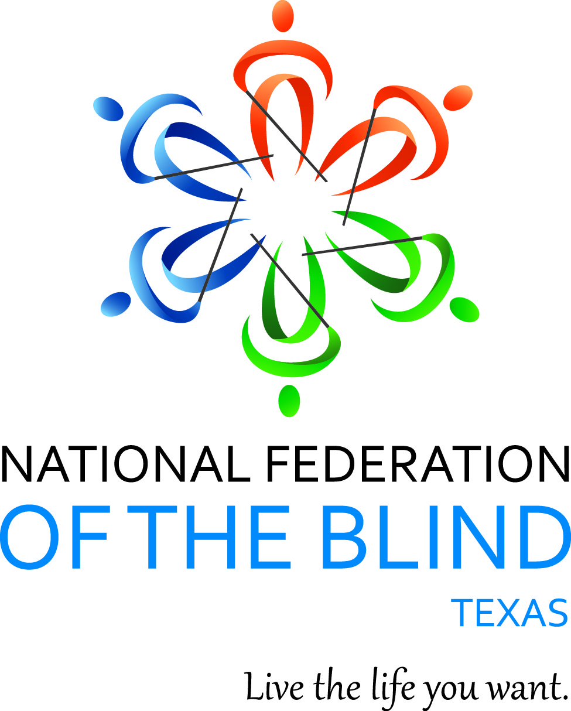
NFB-NEWSLINE® Texas and the
Texas Association of Guide Dog Users Present

Guide Dog Handler Advocacy 101:

Your Rights and Responsibilities

Date: Saturday, September 26, 2020
Time: 1 p.m.-3 p.m. Central
Location: Zoom

Are you a guide dog user or want to become one?
Have you ever wondered what it is like traveling with a guide dog?

Join members of the National Federation of the Blind and the Texas Association of Guide Dog Users to learn about life with a guide dog and how to advocate for your rights. Seasoned guide dog handlers will be unhand to answer your questions and share their experiences. There will be opportunities to network and learn about other blindness resources.

Find out how you can read over 500 updated publications with
NFB-NEWSLINE®, the free electronic information service available on the telephone, iPhone and iPad, Amazon Alexa, and other devices.

All are welcome to attend, whether you are currently working with a guide dog or if you are interested in having one in the future.

Registered participants will be entered to win door prizes!

Please register for this event at: https://forms.gle/u3LotC64fajNuQR4A

Qualifying Texas residents will be registered for the free NFB-NEWSLINE® electronic information service.

