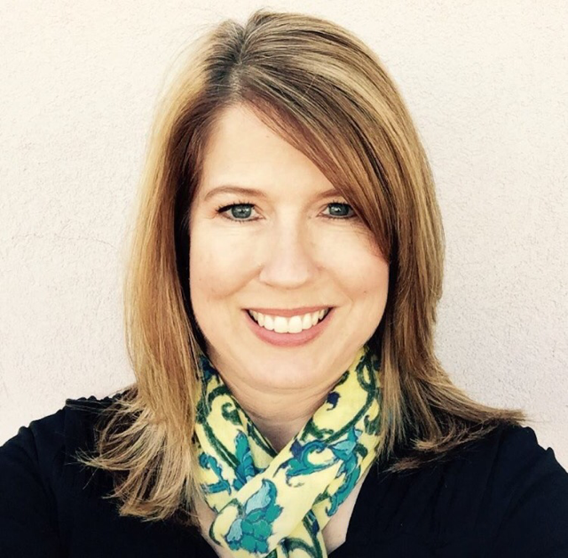

Rebecca Sue Nielson Turley passed away on July 20, 2016 in Sandy, Utah of pancreatic cancer. Rebecca was born in San Diego, California on October 28, 1964. She was the first of four children raised by Kaye Fraughton Nielson and Kenneth Arvle Nielson. Her childhood years were spent in Danville, California, where she enjoyed gymnastics, softball, dancing, piano, playing games with her siblings, time with friends, going to the beach, and annual road trips to Disneyland. She graduated from Monte Vista High School in 1982 and earned her Bachelor’s Degree in 1988 from National University in San Diego, California.

In 1984, she met Mark David Turley and the couple married in the Seattle Temple of The Church of Jesus Christ of Latter-day Saints on June 22, 1985. They made their home in San Diego, California and welcomed two beautiful daughters into their family. While advocating for her daughter with special needs, Rebecca developed significant expertise in the laws, systems, and resources available for children with disabilities. She also discovered a talent for working with other parents facing similar challenges and loved helping them advocate for their children as part of her responsibilities with the Learning Disabilities Association.

In 2005, Rebecca’s husband retired as a civil servant of the Navy and the family relocated to Sandy, Utah in 2006. Rebecca joined the team at the Utah Parent Center where she continued to assist parents of children with disabilities. She was especially proud of her work to establish the Family to Family Network, which connects and provides support to families across the state of Utah. She also founded and facilitated the Center’s IEP Coach Program, which provides training and support to Utah parents seeking the most appropriate education for their children with Individualized Education Programs. Those who worked with Rebecca said she gave her heart to those she helped, was extremely knowledgeable and thorough, and completed everything she did at the highest standard. In 2015, Rebecca chaired the Utah Special Education Advisory Panel to the Utah State Office of Education. Rebecca also shared her expertise as a member of the Disability Support Council for The Church of Jesus Christ of Latter-day Saints. Most recently, the Utah Developmental Disabilities Council named her the 2016 Parent of the Year for being such a strong and effective advocate for her daughter with special needs.

Rebecca’s greatest joys came from time spent with her family and raising her children. She was a committed and loving mother and wife. She enjoyed seeing her daughter Rachel excel at music and cheered her daughter Sarah’s success in figure skating. Rebecca encouraged both girls to pursue their creative passions and to serve others. Rebecca also supported her husband’s interest in sports, his goal to further his education, and his service as President of the Salt Lake County chapter of the National Federation of the Blind. The family has enjoyed going to movies and concerts together, building gingerbread houses with relatives at Christmastime, and has especially fond memories of vacations to Southern California, the Pacific Northwest, and the Bahamas. Rebecca and Mark loved to travel before the girls were born and visited 49 states together.

Rebecca is survived by her husband, Mark David Turley, and daughters Sarah Elizabeth Turley and Rachel Kaye Turley of Sandy, Utah. She is also survived by her parents, two sisters and their families, a brother, and numerous extended family members.

A funeral will be held on Saturday, July 23rd at 1:00 PM in the LDS Church located at 10375 S Leilani Dr, Sandy. There will be a public viewing on Friday, July 22nd at Wasatch Lawn Mortuary located at 3401 S Higland Dr, Salt Lake City. In lieu of flowers, please consider making a donation in Rebecca’s honor to the Utah Parent Center: <http://www.utahparentcenter.org/donate/>